Welcome to the
III - Flow Core Facility

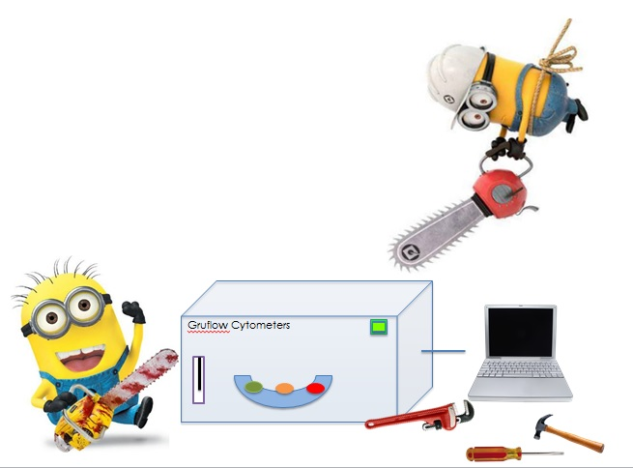
Contents

Overview of how we operate
Emergency Procedures
Safety
Analysis safety risk assessment form
Charges
FACS Booking / Cancellation Etiquette
Shapiro’s Laws of Cytometry
Things to bring with you to the FACS lab
Reporting Problems with Machines
Acknowledgement of the Facility in publications
Discount Quotes and Sales Representatives details
Information for New Users
- The Flow Core Facility is open 24hrs a day for 3I users. Staff assistance is only available between the hours of 9am-5pm.
- You may book the analysers after these hours once you have demonstrated competence on the machines.
- If you would like to sort, assisted sorts are available from 1030am-430pm. Should you wish to sort independently, additional training will be required. This will not be given until you have three months experience of multicolour analysis.
- Should you wish sort training you will be required to commit a minimum of three full days to learning to sort. We will teach you how to sort properly not simply how to start up and shut down the instrument.
- Instruments may only be booked after you have been given training on how to operate them and are signed off as competent.
The facility staff will ensure you are added to the online booking system on completion of training. The online booking system can be found at:
www.labagenda.com
Use the Online Scheduler to make your booking. Remember to book enough time to clean the machine when you are done.
The minimum time slot you can book is 30 minutes for analysis and 2 hours for cell sorting.
If you are running more than 20 minutes later than your booked start time, then your booking will be considered cancelled, unless you contact us to renegotiate a time.
There will be no charge for bookings cancelled > 24hours notice.
Full charges will apply for cancellations <24hours notice.
Cancellation charges may be waived in some circumstances, at the discretion of the Facility manager.
The last booked user of the day is fully responsible for shutting down the equipment. This includes full cleaning, and emptying waste tanks/refilling sheath fluid.
All users should check the online booking system whilst in the FACS lab in order to check whether they have become the last user due to subsequent users cancelling.

Safety
All new staff based in the GBRC should have completed the building Safety Induction Course before commencing work.
The Facility has over 140 users. Our goal is not to inhibit research but to enable users to conduct it in a safe manner.
All users of the Flow Cytometry Facility must read our local safety rules as detailed in the next page, and complete the appropriate biosafety form before undertaking work in the Facility.
One form is for users of the analysers (Calibur/ Quant/LSR II/Celesta/LSR Fortessa); the second one is for users of the FACSAria cell sorters. If you use both types of machine you must fill in both forms.

The Analysis Safety form is provided at the end of this welcome pack, should you require the sorting safety form please ask facility staff.

Local Safety Rules
- Eating and drinking, in the Facility is banned.
- Application of cosmetics in the Facility is banned
- Laboratory coats must be worn at all times whilst running samples in the Facility. When emptying waste tanks all users must wear the safety specs provided
- Door handles etc. must not be touched with gloved hands.
- Gloves must be worn for all manipulations of sample tubes containing potentially infective material.
- Gloves must not be worn when operating computers or control panels (i.e. the hand changing samples on machine is gloved, the hand operating the computer is not)
- Dedicated waste fluid tanks designated for hazardous waste fluids have to be fitted before commencing analysis/sorting
- Follow start up and closing down procedure for the machine used
(Refer to machine SOPs)
- If you are running unfixed human cells you must decontaminate the machine by running FACS Clean through it during the cleaning procedure. Follow the SOP for each machine.
- Remove dedicated waste fluid tank, add disinfectant tablet, close tank lid, disinfect surface of waste fluid tanks and leave waste overnight for disinfection. Attach waste sample label detailing - date, user, sample description and contact details The Flow Core staff will dispose of decontaminated waste the next morning.
- All pipette tips must be discarded into the sweetie jars or metal tins.
Do not put them into autoclave bags.
- Do not put non-hazardous waste into the autoclave bags. e.g. empty quant running buffer bottles, writing paper, and printed results. These should go into the domestic waste, or paper-recycling bin
- On completion of their work each user must leave the area they have used clean and tidy. All waste and samples etc should be removed and work surfaces disinfected with 70% Ethanol.
- The waste tank should be emptied (unless it needs decontaminated
overnight) & the running buffer /sheath tank refilled.
- If you spill anything on the bench or floor mop it up.if necessary clean the area with 70% ethanol.
- If you drop nitex, Facs tubes, pipette tips or anything else on the floor pick it up and dispose of it appropriately.
- Report all machine faults or damage to the facility manager.
- Any accidents occurring in the Facility, however trivial, should be reported to the facility manager and a University “Injury or Dangerous Occurrence” form should be submitted to SEPS.
Flow Cytometers and Biosafety

• All users should faithfully follow the Instrument SOP for correct operation and decontamination of the machines.
• All Instrument faults should be reported to the Facilities manager.

Analysers

Aerosols can be generated by the analysers, through the waste air vent tubing during normal operation, and from the sample injection ports (SIP) if the machine is blocked. Users must ensure that tubes are fitted securely onto the SIP, as if these are blown off during pressurisation, sample could splash onto the operator. If the droplet containment function is not working this results in back dripping of sample which again may splash the user.

Flow Sorting

During normal operation cell sorters generate droplets and aerosols, which can be released into the room. If the machine fails i.e. excess air in the fluidics, or blocking of the nozzle aerosol production is massively increased. We have an aerosol management system to contain aerosols. Sorts are accepted only after a full risk assessment. Sorting of unfixed class 2 material is at the discretion of the facilities manager & safety officer.

Please Note: we do not have the facilities to sort cells infected with unfixed class 3 or 4 agents.

Any accidents should be reported to the Facilities Manager, and a University Accident Report Form completed.
Emergency Procedures Institute Policy
To Summon Help in an Emergency Call extension 4444
This number is a direct line to Security at the gatehouse.
Have the following information ready:
1. Where are you? GBRC, B44/4 Flow Core Lab. Extension is 2626)
2. What happened? Is there further danger? (intruder, fire, contamination)
3. Any casualties? Nature of injury/severity/are they conscious/breathing?
The University phones will not let you dial 999 direct they will put the call through to Security. This is necessary because:
If there is still danger security can attend immediately. Security will provide directions & assistance to the emergency services.
If you are presented with a situation where you need to dial 999 immediate let Security know you have done so at the earliest opportunity.
First Aid
Should there be an incident requiring first aid, first aiders available on level 4 are:
- Fiona McMonagle (Level 4)
- Diane Vaughan (Flow Core Facility Ext 2626)
- Helen Arthur (Chief Technician Ext: 7147)
The first aiders are generally not available before 9am and after 5pm or on Public Holidays.
Remember that any accidents and also near misses MUST be reported to keep the University a safe working place for everyone.
Personal Security when Leaving the Flow Lab out of hours
When working late you may require an escort from University Security staff e.g. when the access doors fail and you need to exit via the car park or if the lights fail outside the front entrance of the GBRC
Do not hesitate to Phone security on 4282 for an escort out the building
They should not take longer than 10 minutes to reach the GBRC.

Reporting Problems With Machines

Sometimes our machines have issues, and it is important that we know about them so we can fix them ourselves or arrange for an engineer to visit.
If you have a problem using a machine either:
- Speak to staff between 9am-5pm (if not in the lab, find us in B427)
- email us anytime :
(Diane.Vaughan@glasgow.ac.uk
Alana.Hamilton@glasgow.ac.uk,
Elizabeth.Peat@glasgow.ac.uk)
- Simply leave a note beside the machine detailing the problem

If the issue appears software related, please take a screenshot and email to us/save to instrument desktop so we can easily access it.
Screenshot is CTRL, prt scn...open Paint and press CTRL+V. (Paint can be found in the start menu)
If we suspect the hardware is at fault we will most likely ask for FCS data files representative of the problem encountered

FACS Booking / Cancellation Etiquette

In order for the facility to run smoothly and for everyone to be able to carry out their research, we have some guidance for users regarding their bookings on the machines.

- Bookings are made on a first come-first served basis

- Users will not normally be allowed to book on two analysers at the same time. Flow Core Staff may give permission for such bookings under exceptional circumstances if experimental justification is provided in advance.

- Should you find you no longer need your booking, please let the facility staff know as soon as possible so that other users can use the now empty slot. Please email us at Diane.Vaughan@glasgow.ac.uk, Alana.Hamilton@glasgow.ac.uk, Elizabeth.Peat@glasgow.ac.uk

- Daily drop-in sessions on the Celesta have been established from 12-2pm on a first come-first served basis

- All users can book the Aria IIU as far ahead as their experimental needs dictate.

- Bookings for the Aria III may only be made 7 days or fewer in advance.

- Users will not normally be allowed to book both sorters for the same time slots. Flow Core Staff may give permission for such bookings under exceptional circumstances if experimental justification is provided in advance.

- Booking of a second sorter will be allowed at 24 hours notice if it is free.

- Sorting will always take priority over analysis on the cell sorters unless a sorter is free within 24 hours in advance.

- On consultation with Flow Core Staff, brief booking for analysis may also be allowed when necessary to test panels and settings needed for previous or forthcoming sorts.

Data Storage Policy
Facility users are fully responsible for their own data files.
We recommend that after sample acquisition you copy your files immediately and check that they have copied across properly.
All data should be backed up to the University OneDrive. There is a protocol available if you are unsure how to use this.
With the exception of the Miltenyi MACS Quant, the use of memory sticks/external hard drives is forbidden on our analysers and sorters.
Flow Core staff will delete any files over a week old on a Monday morning. The Facility does not back up users data to a remote off site storage drive. In addition to storing your data in the building you are strongly advised to have an additional back up drive at home. Our machines receive routine maintenance on a monthly basis, including database backup.
In the event that you or a colleague are unable to back up your data due to exceptional circumstances please contact Flow Core staff

Charges for using the Flow Core Facility

There are two billing option for users:
A Gold Bench Fee:
For an additional FACS access charge of £1157 for a year (August-July) the users is entitled to unlimited access to the Facility. There is an additional charge of £6/hr. for consumables.
A Silver Bench Fee:
FACS Access is not included. The silver charge will be £672 for a year .
Users can pay as they go at the higher charge of £45/hr. for FACS analysis and £75/hr. for FLOW sorting. There is an additional charge of £6/hr. for consumables.
Cancellation Charges: at the discretion of the manager.
There will be no charge for bookings cancelled > 24hours notice.
Full charge for bookings cancelled < 24hours notice unless
**Please note - Institute users will not normally be charged for staff assistance, however in the exceptional case where extended out of hours work is required charges may apply.

Points to Note:
Sample Preparation

- Filtration of samples is mandatory
- Add 10U/ml DNAse II to samples with a high cell percentage death e.g. Apoptosis assays, stem cells, proliferation assays, fragile cells having undergone harsh digestion etc.
- Consider the optimum concentration for your cell type
- Use 2.5-5mM EDTA (final conc) in your FACS buffer if you have sticky or adherent cells.

Minimum Acceptable Instrument Cleaning

After running samples and finishing cleaning the instrument, all users must check the Instrument is clean:
- Take a new clean FACS tube
- Add sterile distilled water and run and acquire events for two minutes
- If there are less than 100 events per minute, you may hand on the instrument to the next user.
- If not, repeat the cleaning procedure until there are less than 100 events per minute

If you continue to have problems with cells persisting in the system please inform the Flow core staff sooner rather than later.
Things to bring with you to the FACS Lab

Your FACS Safety Form if not already submitted. Without this you will not be permitted to work.

What to bring: Acquisition on the Analysers

- Gilson pipettes and tips and /or pastettes.
- Nitex or BD Falcon, or Partec cell strainers to filter your samples before acquisition.
- Any stain/ reagent you need to add to your samples immediately
before running
- Aluminium foil to protect your samples from light.
- Ice bucket – if your samples need to be kept at 4 degrees C
- PBS or other similar diluents for adjusting cell concentration.
- A lab coat and gloves.
- Your prepared samples in appropriate FACS tubes for the
machine you are to use.
- Controls for your experiment. See Sample Preparation for more
details.

FACS TUBES: Use BD Falcon tubes MVLS STORES keep these
TUBE POLY. 6ML - pk/125 £9.01 Code: TU.P06/1-
TUBE POLY .6ML CAPPED £14.01 Code: TU.P06/2-

Additional Things Required for Cell Sorting

- Suitable collection tubes and media to sort you cells into.

- A laptop and/ or work to do whilst the sort is running.

- Be prepared to watch the sorter whilst Flow staff take lunch/deal with emergencies in the lab

Filtering Your Cells: Filter Choices
1) MVLS STORES:
- EASYstrainer - 40um mesh box 50 £35.00 Code: TCG.ST040-
Fit onto a 50ml tube –so not ideal but good value
2) Nitex Monofilament Mesh
- Supplier: Cadisch Precision Meshes, Hatfield UK
Monofilament cloth- cut to size needed. N.B. dispose of used
nitex in the autoclave bin, not on the Flow Lab bench /floor

For a quotation phone: 020 8492 0444

3) CellTrics Cell Strainers
- Supplier: Sysmex UK LTD, Sysmex House, Garamonde Drive, Wymbush Milton Keynes
Order No. Type Colour
04-0042-2314 CellTrics® 10 µm black
25004-0042-2315 CellTrics® 20 µm red
25004-0042-2316 CellTrics® 30 µm green
25004-0042-2317 CellTrics® 50 µm yellow
25004-0042-2318 CellTrics® 100 µm blue
25004-0042-2319 CellTrics® 150 µm white
Sterile CellTrics (for Sorting)
25004-004-2324 CellTrics® 10 µm, sterile single packed black
5004-004-2326 CellTrics® 30 µm, sterile single packed green
5004-004-2327 CellTrics® 50 µm, sterile single packed yellow
5004-004-2328 CellTrics® 100 µm, sterile single packed blue
5004-004-2329 CellTrics® 150 µm, sterile single packed white
For a Quotation email: Walker.Clare@sysmex.co.uk

Acknowledgement of the Facility in Publications

The Flow Cytometry Facility receives operating funds from various sources, allowing us to keep our fees low. In order to help us demonstrate the value of the Facility to your research, please acknowledge us when publishing data generated on our machines.
We suggest something along the lines of: We acknowledge the assistance of the Institute of Infection, Immunity and Inflammation Flow Cytometry Facility at the University of Glasgow.
In the event that Facility staff have contributed significantly to specifics of experiment design, data analysis or provided specialist technical troubleshooting above and beyond the norm please mention this in the acknowledgements.
Please notify the Facility Manager of any publications, and email the reference details.
If any assistance is required with preparation of publications please contact the Facility Manager.

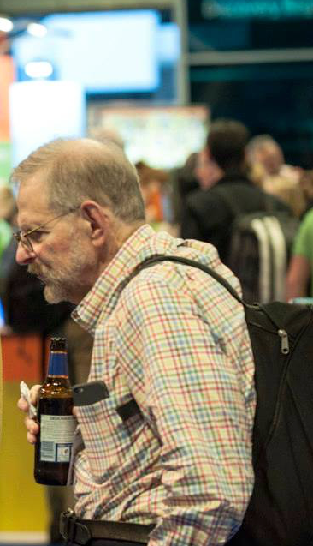
Howard Shapiro’s
Laws of Cytometry

Shapiro’s Zeroth Law:
There is no Magic
Running FACS experiments relies on the application of physics (instrumentation) and chemistry (reagents) to generate data.

Shapiro’s First Law:
A 51 um Particle Clogs a 50 um Orifice
Cytometers are easily blocked when users don’t know that the size of their cells, or whether the cells like to aggregate.

Shapiro’s Second Law:
What You See Is What You Get
If your cells are stained with a fluorochrome, which is excited by the correct laser and you have the correct filter sets to pick up the fluorescence emitted what you see on the cytometer is what you get, provided you have valid controls

Shapiro’s Third Law:
What’s in the Bottle Isn’t necessarily what’s on the Label

Shapiro’s Fourth Law:
Most Babies Aren’t Born in Supermarkets
This concerns cell acquisition and loss of antigens during maturation. Depending on where the sample of cells is taken, the population changes could be occurring there or be a rare event in that tissue compartment. This relates to babies in supermarkets as we see pregnant women and women with babies but rarely see babies being born there. That would be a rare event.

Shapiro’s Fifth Law:

No Man Walks into a Barbers Shop with a Long Beard Who Hasn’t Had a Shorter One and No Barber Can Make a Beard a Lot Shorter Without Cutting It.

This relates to short-lived transitional states that some cell types undergo. For example distinguishing between immature reticulocytes and mature RBC. Reticulocytes can be identified by their content of RNA, which is lost within a day or so as the cells enter the blood from bone marrow. The distribution of RNA in RBCs is therefore continuous. Consequently, the ‘human observer’ has to decode where to place the razor (gate) into order to determine where to measure the distribution in a continuous population as cells change state.

Shapiro’s Sixth Law:

There Are Some Cell Identification Problems That Even Monoclonal Antibodies Can’t Solve

Monoclonal antibodies can be used for phenotyping cells and sub populations of cells which is convenient for immunologists but they are more than simply surface markers. These antigens serve a function to the cell and they will not answer all questions about cells.

Shapiro’s Seventh Law:

No Data Analysis Technique Can Make Good Data out of Bad Data
If you have a bad sample and your cells don’t look right when running them on the cytometer, they will not suddenly look good in post-acquisition data analysis. This links to the Zeroth law – there is no magic.

Shapiro’s Eighth law:
Know Thy Cells
When buying a cytometer you need to know what cells are likely to be run, and what fluorescent proteins they should express. This links back to Shapiro’s third law, find out what is on your cells before running them through the cytometer.

Discount Codes and Sales Rep. Details

BD Bioscience – Steve Rackstraw
Stephen.rackstraw@bd.com
Discount code – Q18-IS-GS-046 entitles you to
25% discount on Clinical Reagents, (product codes beginning 33,34,64,65)
20% discount on Pharmingen Reagents (product codes beginning 55,56,61)
A full list of reagents and prices is available on request from Flow Core Staff on request.

Affymetrix/eBioscience – David Harley
David_Harley@affymetrix.com
Discount code - SA00003347 entitles you to
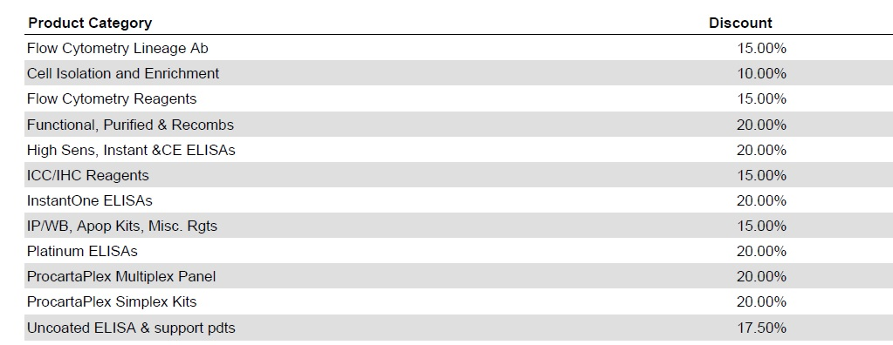

Biolegend - Sara Sampietro
Ssampietro@biolegend.com
Discount code – YSS141216-UniGla entitles you to
20% off all products, except Goin Vivo which has a capped discount of 15%

ThermoFisher/Life Tech – Lynesay McKay
Lynesay.McKay@Thermofisher.com
Discount code E1740830 entitles you to a variety of discounts.
For the full list, please ask Facility staff

Miltenyi Biotec – Graeme Pollock
Graemep@miltenyibiotec.com
No discount code as such, but regular offers run on Antibodies. Contact Rep for further details

ANNUAL BIOSAFETY QUESTIONNAIRE A
This sample form must be filled out and signed by the staff member who will be analysing samples in the flow cytometry facility before experiments or projects are started.
It must be also be checked and signed by the PI.
This biosafety form will be kept on file, the PI must inform the Facility Manager if any of the information it contains changes. Appropriate risk assessment, and where necessary approval, of experiments is required before work is undertaken.

. Appropriate risk assessment, and where necessary approval, of experiments is required before work is undertaken.

Flow
Core

Facility

The 3I
ANALYSIS (Calibur/LSRII/Quant/Celesta/LSRFortessa)
Date: ________________ Year: August 2018 - 31st July 2019
Principal Investigator: __________________________________________________________
Phone Number: _______________________________________________________________
E-mail: ____________________________________________________________________
Staff member using Flow Cytometry Facility: ______________________________________________________
Phone Number: _______________________________________________________________
Lab Number: _________________________________________________________________
E-mail: ____________________________________________________________________
Are you an existing user having been trained by 3I’s Flow core staff? (Yes/No)
All new users must be formally trained on the machines by 3I’s Flow core staff.
Please answer all of the questions below, print, sign and date and return, to the Flow Cytometry Facility, Room B4/44
Project Title:

Cell types for analysis: __________________________________________________________
Species: ____________________________________________________________________
Pathogen or Cells from potentially infectious source? Yes _______ No ________
Pathogen
If Yes indicate Hazard Class of organism: Class I _____ Class II_____ Class III___
Fixed cells from prior infectious source? Yes _______ No _______
Please indicate fixative used: _____________________________________________________
Note. It is the P.I.’s responsibility to insure that the fixation used is suitable to render the samples non-infectious.
For human samples, what is the source of cells (e.g. volunteers, patients, blood bank, etc.) and are patients tested for HIV, Hepatitis, HTLV, EBV, and other pathogens? ____________________________________________________________________
For cell lines, were they transformed by, or carry, any known viral pathogens (e.g. HIV, EBV, other)? __________________________________________________________________
IF NOT TESTED, PLEASE INDICATE: ___________________________________________
Have copies of COSHH forms been submitted to the facility? Yes ____ No ____
Please give relevant COSHH form number _____________
Analysis of genetically manipulated cells
Are the cells to be analysed genetically engineered or manipulated? Yes ______ No______
If yes, is a gene therapy virus, e.g. adenovirus, retrovirus, lentivirus, herpesvirus, etc., employed? Please indicate and specify: -
Viral vector: ____________________________________________ (e.g., LentiMax, or other)
Is a helper virus used also? _____________
If so, which? _____________________________
Nature of insert(s) (oncogenes?): _________________________________________________
Replication incompetent (specify):________________________________________________
Capacity of virus to infect human cells: ____________________________________________
Are transduced cells passaged at least 3 times prior to analysis? Yes ________ No ________
Are cells transfected with plasmids? _____
Nature of inserts? _____________________ ____________
Have copies of GMO approval documents been submitted to the facility? Yes ____ No ____
Please give relevant GMO form number _____________

Signature of P.I. ___________________________________
Date: ______________________
Signature of staff member: ___________________________________
Date: ______________________

Samples accepted by Facility Manager _____________________________ Date __________

Note. Safe use of the Flow Cytometry Facility relies upon co-operation between the staff and investigators who use the facility. As cell types and/or biohazard information change, prior to the next annual survey, this form must be updated.

BILLING INFORMATION

GOLD Bench Fee

Only complete this section if fall you are a GOLD bench fee holder. Discounted one off annual payment of £1157, (plus £6*/h for unlimited access) exclusive to 3I users.
Principle Investigator | College/Institute | Cost Centre | Project Code  NB email to Alison Wallace  Head of Research Administration

Silver Bench Fee

Only complete this section if you are a SILVER bench fee holder, there is a £672 one off charge. You will pay the basic charge of £40*/hr. for analysis and £75*/hr. for cell sorting plus £4*/hr. for consumables.

Principle Investigator | College/Institute | Cost Centre | Project Code

*Costs are subject to annual review. PI will be notified of any changes.

