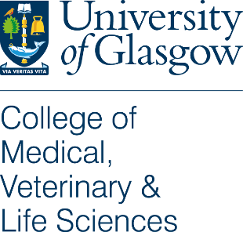
MVLS Public Engagement with Research

Training Request Form

If you are unable to identify appropriate training or support within the existing programmes, would like to request a repeat opportunity to attend a previously held training event, or learn of mentoring or support opportunities, please complete this Training Request Form.

Please discuss any applications with your line manager.

Completed Forms should be emailed to: MVLS-Engage@glasgow.ac.uk

Name
Email
Job Title
Location within MVLS

What is your training/development need?

How does this link with public engagement with research activities of the University and/your institute/school or team?

If you have already identified an appropriate activity (e.g. a course or workshop) please note course reference here along with any other supporting information.

How will the proposed training/development activity benefit or relate to your own job?

What do you hope to learn?
Try to express this in terms of three key learning objectives, using the bullet points below:

Line Manager Details
Please note we may contact your line manager to discuss your request
Name
Email
Job Title
Location within MVLS

Completed Forms should be emailed to: MVLS-Engage@glasgow.ac.uk

Any other details (eg. Preferred timing, location requirements, financial arrangements etc.

