**Title of the contribution prepared for ESCAMPIG XXIV**

Topic number

**(Times 14, bold, centred)**

First AuthorP1P, Presenting AuthorU12P, Corresponding Author (*)1P, Last AuthorP3P (Times 12, normal, centred)

P1P School of Physics & Astronomy, Kelvin Building, University of Glasgow, Glasgow G12 8QQ, UK

P2P Department of Physics, SUPA, University of Strathclyde, Glasgow, G4 ONG, UK

33 School of Engineering and Computing, University of the West of Scotland, Paisley Campus, Paisley, PA1 2BE UK

*(Times 10, Italic, centred)*

(*) email of corresponding author

Replace this text with the abstract of your contribution, minimum of 4 and a maximum of 8 lines are requested. Use Times font, 10 pt, simple line spacing, left and right justified. For the title, author names and affiliations, the margins are 2.5 cm left and 2.5 cm right, and for the abstract use 3.5 cm left and right.

All interested participants are invited to present the latest results of their scientific work in one of the ESCAMPIG subject areas. The deadline for abstract submission is March 2, 2018. Notifications of the acceptance or rejection of the contributions will be distributed no later than April 2, 2018.

However, in order to get a fast response from the International Scientific Committee on the final decision, early submission is highly encouraged.

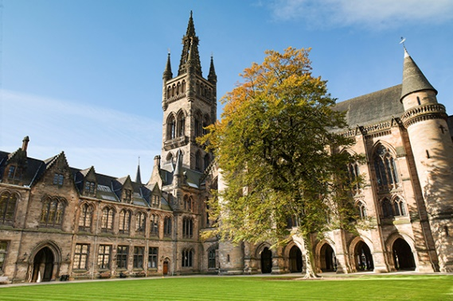

ESCAMPIG 2018

Fig. 1: Captions should be Times New Roman, 10 pt. Note that figures can be embedded in the text.

Contributed, full-length papers must be written in English and should report previously unpublished work. The authors are responsible for both the content and style of their contributions. No editing or re-typing will be carried out by the conference organizers, and accepted contributions will be reproduced without reduction or modification. Contributions that do not conform to the format of the template may be rejected.

Each contributed paper must be submitted as pdf file. A docx template and a Latex template file are available for download. In order to have a paper published in the conference proceedings, at least one of the authors must have paid the registration fee by the early registration deadline: April 30, 2018.

Papers should be in single column A4 layout, with a maximum of 2 pages for contributed papers, and 4 for invited papers (inclusive in each case of references and figures). Please don’t forget to put the topic number on the top right-hand corner of the first page.

|  |  |
| --- | --- |
| **Item** | **Format (using Times New Roman font):** |
| Title | Bold, centred, 14 pt |
| Author names | Normal, centred, 12 pt |
| Affiliations | Italic, centred, 10 pt |
| Main text | Normal, justified (left and right, use hyphenation), 11pt, A4 portrait |

Place references at the end of the paper, and cite using a numerical scheme [1]:

**References**

[1] A. N. Other, *J. Defined Ambiguity,* **22** (2018) 37-47