New café can Make it Happen for newcomers from eastern Europe
- The Courier & Advertiser (Angus and The Mearns Edition)
- 14 Oct 2016

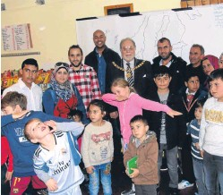

Councillor Alex King, centre, with some of the visitors to the new Make It Happen café in Arbroath’s West Port.
A new Angus project aimed at providing a new social setting for people who have come to the area from eastern Europe has been opened.
The Make it Happen café, in the former OBs premises in Arbroath’s West Port, was opened by Angus Depute Provost Alex King as part of a Social Support and Migration in Scotland programme of action and awareness-raising.
It is hoped that people from a variety of eastern European countries and other nations who have settled in Angus will use the café as a regular meeting place.
Councillor King said: “Angus Council is very happy to see the inauguration of this initiative, aimed at welcoming newcomers to our community.
“The council would like to acknowledge the important role that people coming to work and live in Angus play in our region and we would like to see everyone feel welcome.
“Providing a space for people from all communities to come together is a very worthy cause and we hope this project goes well and leads to the establishment of a permanent community hub in Angus.”

