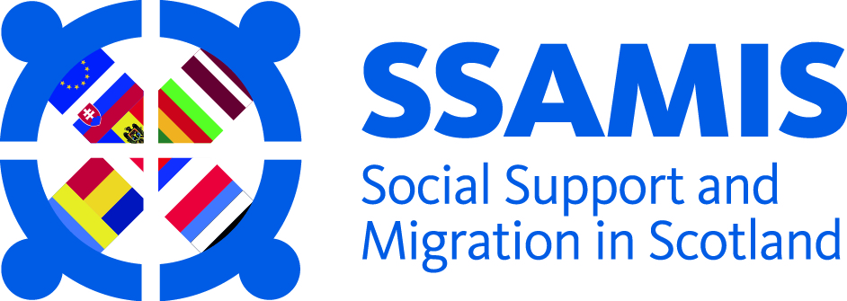

Living and Working Together in Scotland: Lessons for Policy and Practice

9 November 11am – 4pm
Credo Centre, 14-20 John Street, Aberdeen, AB25 1BT
This event is organised in collaboration between SSAMIS, GREC and CPAG in Scotland and will bring together research findings and recommendations from projects undertaken with, by and about migrant communities in Scotland. It will focus on supporting the development of evidence-based practice and offer practical resources and recommendations for those involved in service provision, advocacy and advice agencies, crisis support and policy-making at local, regional and national levels.
Themes relating to employment, poverty, family issues and the importance of community development responses will be highlighted through the day. Practical initiatives that have developed as a result of several of the projects involving local communities and partners will be showcased, and participants will be invited to showcase examples of good practice from their own work.
There will be opportunities for facilitated discussion and a focus on influencing and changing policy and practice at local, regional and national levels.
Please register for the event at: https://www.eventbrite.co.uk/e/migration-to-and-settlement-in-scotland-lessons-for-policy-and-practice-tickets-26749723142
For further information or queries contact: Rebecca.Kay@glasgow.ac.uk; 0141 330 2847

Provisional Programme:
10.45 – 11.00 Registration and Tea/Coffee
11.00 – 11.15 Welcome and introduction to the day
11.15 – 12.30 Presentations:
Employment and Economic Experiences of Migration (GREC)
Migrant Experiences of Childcare, Poverty and Welfare Rights (CPAG in Scotland)
Community Initiatives and Local Inclusion Projects (SSAMIS)
12.30 – 1.15 Lunch break
1.15 – 2.30 Themed discussion groups, focus on development of policy/practice responses
2.30 – 2.45 Coffee break
2.45 – 3.30 Feedback from discussion groups and prioritising of policy/practice responses
3.30 – 4.00 Wrap up and close
