Slave Sources

- Read/look at the following sources to determine the experiences of slaves on the slave ships during the Middle Passage.

- Once all sources have been analysed, try to use the descriptions to answer the 5 questions at the bottom of the worksheet.

- Note these questions will be useful for the following debate with the other group who are analysing the sailors experiences during the Middle Passage

N.B Words in italic are defined in the glossary after source 6

Source 1

The Captain tied a gun tackle around her wrist, fastened it to the mizzen stay, and suspended the naked girl above the deck. Her skin was covered with pustules, the ribs jutted out of her slight torso, and one of her legs was misshapen. The captain held the tackle while one of the cabin boys pulled and jerked her limbs as her body hung in the air. She swung for five minutes before the captain released the tackle and the girl fell to the deck. Then the captain suspended her by the other wrist. He watched the body writhe and then let her drop to the deck…Gravity emptied her upper half of blood. Her appendages turned gray, then blue from the lack of oxygen.

(Hartman, S., ‘The Dead Book,’ in Lose Your Mother: A Journey Along the Atlantic Slave Route p139)

Source 2

The negroes are so wilful and loath to leave their own country, that they have often leap’d out of the canoes, boat and ship, into the sea, and kept under water till they drowned, to avoid being taken up and saved by our boats, which pursued them; they having a more dreadful apprehension of Barbadoes than we can have of hell, tho’ in reality they live much better there than in their own country’

(Thomas Phillipps, A Journal of a Voyage Made in the Hannibal of London, Ann. 1693, 1694, from England, to Cape Monseradoe, in Africa: And Thence along the Coast of Guiney to Whidaw, the island of St. Thomas. And so forward to Barbadoes)

Source 3

'Another purpose for which these temporary houses are erected, is, in order to prevent the purchased negroes from leaping overboard. This, the horrors of their situation frequently impel them to attempt; and they now and then effect it, notwithstanding all the precautions that are taken, by forcing their way through the latticework.'

(Falconbridge, Alexander., An account of the slave trade on the coast of Africa, p8)

Source 4

'Thus they are all placed in different apartments. But at the same time, hey are frequently stowed so close, as to admit of no other posture than lying on their sides. Neither will the height between decks, unless directly under the grating, permit them the indulgence of an erect posture.'

(Falconbridge, Alexander., An account of the slave trade on the coast of Africa, p25)

Source 5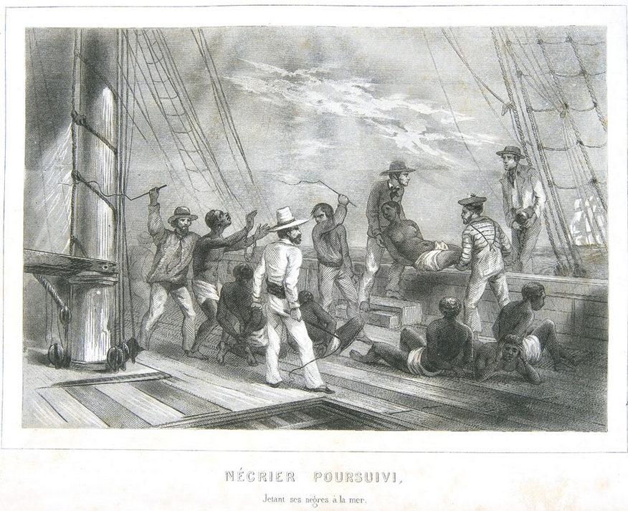

(http://hitchcock.itc.virginia.edu/SlaveTrade/collection/large/mariners30.JPG)
Source 6

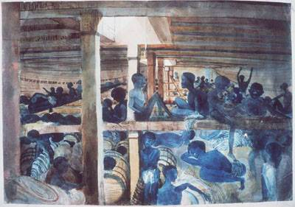

(http://hitchcock.itc.virginia.edu/SlaveTrade/collection/large/E029.JPG)

Glossary

tackle A mechanism consisting of ropes, pulley blocks, hooks, or other things for lifting heavy objects

mizzen A sail on the mizzenmast of a ship, in particular the lowest sail on the mizzenmast of a square-rigged sailing ship

pustules A small blister or pimple on the skin containing pus.

appendages A projecting part of an invertebrate or other living organism, with a distinct appearance or function

latticework - is a framework consisting of a criss-crossed pattern of strips of building material, typically wood or metal.

Questions

- What would you (as a slave/sailor) have feared on the Middle Passage?

- What conditions would you have faced on-board?

- Who would have controlled you?

- How could you have died during the journey?

- How do you think you would have felt?

