Troubleshooting CoreBI and Core BackOffice
Contents
1. Revision History 2
2. Problems common to CoreBI and BackOffice 2
2.1. Incorrect or multiple versions of Java 2
2.2. Java warning message in Firefox 2
3. Problems with CoreBI 3
3.1. The error message “Unable to open a new browser window. Ensure that you do not have popup windows disabled for this site.” is shown 3
4. Further problems 3

Revision History
Author | Date | Revision
Raj Bhaskar | 2013-10-30 | Original version
Raj Bhaskar | 2013-11-14 | Updating to reflect that an exception is automatically added to IE popup blocker and following review by Desktop Solutions team
Milda Butkiene | 2021-07-06 | Updated wording to reflect that users should now contact the HR Helpdesk instead of Supportworks.

Problems common to CoreBI and BackOffice

Incorrect or multiple versions of Java
Core requires a specific version of the Java Runtime Environment (JRE): version 1.6.0 update 45. The architecture of this JRE should match that of the browser. I.e. if you are using a 32-bit browser, you need the 32-bit version of Java, and if you have a 64-bit browser you’ll need the 64-bit version of Java.
Go to the Control Panel and if there are multiple versions of the JRE or any version other than 1.6.0 update 45 then ensure that all JREs are removed, before installing a fresh version of Java 6 Update 45 from our System Resources section. If later prompted to update Java, the user should not do so.

Java warning message in Firefox
Mozilla have decided that the version of Java required for Core applications is insecure and now, by default, show large, scary-looking warning messages before allowing Java applications to run in later versions of Firefox.
If this screen is encountered, click on the ‘no entry’ sign in the middle of the page. This should display a message asking the user to confirm that they want to run the applet and offering two options (see below). To avoid seeing this message again, they should select the option ‘Allow and Remember’. After that, the message should no longer appear the next time they run BackOffice or CoreBI.
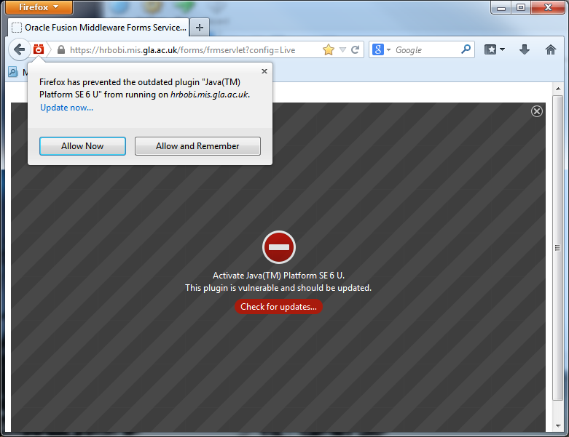

Problems with CoreBI

The error message “Unable to open a new browser window. Ensure that you do not have popup windows disabled for this site.” is shown
CoreBI requires popups to be enabled for that site, and seems to bypass the browser’s notifications that a popup has been blocked.
Internet Explorer (8+): select menu item Tools -> Pop-up Blocker -> Pop-up blocker settings and add the address: hrbobi.mis.gla.ac.uk to the ‘Allowed Sites’ list.
Note: this is now done automatically for SSD workstations.
Firefox: Press the ‘Firefox’ button (top-left of window) and select Options (or use menu Tools -> Options). From the list of tabs at the top of the window, select Content and click the ‘Exceptions…’ button. In here, add hrbobi.mis.gla.ac.uk to the list.
Chrome: Press the ‘Tools’ button at the far end of the location bar and select ‘Settings’. From the bottom of the new page, click the ‘Show advanced settings…” link and in the Privacy section, select ‘Content settings…’. In the new window that opens, scroll down to ‘Pop-ups’ and click the ‘Manage exceptions…’ button. In the ‘Hostname pattern’ box add hrbobi.mis.gla.ac.uk and click ‘Done’.

Further problems
If you have any further problems that aren’t resolved by this guide, please contact the HR Systems Support Helpdesk or raise a ticket on the HR Helpdesk through Ivanti.

