DIRECTIONS
University of Glasgow,
James McCune Smith Learning Hub
University Avenue,
Glasgow, G12 8QW.

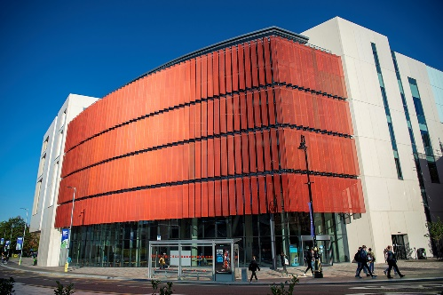
SOLVING THE CRISIS IN
MENTAL HEALTH SERVICES:
GLOBAL SOLUTIONS

Public transport …
https://moovitapp.com/index/en-gb/public_transportation-James_Mccune_Smith_Learning_Hub-Scotland-site_163701197-402

General Map … https://www.google.com/maps/dir//University+Ave,+Glasgow+G12+8QW/@55.8731442,-4.3748766,12z/data=!4m8!4m7!1m0!1m5!1m1!1s0x48884574f0008a73:0x5bfb31eedc4517b5!2m2!1d-4.2924767!2d55.8731717?entry=ttuhhttpom/maps/dir//University+Ave,+Glasgo

General information…
https://frontdoor.spa.gla.ac.uk/map/embedded.html#!/?to=1730438AB31717?entry=ttuttps://www.google.com/maps/dir//University+Ave,+Glasgow+G12+8QW/@55.873144,-4.3748766,12z/data=!4m8!4m7!1m0!1m5!1m1!1s0x48884574f0008a73:0x5bfb31eedc4517b5!2m2!1d-4.2924767!2d55.8731717?entry=ttuByres Road, Glasgow G12 8TV

