Honorary & Affiliate Policy

[v5 20240219]

Overview
Honorary status is awarded in recognition of an individual’s contribution to teaching, research and scholarship in the University. The posts are non-stipendiary/unpaid and provide a mechanism for any such contribution to be recognised. This status may, provide access to the University Library, online resources, @glasgow email address and IT systems as deemed appropriate, based on the level of any such contribution directed towards the interests of the University.

Affiliate Status is granted to individuals who are not directly employed by the University in a formal contractual capacity but may undertake roles of a temporary nature within the University for a period of time, e.g. agency workers, consultants and/or sub-contractors. Such roles usually require IT access to University systems.

Governance

Applications for honorary or affiliate status are co-ordinated and managed locally within each College and University Services. All such applications will be submitted and managed via a central records management system with effect from 30 June 2020. The system will enable administrative access to records for each College/unit via single sign-on.

System administration and governance resides with Information Services, with strategic oversight provided by the Information & Data Governance Group (chaired by Susan Ashworth, Executive Director of Information Services reporting to IPSC).

Benefits and Responsibilities

Honorary and Affiliate Status may confer a number of benefits on the holder and will normally include:

- A GUID and access to University IT systems
- An ID card
- An entry on the A-Z Staff List
- Access to Glasgow University library and online resources
- Access to buildings and facilities as appropriate
- Honorary Clinical Associate Professors and Honorary Associate Professors may use the title in letter headed stationery, e-mail signatures / business cards, etc. but are not permitted to apply the title ‘Professor’ in front of their name.
- Honorary Status holders are duty bound to inform the University of Glasgow of any legal proceedings levelled against them by professional bodies. The University of Glasgow

reserves the right to suspend or remove Honorary status rights without notice based on any information and/or action deemed to be reputationally damaging to the University.
- Honorary status holders are not normally allocated office or lab space, printing facilities, access to budgetary support, etc.

Development

The software system built to support the management of honorary and affiliate staff is maintained by IT Services, based on a re-design and extension of an existing application system developed in 2012 for the College of Medicine, Veterinary and Life Sciences, and will operate on a University wide basis effective from June 2020. Active Honorary and Affiliate data records have been migrated from CoreHR into the new central records management system thereby simplifying and streamlining related administrative processes accordingly whilst improving data quality and service user experience.

Honorary Titles

- Honorary Professor applies to individuals engaged in clinical settings, industry, business and commerce, the arts, public administration, law and accountancy. Those appointed to Honorary Professorships will not normally be career academics, nor will they hold honorary or part- time appointments in higher education.

The title of Honorary Professor may be conferred on individuals who are of sufficiently high academic or professional distinction that, were they University of Glasgow employees, they would be credible candidates for the award of a Personal Chair. There is the expectation that those appointed in this capacity will have several years of experience at the highest level in their field and have achieved considerable distinction in their field - demonstrated for example by holding high office at a national level or Directorship of organisations with which the University has a close working relationship. This will also normally include experience of, and a demonstrated commitment towards, fostering excellence in education and/or research. There is an expectation that those appointed in this capacity will have a significant presence within the University, for example, delivering lectures and/or conducting seminars.

- Visiting Professor applies to those who already hold a Chair (or equivalent) in another Higher Education Institution. There is an expectation that those appointed in this capacity will have a significant presence in the University, delivering lectures/seminars and collaborating in research activities.

- Honorary Fellow is awarded to individuals who have made a special contribution to the strategic aims of a college, usually over a number of years, although does not exclude those who have made a significant contribution over a shorter period of time. The contribution may be in the field of industry, civic engagement, health, education, science or in another relevant field.

- Honorary Senior Research Fellow, whilst not automatic, may be conferred upon senior members of staff (Senior Lecturer, Reader or Professor) on retirement from a salaried post and in circumstances where there continues to be a contribution to research and/or teaching. This may include undergraduate or postgraduate teaching, and/or supervision of research students, and/or contribution to the research activities of a School or College.

- Honorary Clinical Associate Professor may be conferred on those who satisfy the requirements applicable to Honorary Clinical Senior Lecturer subject to a number of additional considerations. Those appointed in this capacity will normally be expected to demonstrate additional evidence of externally recognised national or international standing, enhancing individual and institutional reputation. Individuals will normally be expected to demonstrate successful leadership and management of a clinical group and demonstrate the successful generation of clinical findings into impact outcomes that permits sustainable enhancement of existing or new services, research and/or the student experience.

- Honorary Associate Professor may be conferred on those who satisfy the requirements applicable to Honorary Senior Lecturer subject to a number of additional considerations. Those appointed in this capacity will normally be expected to demonstrate additional evidence of externally recognised national or international standing, enhancing individual and institutional reputation. This will normally include experience of, and a demonstrated commitment towards fostering excellence in undergraduate and postgraduate education and/or research.

- Honorary Clinical Senior Lecturer normally applies to an NHS Consultant, Top Grade Scientist, Staff Grade, Associate Specialist or those who have been on the GP performers list for a minimum of five years. Those appointed in this capacity will normally be expected to demonstrate evidence of involvement in academic activities in addition to the delivery of teaching with eligibility normally given due consideration immediately on appointment.

- Honorary Senior Lecturer normally applies to those who contribute at an appropriately high level to teaching and/or research, and/or otherwise make a special contribution to the academic work of the University. Can be Specialist Registrar or General Practitioner and other grades of staff in medicine and dentistry whose contribution is limited to the delivery of teaching or new appointees whose contribution cannot be readily assessed in advance. Other trainees (e.g. Visiting Registrars), with a National Training Number in a programme leading to CCST, will also be eligible for consideration. Individuals will be eligible for advancement to Honorary Clinical Senior Lecturer if their contribution extends to academic activities beyond the delivery of clinical teaching.

- Honorary Lecturer normally applies to those suitably qualified persons who act in a lecturing capacity including undergraduate or postgraduate teaching and/or supervision of research students.

- Honorary Clinical Lecturer normally applies to those who hold a medical or dental qualification, e.g. specialist trainee or GP with less than five years’ experience. Those appointed in this capacity will normally be expected to contribute to teaching or research at an appropriate level, or otherwise make a special contribution to the academic work of the University.

- Honorary Clinical Fellow normally applies to an Academic Foundation Trainee for the purpose of permitting access to University facilities during the standard two-year academic rotation.

- Honorary Research Fellow normally applies to those in a post-doctoral appointment capacity at another institution in recognition of a significant contribution to the research of the University. A PhD followed by five years research experience provides a reasonable indication in terms of the requisite skills and experience base in considering nominations for Honorary Research Fellow status

- Honorary Research Assistant normally applies to graduates without doctoral status in recognition of a contribution to the research of the University in association with a senior supervisor.

.

Approval

The requisite approval process in conferring honorary titles is determined by title and by the relevant College or University Services to which the application is submitted.

- Colleges of Arts, Science & Engineering, Social Sciences and University Services – Applications are submitted via the system and subsequently considered and approved by the relevant College Management Group and exceptionally, by the Principal/Thematic Vice Principals in the case of University Services.

College of MVLS –
  - Applications up to and including Honorary Clinical Senior Lecturer are submitted to via system and subject to the approval of the Head of School/Director of Institute.
  - Applications for Honorary Clinical Associate Professor and Honorary Associate Professor are submitted online for the consideration of the MVLS Honorary Status Committee which meets three times per year.
  - Applications for Honorary Professor, Visiting Professor or Honorary Fellow are submitted to the system and subsequently considered and approved by the College Management Group.

Records Duration

- Colleges of Arts, MVLS, Science and Engineering, Social Sciences, and University Services – Honorary Status is normally awarded for a maximum of 5 years.
- Individuals holding Honorary Status are automatically notified at a point when the term of status is due to lapse at which time those in scope may apply for renewal. In the absence of a renewal request or in the event the request is not approved, the status and benefits will lapse.
- The record of those holding Affiliate Status will be closed by the relevant administrator on termination of the relationship with the University of Glasgow.

Process Flow

College of Medicine, Veterinary & Life Sciences
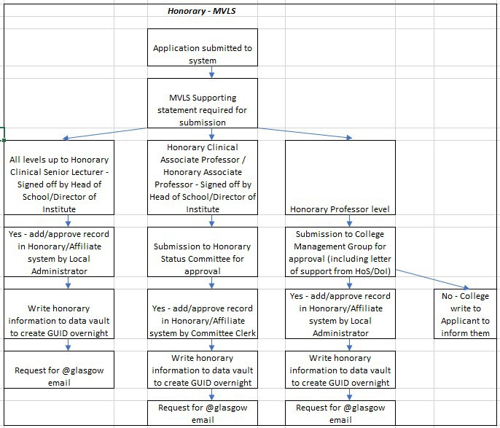

Colleges of Arts, Social Sciences, Science & Engineering, and University Services
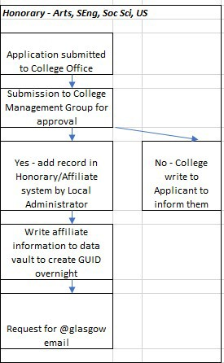

Affiliate Status (all areas)

