**GENERAL PRACTITIONERS AT THE DEEP END**

**INTERNATIONAL BULLETIN NO 10**

**DECEMBER 2023**

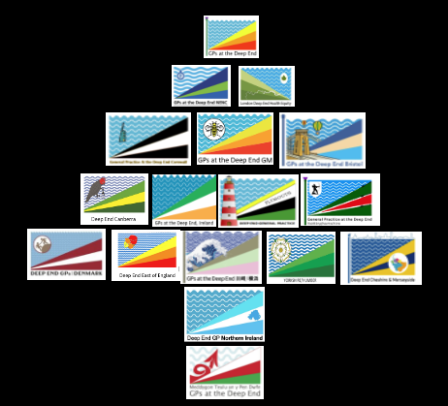

**Season’s Greetings**

and welcome to the 10th Deep End International Bulletin

with reports from 16 Deep End Projects in 7 countries

which is both a milestone and a record.

**INTRODUCTION**

The Deep End Movement, for that is what it has become, never fails to impress with the volume and range of activity across 17 separate projects, 16 of which have sent in reports for this 10th edition of the Bulletin.

The projects range in size but size is not an issue. Wherever front line practitioners meet to share experience, views, learning, plans and activity, the same Deep End values are being expressed – making a difference, inclusiveness, partnership and solidarity. Roo Shah from Deep End London captures all of this in her article on “Generalism in the Deep End” (Page 20).

There are great reports from Japan, Australia and Denmark and special congratulations are due to Deep End Canberra for their AMA President’s Award.

Deep End Projects start by engaging front line general practitioners, whose participation is crucial. Some form of central coordination is needed. Activities are needed to maintain momentum. Communication is necessary to keep everyone informed and on board. The 16 reports show all of this.

The Inverse Care Law remains an obstacle and much more difficult to change than many of us imagined. Initiatives are easier outside the mainstream where established distributions of power and resource are not being challenged – and so, both established distributions and the Inverse Care Law persist.

Julian Tudor Hart, who first described the Inverse Care Law, was clear about what needed to be done, “*Everything depends on leaders at practice level, demanding media attention, gaining public support and insisting on material resourcing from governments, in return for which they can guarantee immensely greater efficiency of care generated by people who know each other.”*

Carey Lunan’s account of the successful campaign to reverse funding cuts in the Scottish Community Link Worker Programme (Page 17) is a worked example of such advocacy. Colleagues in Greater Manchester are also leading the way (Page 28). Advocacy isn’t only what you say; it is also what you do. Worked examples transform rhetoric into reality. Persistence is key, outlasting doubters and not taking No for an answer.

Capacity building is probably the Deep End Movement’s main achievement : building relationships with patients and communities, building stronger local teams with embedded co-workers, building networks of like-minded practices, building the next generation of front line practitioners. Whatever the future holds, we are better prepared for it.

We are looking forward to the Deep End International Conference in Glasgow on 12/13 April 2024. Check out the important announcement on Page 19 to make sure your Deep End Project is represented.

**Graham Watt**

[**graham.watt@glasgow.ac.uk**](mailto:graham.watt@glasgow.ac.uk)

**CONTENTS PAGE**

**Introduction 2**

**Contents 3**

**International Deep End Reports**

Kawasaki/Yokohama – Makoto Kaneko 4

Canberra – Joo-Inn Chew 7

Denmark – Nynne Bech Utoft 10

Ireland – Susan Smith and Patrick O’Donnell 14

Northern Ireland – Daniel Butler and Nigel Hart 15

Scotland – Carey Lunan 17

**Generalism in the Deep End –** Rupal Shah20

**Deep End Reports from England**

Bristol – Beth Winn 23

Cheshire and Merseyside – Greg Irving 25

Cornwall – Judit Konya 26

East of England – Emily Clark 27

Greater Manchester – Anna Pratt 28

London – Lili Risi and Chad Hockey; Hina Shahid and Camille Gajria 31

North East and North Cumbria – Jon Quine 36

Nottinghamshire – Jukia White 38

Plymouth – Richard Ayres 39

Yorkshire and Humber – Dom Patterson 41

A wise man learns from experience

but a wiser man learns from the experience of others.

**Socrates**

**DEEP END KAWASAKI/YOKOHAMA 2023**



We launched the new program for collaboration between Kotobuki Clinic of Deep End Kawasaki/Yokohama and Yokohama City University in April 2023. The program enables general practitioners (GPs) to contribute to practice, education, and research at Deep End. GPs in the surgery can become collaborative researchers at the university. In addition, the surgery provides research funds to the university to establish the educational environment and conduct research. The faculty of the university can see patients in the clinic as a role in the university. Under the scheme, six GPs now work at the surgery and one GP will join the scheme. We published short papers about the program and Deep End Kawasaki/Yokohama with city government officials in a Japanese journal for GPs called “Sogoshinryo” which means general practice in Japanese. 1,2 Figure 1 shows a part of the manuscript.

Figure 1. The paper about the Deep End project and Deep End Kawasaki/Yokohama in Japanese

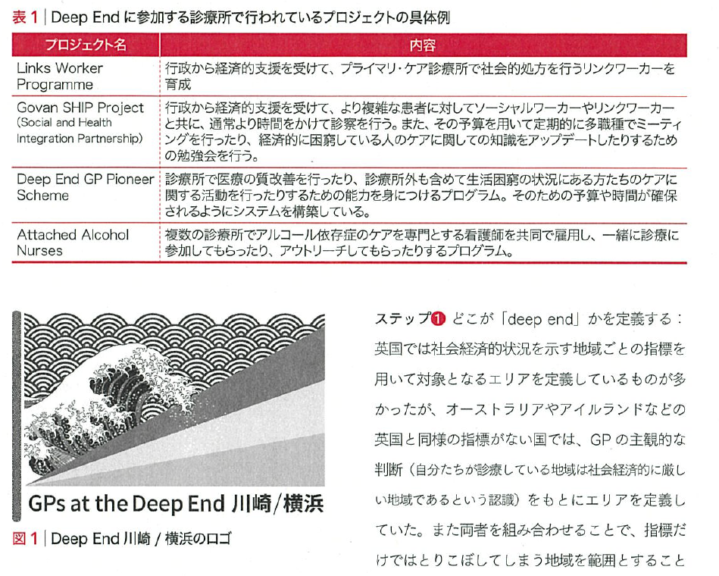

(Coordination in urban primary care -GPs at the Deep End Kawasaki/Yokohama. Sogoshinryo.2023: 22(8)952-954)

The surgery is located in the Kotobuki district in the city of Yokohama near Tokyo. The Kotobuki district includes around 5,000 people in an area of 0.06 km2. The population ageing rate is approximately 55.3% and 94% of the residents receive Public Assistance from the local government due to social deprivation for various reasons.3 Public Assistance in Japan covers livelihood, housing and healthcare services. People in the district tend to have multiple chronic diseases, mental health problems or substance abuse.3 The surgery provides comprehensive care for the marginalized population with multidisciplinary teams and private and public sectors in the district.3

As a next step, we have offered clerkships for medical students and doctors. Since August of this year, six medical students, one graduate student and five GPs have visited the surgery. They participated not only in patient care in the surgery but also in a lot of activities in this community such as health checks by public health nurses, housing for homeless people, soup runs, self-help groups to stop drinking and daycare for people with mental health problems. The educational program aims to provide the experience of “putting yourself into someone else’s shoes”. The experience of communicating with people from diverse backgrounds in the district allows learners to gain new perspectives. The multidisciplinary collaboration also helps them to reflect on the meaning of providing patient care in the district. On November 29th, two medical students and one GP revisited our surgery and gave a presentation about their reflections on their clerkships. The staff of the surgery and the collaborators attended the meeting. The students reflected on their experiences and described what they learned in the Kotobuki district. Figure 2 demonstrates the meeting.

スーツを着た男性グループの写真

Figure 2. Medical students, staff and collaborators

For future steps, we cooperate with companies or organizations outside the district. In order to publicize our activities and to recruit and retain medical students and GPs, Mediva4 and Community & Community Hospital Association5, which are companies promoting general practice in Japan, created a brochure about our surgery. (See Figure 3).

Figure 3. Illustration of clerkship in a day in our surgery

To gain the attitude, knowledge and skills for community outreach, Community Doctor Fellowship6, an organization for fostering GPs who can co-create well-being with people outside a surgery/hospital, helps the GPs in our surgery to learn how to collaborate with the “community”. With our staff and many collaborators, we will develop a sustainable environment to provide better care for the people in the district.

**Makoto Kaneko**

**References**

1. Makoto Kaneko. Research of urban primary care. Sogoshinryo.2023: 22(8)921-923 (in Japanese)

2. Makoto Kaneko. Coordination in urban primary care -GPs at the Deep End Kawasaki/Yokohama. Sogoshinryo.2023: 22(8)952-954 (in Japanese)

3. Keiko Kudo, Taigo Shinbori. The government's vision for primary care in urban areas. Sogoshinryo.2023: 22(8)955-957 (in Japanese)

4. Mediva. <https://mediva.co.jp/> (in Japanese)

5. Community & Community Hospital Association. <https://cch-a.jp/> (in Japanese)

6. Community Doctor Fellowship. <https://www.commudoc.com/> (in Japanese)

**DEEP END CANBERRA 2023**



Our small, passionate Deep End group continues to meet six-weekly to connect, share knowledge, and advocate for more just and equitable health care.

**Mental health system reform:**

Deep End members Peter Tait, Tanya Robertson, Bree Wyeth and Joo-Inn Chew combined with our local branch of the Australian Medical Association to hold a series of creative collaborative workshops with mental health providers, organisations, consumers and health bureaucrats. Workshops followed a survey of primary care practitioners highlighting gaps in mental health care particularly for those from DE populations. The aim was to take the first steps towards a co-created, patient-centred, co-ordinated primary and secondary care, respectful public mental health service in Canberra. From these workshops a seed document of recommendations was drawn up and taken to meetings with political and health leaders to bring a DE and grassroots informed perspective to mental health policy and planning. To be continued…

**AMA Award:**

In May this year we were thrilled to receive the ACT branch of Australian Medical Association’s President’s Award for ‘services… to people experiencing deep urban poverty.’ Thank you to Tanya Robertson, Deep End Co-Convenor, for advocating on the AMA board for Deep End concerns.

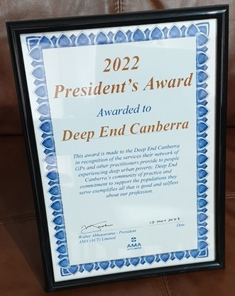

**Publications:**

Peter Tait was interviewed by Canberra Doctor (AMA ACT) about our work and recent activities.

<https://issuu.com/ama-act/docs/candoc_issue_1-feb_2023/s/19914427>

Peter also spoke with Australian Doctor, a national GP publication, about barriers Deep End populations face in accessing mental health care.

<https://www.ausdoc.com.au/news/gps-seething-with-discontent-as-their-patients-miss-out-on-mental-health-care/>

Joo-Inn Chew wrote in The Canberra Times about the closure of a longstanding Canberra clinic, Hobart Place General Practice, known for its high quality non-judgemental health care for disadvantaged communities. This is against a backdrop of increasing financial strain on general practice, making it harder to provide affordable care to the community:

<https://www.canberratimes.com.au/story/8134862/hobart-place-made-me-a-better-doctor-and-a-better-person/>

**Abortion Matters:**

Mel Dorrington followed up her 2022 work with a submission on behalf of Deep End to the Federal Senate Inquiry into Universal Access to Reproductive Healthcare, highlighting gaps in access to terminations and contraception particularly for disadvantaged populations. Many of these barriers continue despite recent funding from local government aimed at providing free abortion care. Jess Tideman, Mel Dorrington, Danica Vress and Kirsty Douglas advocated for increased medical undergraduate teaching on abortion (including moving it out of Ethics and into Reproductive Health Care!).

**General advocacy:**

Tanya Robertson and others contributed to a Deep End submission to the ACT Inquiry into Cost of Living Pressures, and also to the associated public hearing.

**Students:**

Medical student April Thompson attended DE meetings and organised a successful Deep End-Student Mixer night at The Junction Youth Health Service in July. Medical students were able to meet a range of DE doctors and hear how we found our way into the work we do, as well as join us for our regular meeting. It was wonderfully warming to connect and share ideas, enthusiasm, and pizza on a chilly Canberra evening with the next generation.

**Joo-Inn Chew**



**DEEP END DENMARK 2023**

As a relatively new Deep End project, it has been an exciting and busy year, and many decisions had to be made along the way. We greatly appreciate being able to draw on the experience from other Deep End groups, and we hope that, in time, we can be of help and inspiration to you as well.

The highlight of this year must be the first-ever meeting of the Danish Deep End group, which we held on November 3-4. Thirty-two enthusiastic and committed Deep End GPs attended the event. However, before we could hold the meeting, we had to figure out whom to invite.

**Identifying and inviting Deep End practices**

After extensive research, we chose to identify Deep End practices using the Danish Deprivation Index, which comprises five variables with documented social inequality in health: employment, education, economy, ethnicity, and cohabitation. By using register data, we linked patients with general practices and calculated a deprivation score for each. Subsequently, invitations were sent to the 200 practices with the highest deprivation scores (practices left of the red line). At present, 45 practices, with a total of 55 GPs, participate in the Deep End group, marking a positive start. Recruitment takes time, and we will continue to recruit more participants to the project.

Deprivation score

Ranking (in groups of 5 practices)

The map below illustrates deprivation scores in Danish municipalities, with the darkest color indicating the most deprived areas. The small red houses shows that at least one Deep End GP participates from that municipality. The 55 participating GPs comes from various practices across the country, encompassing both urban and rural areas. Despite this, some highly deprived areas remain under-represented in the project. We believe that factors such as busyness, stress, and burnout may be hindering their ability to participate. The participating GPs are likely the least burned-out in the most deprived areas and as one of the participants said: “I was probably the only burned-out doctor attending. The good thing is that something can possibly be done despite the ongoing breakdown in the healthcare system.”

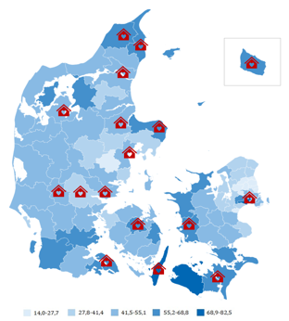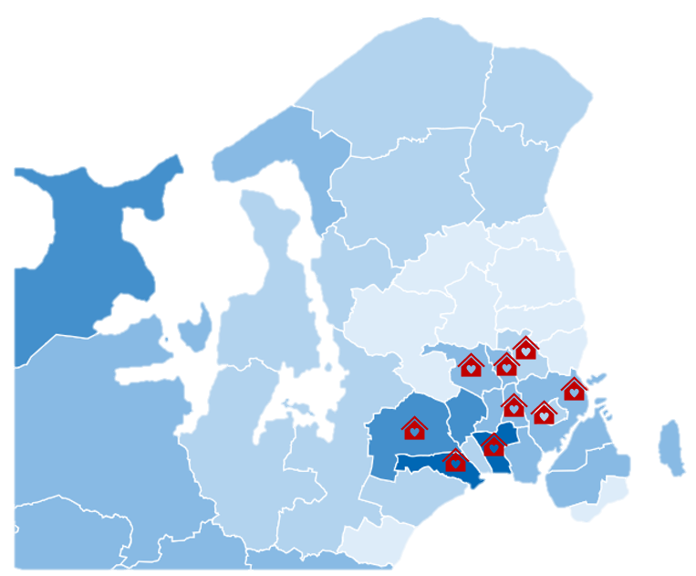

Copenhagen and surrounding municipalities

**Planning and facilitating the first Deep End meeting**

The first Deep End meeting took place over two days in beautiful surroundings, with trees still adorned in vibrant yellow and red colours. Thirty-two enthusiastic Deep End GPs participated in the meeting, discussing challenges in Deep End practices, the future organization of the healthcare system, and key topics for upcoming meetings. Graham Watt from Glasgow and Susan Smith from Dublin kindly contributed with video postcards which gave the meeting an international touch. We maintain a close collaboration with The Danish Organization of General Practitioners, which not only funds network meetings but also plays a pivotal role in planning and facilitating them.

**Some of the challenges the Deep End GPs discussed:**

* How can I stick to the ideal of more time for the vulnerable while securing my finances so I can afford staff?
* How can I create a good working life with time for patients and time to take care of myself?
* More time for the complex patients.
* How do I make the patient understand the seriousness of their illness? – better compliance/insight.
* Coordination of complex patients? 31-year-old man, in substance abuse treatment, criminal, just had a baby, doesn't have a job, and has previously had psychiatric treatment.

At the meeting, Chairman Jesper Fisker and Commission Member Mogens Vestergaard from the Health Structure Commission participated. Established by the government, the commission is tasked with preparing new models for the future organization of the healthcare system. Seated in a large circle alongside Deep End GPs, they actively listened to the challenges GPs face working in the Deep End, what they do to solve the challenges and what they could do if they had more time and resources.

**Some of the key points for a future healthcare system:**

* Cross-sectorial collaboration must be improved and be the logical and natural thing to do.
* The income of doctors working in the Deep End is lower compared to doctors working in the shallow end, because outpatients need longer consultations, which is a barrier to recruitment.
* Pay attention to the narrative. By using words such as difficult, complex, and burdensome patients you may scare off young doctors. Better to emphasize that working in the Deep End is exciting and meaningful.
* Employment of a social worker in general practice.
* We must differentiate health resources and give more to those who need it the most.
* Less control and more freedom to organize and plan health care.
* Hospitals are cutting bed-days and shifting responsibilities, burdening general practice, particularly in resource-scarce deprived areas. To maintain public healthcare quality and reduce inequality, slow down the shift of tasks from the public to private healthcare.
* Prioritize resources to areas where they have the greatest impact.

We strongly believe that this first meeting marks the beginning of something promising, as we collaboratively strive for a better future for general practice in the Deep End. The next meeting is scheduled for the end of May 2024. In the meantime, the GPs will meet in smaller local groups to discuss topics of their own choosing.



*“It was a great pleasure to be with colleagues who face challenges similar to my own. I have a feeling that there is great potential in this collaboration” Deep End GP.*

*“There is a glimmer of hope to be able to influence the politicians to stop hindering our work. Maybe we can find a way to stand together on the matter” Deep End GP.*

**Research**

2023 was primarily dedicated to establishing the Deep End project and conducting the first meeting. In 2024, our focus is to intensify research efforts. Mogens has recently assumed the role of Professor of General Medicine at Aarhus University, with a specific focus on health inequality and the Deep End project. Nynne is currently preparing a PhD protocol within the same field, with Mogens as the main supervisor. We have many exciting projects in the pipeline and look forward to telling you more about it.

**Nynne Bech Utoft and Mogens Vestergaard**

**On behalf of Deep End Denmark**

**DEEP END IRELAND 2023**



**A review of where we are now**

In 2018 we wrote a chapter for Professor Watt’s book *The Exceptional Potential of General Practice* describing the context and challenges Irish Deep End GPs were facing. We continue to have a mixed public and private funding model for general practice, and as a result close to half of the population are entitled to free GP care and medicines. This is called the General Medical Services (GMS) scheme or the ‘medical card’ scheme. GPs receive an annual capitation payment based on the age of each of these medical card patients, and there is still no weighting for deprivation. Patients who do not have a medical card must pay a consultation fee at the point of care of approximately €60 per visit. Just under half of the population have private health insurance as this ensures timely access to specialist review and procedures in the private health system, compared to the public system which can have long waiting times. As a result of this mixed public and private model, the Inverse Care Law affects the most disadvantaged groups. Even though we do have free GP care with the medical card system, patients can face long waiting times for allied healthcare and secondary care appointments.

We described Irish general practice as being at a crisis point at the time, and that was felt by practices across the board, not just in deprived areas. We developed some recommendations that we felt were important to highlight and address to begin to balance the inverse care law in the Irish context. These included the development of fully functioning multidisciplinary primary care teams in disadvantaged areas. This has happened in some places, but not in a uniform way and there is still no recognition that patients in deprived areas are particularly reliant on these public health services as they are unlikely to be able to pay out-of-pocket for them when they are needed.

We also suggested that the public primary care infrastructure in areas of deprivation could be developed to act as community hubs to facilitate links with community services and forums. Again, this has happened in some areas with the development of new primary care centres. Some of these buildings host initiatives and meetings of services such as smoking cessation and integrated alcohol clinics.

We then recommended that GPs be offered more support to allow them to engage with their patients from deprived areas in a meaningful way to address complex health needs. We felt that this could have been facilitated by introducing deprivation weighted capitation payments or the employment of salaried GPs or additional practice nurses or administrative staff in areas of deprivation. This has not happened. Lastly, we wrote that giving GPs improved access to diagnostics would be beneficial. Thankfully, this has happened and a very successful programme was introduced allowing for GPs to refer patients to the private hospitals for radiological tests paid for by the public system. This allows GPs to investigate and appropriately triage and refer to secondary care where necessary.

There has also been a swathe of new payments to GPs for improved chronic disease management programmes and initiatives around preventive care. While these are not weighted for deprivation, they are only available to public patients for now. We also saw the introduction of a grant for self-identified practices serving patents from deprived areas, and this small amount of funding allowed practices to be innovative in enhancing the care they can offer patients. This grant now needs to be reviewed as a more targeted delivery of increased amounts of funding to the practices servicing the areas of highest need would be more appropriate.

**Patrick O’Donnell and Susan Smith**

**Deep End Ireland (**[**www.deepend.ie**](http://www.deepend.ie)**)**

**DEEP END NORTHERN IRELAND 2023**

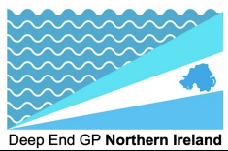

As we look back over 2023 there has been slow but steady progress here in Northern Ireland. Collaboration with the Royal College of General Practitioners has helped progress plans and work, and we hope, and expect , that 2024 will be a pivotal year in gaining greater momentum.

In July colleague and academic GP trainee, Dr Lisa Collins, represented the NI voice at the RCGP Health Inequalities summit, talking amongst other topics, about her experience of growing up in the context of ‘The Troubles’ and how the unique recent history of Northern Ireland means it can be seen as the ‘Deep End of the Deep End’ in many ways.

Prof Nigel Hart has led work, alongside Dr Caren Walsh and colleagues at Grosvenor Road Surgery, Belfast, to take on an extended service providing GP cover for the well-established Belfast Inclusion Health Service. This service for the homeless has been tirelessly led by Susan Semple and 2023 marks the start of much awaited medical/GP cover within the already successful and highly regarded homeless health hub.

Dr Daniel Butler, an academic GP trainee, has published work on GP training opportunities at the Deep End in Northern Ireland. The work demonstrated that although half of the NI’s Deep End practices were postgraduate training practices, there was still an underrepresentation of practices serving populations with higher socioeconomic deprivation while the current postgraduate GP training practices have more affluent populations. Given the increasing efforts to bolster GP training numbers, ensuring training opportunities are representative of the workforce needs is essential if we want to close the gap of health inequalities, particularly around workforce. <https://bjgpopen.org/content/7/3/BJGPO.2022.0178>

Finally, colleague Dr Alex Huey has been leading work, alongside colleagues at The Centre for Homelessness Impact, developing a primary care tool to identify those at risk of homelessness. This was presented at the RCGP annual conference and is hoped to be of benefit to colleagues across primary care as we look to identity and protect those at highest risk of severe and multiple disadvantage.

We hope and expect 2024 will be a year of continued growth and progression, both in terms of academic awareness and advocacy as well as initiatives to improve frontline service. We are thankful for the support of colleagues across the Deep End network and their inspiring progress as we work together to improve healthcare delivery for those who need it most.

**Daniel Butler and Nigel Hart**

**RESEARCH NEWS**

**Question :** Is Scotland's new GP contract addressing the inverse care law?

**Answer:** No

**See:** <https://www.rcpjournals.org/content/futurehosp/10/3/287>

**Authors** Stewart W Mercer, Carey Lunan, David Henderson and David N Blane

**THE SCOTTISH DEEP END PROJECT 2023**

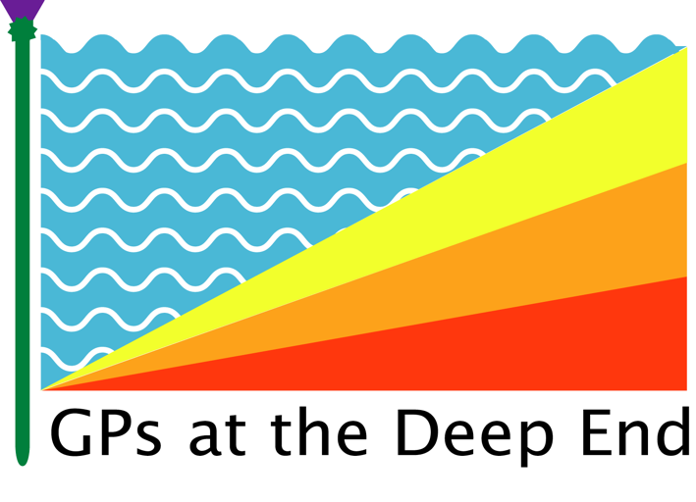

The last six months for us have been largely taken up with engagement and lobbying activities. Earlier this year, an announcement was made that the Community Link Worker (CLW) workforce in Glasgow was to be cut by one third, with effect from April 2024. Glasgow is home to roughly 80% of Scotland’s Deep End practices, and with the key role that CLWs play in supporting people with social isolation, housing, benefits, food insecurity, fuel poverty, physical inactivity, loneliness, and so much more, this was devastating news for many of our most vulnerable patients and the teams caring for them, who have very much come to rely on the vital social support and connection that they offer.

The CLW programme started as a Deep End pilot in and has gradually been rolled out more widely across Scotland, with more than 300 CLWs, based mostly in Scotland’s most economically disadvantaged communities. The funding model has always been fragile and uncertain, having to compete with other services negotiated through the 2018 GP contract. We have long argued that their funding needs to be core, sustainable, and ring-fenced in order to protect this essential workforce in deprived-area general practice from future cuts, in favour of other services.

Upon the announcement, we coordinated a significant lobbying campaign, writing to all local MSPs and Councilors in Glasgow. We wrote to the Cabinet Secretary for Health (Michael Matheson), the CMO in Scotland and the Minister for Social Care, Mental Wellbeing and Sport (Maree Todd). We undertook targeted media work to raise awareness, on social media, in print media, and on radio and TV. We met with several MSPs and with the Cabinet Secretary to raise our concerns directly. Finally, we submitted a petition to the Scottish Parliament to have the decision overturned and the funding model reconsidered, which currently has more than 2500 signatures. Throughout all of this, we worked closely with our CLW colleagues, patients, and third sector groups. In November 2024, an announcement was made by the Cabinet Secretary that funding has been found to protect the workforce for the next three years, bringing huge relief to all concerned. We have learned a lot throughout this process; the power and support of a collective voice, the strength of working alongside the patients that we care for, the importance of not getting drawn into taking sides “we are doctors, not politicians”, and the importance of collaboration – where collaboration is possible. It has helped provide us with a template for future lobbying activity.

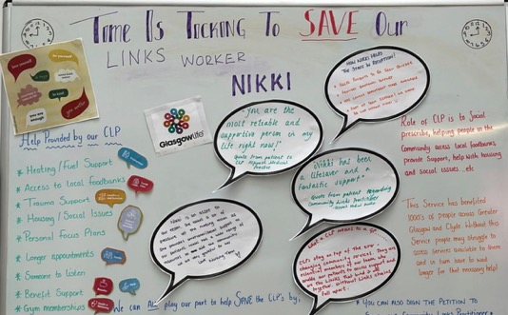

Photo courtesy of Keppoch Medical Practice, Possilpark, Glasgow.

We have been involved in roundtable discussions on the future of Minimum Unit Pricing (hosted by the Minister for Drugs and Alcohol) and Drug Related Harms (hosted by the RCGP in Scotland). We have also contributed to the development of a policy/position paper for the RCGP in Scotland on adopting a harm reduction approach to drug misuse issues which was taken to their UK Council earlier this month. We also met with the Minster for Drugs and Alcohol to discuss the role of general practice in supporting and managing people with harmful alcohol use, in light of the rising number of alcohol related deaths in Scotland.

We took the opportunity to share the [evaluation](https://www.gla.ac.uk/media/Media_874443_smxx.pdf) of one of our Deep End projects in Glasgow, the PCANOS (primary care alcohol nurse outreach service) model, which evaluated successfully, and which we support being rolled out more widely, in recognition of the fact that many of our patients struggle to get linked in with specialist services and remain missing in the system, at risk of early death. PCANOS is another example of the importance of ‘sticky systems’ where the model of engagement is proactive, reaching out and embedded within a team (general practice) that is known and trusted, reducing the stigma around accessing help.

Since our last update for the Bulletin, Scotland has had a new Cabinet Secretary for Health, Michael Matheson, with whom we have had an introductory meeting. With a generalist health background as an occupational therapist and having grown up in one of Glasgow’s Deep End areas, we have found him to be supportive and enthusiastic about our work. We discussed a wide range of topics including many of the Deep End projects, the reasons underpinning the persistence of the inverse care law, the vulnerability of CLW funding, the importance of community-based generalism in addressing health inequalities and the concerning rise in two-tier systems of care.

There have been two other areas of work that have been exciting to be involved in recently; improving the quality, exposure and consistency of Inclusion Health training for GP trainees – both as part of core training schemes, but also as part of a plan to pilot a Health Equity Focused Training (HEFT) scheme in Scotland from August 2025. We are also co-designing a Women’s Health project in Edinburgh’s Deep End practices, with outreach specialists embedded in general practice, with the aim of improving access to underserved women. More on that next time!

Last but not least, we are well underway with planning for our next Deep End International conference, to be hosted in Glasgow, 12-13 April 2024. Building on the success and momentum of the Dublin conference earlier this year, the themes will again be hope, joy, kindness, advocacy and inclusivity. There has been a lot of interest so far, and the venue size limits numbers to 150, so we will let you know as soon as tickets are available! The Ceilidh on the Friday night is not to be missed…

**Dr Carey Lunan**

**Chair of the Scottish Deep End Project**

**DEEP END CONFERENCE**

**IMPORTANT ANNOUNCEMENT**

With only 150 places at the forthcoming Deep End Conference in Glasgow on 12/13 April 2024, competition for places will be strong. To guarantee the presence of colleagues from every Deep End Project (n=17, see logos on page 1), 2 places may be reserved for each project by notifying Elspeth Rae ([elspeth.rae@glasgow.ac.uk](mailto:elspeth.rae@glasgow.ac.uk)) with two names by 31st January. Registration after that will be on a first come first served basis once details are available.

**GENERALISM IN THE DEEP END**

**Rupal Shah**

**GP trainer in London and Associate Dean NHSE-WTE**

As anyone working in a Deep End practice in the UK knows, the NHS is facing difficult times. Beyond funding issues, there are other contributory factors: protocolised pathways leading to disjointed care and inefficiency; over-medicalisation; widening health inequalities; and a breakdown of relationships, leading to low morale, with inexorable attrition of healthcare staff. Many of us working in areas of deprivation face injustice on a daily basis and may find ourselves practising medicine in a way that we know doesn’t address the root causes of the problems our patients face. Working within a system in which the most vulnerable clearly have worse outcomes than those who can advocate for themselves has effects on us as practitioners, potentially leading to moral injury and burnout.

It is becoming increasingly apparent that we need culture change, which allows a more sustainable, person-centred approach to healthcare - the kind, careful care that Victor Montori1 and others describe. Since the publication of the *Future Doctor* Report*2* in 2020, there has been a national move in England towards generalism as a potential solution to some of the problems we are currently facing in healthcare.

**What is generalism and why might it be part of the solution?**

‘Medical generalism is, at root, a way of thinking and acting as a health professional and, more than that, a way of looking at the world. It is possible to be a generalist in any speciality or profession and, equally, it is possible to work as a GP without being a true generalist. The essential quality is that the generalist sees health and ill-health in the context of people’s wider lives, recognising and accepting wide variation in the way those lives are lived, and in the context of the whole person”3

The *Future Doctor* report advocated that generalist training should be rolled out to all doctors. It proposed that this training should be about equipping doctors to manage complex care and co-morbidities; providing a deep connection and understanding of the communities that doctors serve; and moreover that it should instil a strong professionalism from the start of medical education and training. The six curricular domains of the *Enhancing Generalist Skills* (Enhance) programme4 in England are designed with these aims in mind: social justice, person centred care, complex multimorbidity, systems working, population health and sustainability.

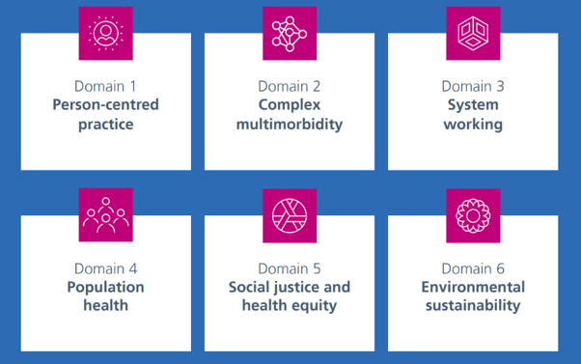

Figure 1 – the six domains of generalism

Defining generalism in this way is significant - the version of generalism being proposed is more about values, connections and relationships than about being a Jack of all Trades. It is important that these domains have now been validated as core components of postgraduate curricula, regardless of specialty.

The *Thinking Together* programme is London’s attempt to introduce generalist skills teaching to postgraduate learners from different healthcare specialties and professional backgrounds in primary and secondary care. It is a four day in-person course that looks at generalism through a systems lens and through an individual one and it is explicitly about ideas. Day 1 focuses on person-centred care, with the contribution of people with lived experience and a theatre company to help trainees imagine the experience of their patients. Day 2 looks at systems issues which propagate inequalities. The theme of day 3 is the role of the human clinician in a landscape where AI will hold increasing prominence. Day 4 is about how we flourish as clinicians, including the use of creative enquiry as a way of processing emotion.

Trainees are supported to undertake a quality improvement (QI) project, in keeping with the Deep End principles of improvement and advocacy. The group is encouraged to stay in touch through a social media platform to build relationships, exchange ideas about their QI projects and to start to form a community of practice. An underlying principle has been to give trainees the belief that they have agency to change things - both the system they are in and their own personal approach to practice.

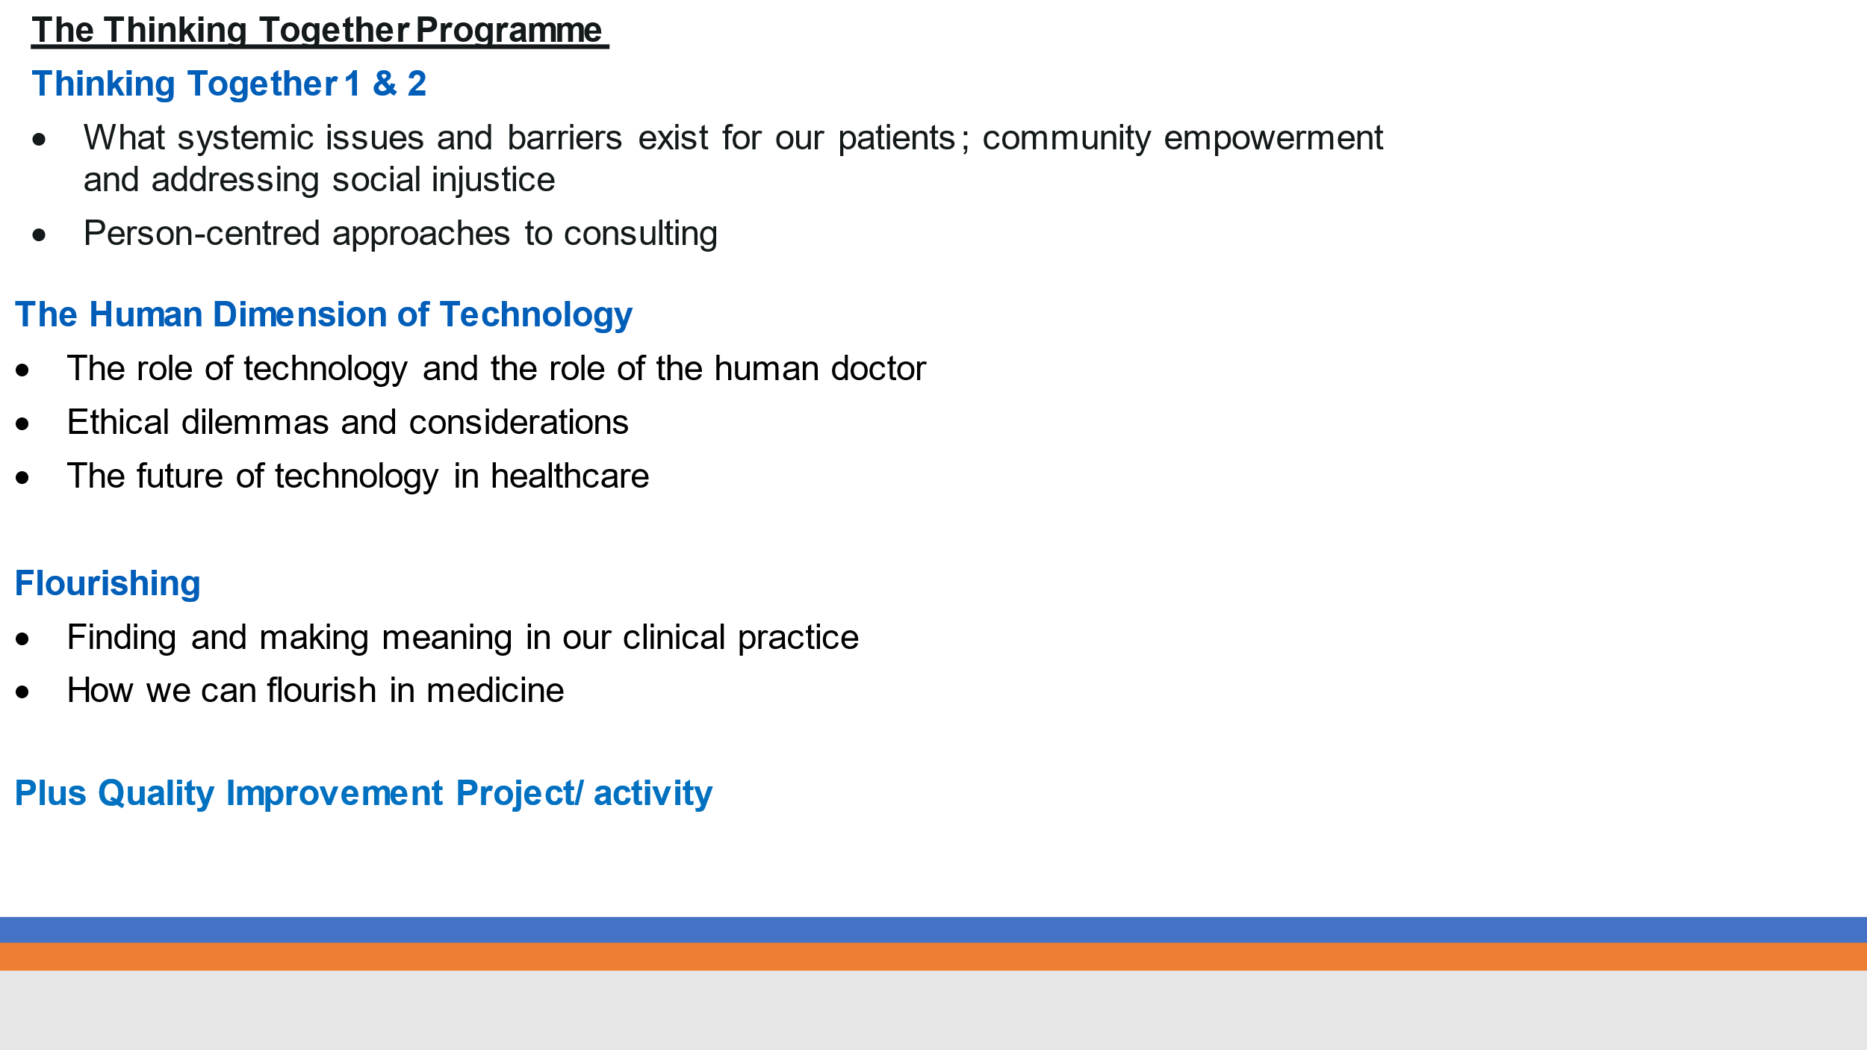

Table 1 - an outline of the Thinking Together programme

It may seem unrealistic to think that every primary care practitioner will be able to engage with all six domains of generalism, but each one is linked to the others. For example, person-centred care is likely to improve care of complex multimorbidity and impact positively on sustainability, by leading to a reduction in unnecessary investigations, referrals and medication (and the need for multiple follow up appointments). There is a need for system-wide changes that enable generalism to be enacted meaningfully – longer GP appointments; wider introduction of link workers and better communication between primary and secondary care are obvious examples. However, perhaps it is a start to acknowledge that each of the six domains is integral to the wellbeing of our patients and of our planet.

Generalism as a philosophy of care is congruent with the Deep End principles of community engagement and of acting to understand and reduce health inequalities. If, as Karl Marx suggests, alienation arises when workers lack agency and when work has no clear purpose, generalist approaches might help clinicians to reimagine the meaning inherent in their work. Working within the domains of social justice, population health, sustainability and person-centred care requires moral engagement. Perhaps there is an opportunity to stem the tide of attrition of clinicians from the NHS by giving people the ability and opportunity to work in a way that is congruent with their values.

Don Berwick describes three eras of medicine.5 The third era is a moral era that rejects both protectionism and reductionism, where values matter and relationships underpin everything we do. Generalist training that is based on relationships and values may be a vehicle that helps bring us closer to era 3.

**References for Generalism in the Deep End**

1. Montori, V.M. (2020) Why we revolt: A patient revolution for careful and kind care. Rochestor, MN: Mayo Clinic Press.
2. Health Education England. The Future Doctor Programme: A Co-Created Vision for the Future Clinical Team. NHS; n.d. Available from: chrome-extension://efaidnbmnnnibpcajpcglclefindmkaj/<https://www.hee.nhs.uk/sites/default/files/documents/Future%20Doctor%20Co-Created%20Vision%20-%20FINAL%20%28typo%20corrected%29.pdf>.
3. Royal College of General Practitioners. Medical Generalism: Impact Report, May 2013. 2013. Available from: <https://www.rcgp.org.uk/policy/rcgp-policy-areas/medical-generalism.aspx>.
4. Health Education England: Enhancing Generalist skills. Available from: https://www.hee.nhs.uk/our-work/enhancing-generalist-skills
5. Donald M. Berwick, “Era 3 for Medicine and Health Care,” JAMA 315, no. 13 (2016): 1329–30.

**DEEP END BRISTOL 2023**



The Deep End network Bristol launched in May 2023, as per our entry in the July International Bulletin.

**Launch event:**

We had our launch event on Friday 14th July, which was attended by 38 GPs, frontline clinicians and practice managers from the most deprived 17 surgeries in Bristol and Weston-super-Mare. We were delighted that all of our Deep End practices were represented, and all of the attendees were engaged and offered valuable contributions, as summarised in the visual minutes.

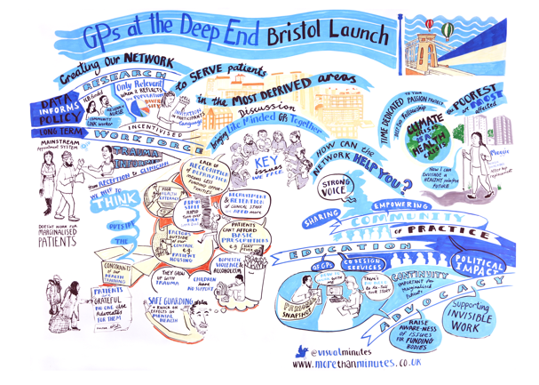

Attendees’ feedback included hosting webinars so that they had opportunities to learn from each other and identify research opportunities. As a result, we hosted online webinars in September and November 2023 respectively.

**Health Inequality fellowships:**

We currently have six fellows who all work in Deep End practices, and have eight hours a week to work on a project that tackles local health inequalities, aimed to improve staff retention and recruitment. The diverse group of GPs are focusing on a variety of areas including: the greener practice movement, deprescribing pregabalin with opiate replacements, tackling childhood obesity through exercise, becoming research active, recruitment challenges and implementing trauma informed care.

**PPI:**

We hope to develop a diverse Patient and Public Involvement (PPI) group who will be involved in shaping this agenda to transform the landscape of this area. We had our first meeting in October 2023 which was attended by community representatives. We wanted to understand what primary care related issues/priorities mattered to them. We also made them aware of the subsequent face-to-face event in January 2024 and invited them to attend it alongside a colleague or a member of their community.

**Moving forward:**

We are currently recruiting for a research nurse who we hope can help us with carrying out engagement work and research, without redirecting precious resources from clinical time. The post is funded to work 50% FTE for 1 year.

We will also be recruiting a community research link worker in the New Year to help facilitate inclusivity in recruitment to research studies and raise awareness regarding research opportunities in the communities.

Our six Health Inequality fellow posts have been renewed for the coming year with recruitment starting in January 2024.

Our new Health equity focused trainees (HEFT), which started in August 2023, will be supported by Deep End Health Inequality fellows as mentors.

On January 19th 2024, we will host a second face-to-face event, expected to be attended by 35-40 people, including clinical Deep End staff and community representatives. We will also have researchers and representatives from local ICB and ICS and CRN in attendance.

**Beth Winn**

**DEEP END CHESHIRE AND MERSEY 2023**



The Deep End Cheshire and Mersey group have been working with GP practices across the region to develop a strategy for taking action on the key health inequality indicators highlighted in Sir Michael Marmot's *'All Together Fairer'* report for the Cheshire and Mersey Region. To this end we are strategically aligned with the Cheshire and Mersey ICB and have presented at the ICB population health board where we were seen as a key mechanism for action on several beacon indicators that apply to primary care.

Other key areas include supporting the 20CorePlus approach to tackle health inequalities in cardiovascular disease, COPD, cancer, and mental health. To achieve this, the group takes a multidisciplinary approach to knowledge exchange, combining research, workforce development, education, advocacy, and research themes to add value to existing programmes of work.

**Addressing research challenges in the Deep End**

It is vital that research is representative and generalisable to the populations in which it is implemented. Through strengthening relationships between organisations like NIHR NWC CRN, NIHR NWC ARC, RCGP, HEIs, Cheshire & Mersey ICB, primary care providers and VCSE partners, the Deep End C&M group are championing inclusion of the populations in primary care in the design and delivery of research projects. This also involves initiatives such as empowering primary care staff to transition into principal or chief investigator roles and offering them the resources and training required for impactful research.

Another key piece of work involves co-designing a Deep End C&M research delivery toolkit, adding value to existing work from NIHR INVOLVE / Be Part of Research to ensure Deep End populations are represented in research. Tools such as FOR EQUITY and HIAT, developed by the NIHR North West Coast Applied Research Collaboration, will provide a lens into the impact the group has on health and socio-economic outcomes. The group links in the regional Deep End CRN sharing meetings to share best practice and resources.

If you would like to know more about the Deep End Cheshire & Mersey Group or would like to get involved please contact [irvingg@edgehill.ac.uk](mailto:irvingg@edgehill.ac.uk)

<https://sites.edgehill.ac.uk/epic/research-projects/deep-end/>

**Greg Irving**

**DEEP END CORNWALL 2023**



Our small Deep End group has been working on developing cardiovascular approaches in the area to reduce Emergency Department attendance.

Advocating for the group is ongoing taking into account newly emerging challenges.

We are planning a stakeholder engagement event in the New Year and an educational event towards the end of the winter in 2024.

We are excited about these opportunities and looking forward to sharing the outcomes and progress in due course!

**Judit Konya**

**on behalf of Deep End Cornwall**

**DEEP END EAST OF ENGLAND 2023**



2023 has seen the Deep End East of England establishing itself as one of the newest networks in the UK with an ever growing community of practice on our active whatsapp groups.

This supports our Deep End workforce and practitioners passionate about Deep End issues to connect, learn, offload and share. We have been advocating for the Doctors of the World Safe surgery campaign with now over 100 surgeries across the 6 Integrated Care Systems in the region. We have been spreading our roots in education by linking with the RCGP over health inequalities in Mid and South Essex (MSE) and a well-attended annual Deep End September Symposium.

We are trying to ensure GPVTS schemes have robust health equity and inclusion health teaching and linked with Health Education England/ NHSE on their new Enhance Foundation Year Programme which aims to give future doctors and dentists enhanced training in issues of social justice, health equity and system working . In research we are thinking partners for large scale NHSE REN (Research Engagement network) bids across 3 ICSs. For example, Norfolk & Waveney are supporting over 30 VCSE organisations to undertake Research Ready Communities training and ICS Community Voices training (a tool used collate qualitative information from our communities to shape practice policy and research in the Core20 areas).

Looking ahead to 2024 we are excited to be strategic and thinking partners for the formation of the Health Equity Evidence Centre, a new online hub with evidence-informed solutions for equitable health and care led by Queen Mary, which will produce living maps of evidence, evidence briefings for ICBs and how to guides (e.g. how to do equity-focussed quality improvement in primary care).

**Emily Clark**

**DEEP END GREATER MANCHESTER 2023**

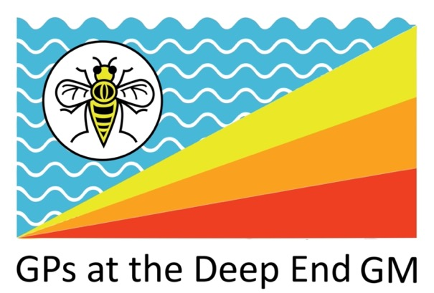

Deep End GM is a collective of GPs and other health professionals who share good practice, try some on the ground initiatives, and shout loud about inequalities! The three companies linked with Deep End GM are Hope Citadel (that runs to 10 GP practices), Shared Health Foundation (who advocate for change and provide resources and training), and Focused Care (who work within primary care for households needing extra support).

**Hope Citadel** is 15 years old next year! We have grown from 4 practices to 10, from 40 staff to over 200. We are looking to bring together the stories, facts and figures that show the change in our communities over the last 15 years, brought by healthcare that cares about the most vulnerable. Watch this space!

**Shared Health Foundation** has been working with Homeless Families for the last few years, both on the ground with our Cribs and in a political advocacy space through the Households in Temporary Accommodation All Party Parliamentary Group. In recent months we have worked with the National Child Mortality Database to include housing data in their analysis of child deaths. In response to this, our Christmas campaign is highlighting the increased risk of Sudden Infant Death Syndrome for children living in Temporary Accommodation. Watch our video [here](https://youtu.be/w65yrQB2s3c?si=ki-r48W4sENHj48Q) or if you’re a Twitter person, then follow along our Advent Calendar during December. Most importantly, sign our petition at <https://householdsintemporaryaccommodation.co.uk/silent-nightmare-petition/>

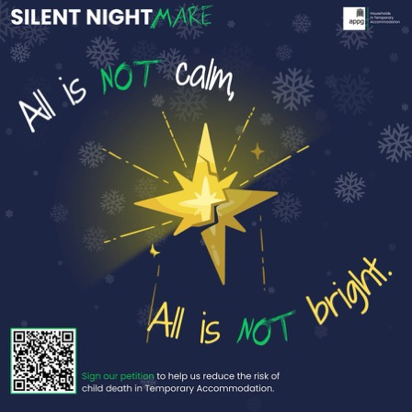

**Focused Care** continues to work within Primary Care, funded partially through the ARRS scheme, currently in 67 practices across Greater Manchester. We have also recently started talking about what Focused Care would look like within secondary care – out of A&E or with non-engaging cancer patients. There are lots of Good News Stories that come through Focused Care all the time – here is an example of a patient’s story.

*When Janet and her family were referred by a concerned nurse, they were struggling to stay afloat after losing a key source of income. Janet had even fainted at an appointment with the nurse from feeling so overwhelmed by their situation. Though in dire straits, they were a private family who didn't want to make a nuisance of themselves or self-refer for assistance.*

*Janet's husband had been a full-time caregiver for his mother and received carer's allowance. But after her passing, their benefits were suddenly cut off in February. For months, Janet and her husband borrowed money from other family members just to survive and care for their two sons. Janet's husband was skipping meals and not eating well due to their finances. One son was having trouble emotionally at school, leading to medical issues. The parents had even resorted to sleeping on their sofa after their bed broke, unable to afford a replacement.*

*The Focused Care Practitioner acted immediately with practical referrals and advocacy. A new bed was secured via a referral to the Local Welfare Provision so the parents could sleep. The Warm Homes program helped the family get caught up on utilities bills. A food bank provided urgent food parcels. The FCP walked the family through applying for Discretionary Housing Payments to assist with rent and advocated for free school uniforms. Crucially, the lost child benefit was restored after the FCP liaised with Housing Benefit, including getting school meal vouchers for the summer holidays for the child who had gone without.*

*The focused, collaborative care quickly eased the family's crisis. With a place to sleep, food on the table, and utilities restored, Janet felt less overwhelmed. The referring nurse later shared her gratitude at the dramatic impact of the FCP’s work. “Can I express to you my heartfelt gratitude. You have evidently worked very hard, and it looks like you are still working very hard for them.” She noted the immense amount accomplished in a short time for a family too private to self-advocate. The nurse could see first-hand how the tailored referrals gave Janet hope and the ability to ask for help in the future. Janet's story shows how FCP’s can rapidly stabilize crises through holistic support and access to resources. By addressing urgent needs like food, housing, and benefits, while also providing emotional support, the care practitioner helped this family get back on their feet.*

**Other news** – we have started a podcast called ‘*Hope In The Deep End’* – available on Spotify. Have a listen as we bring together professionals working in areas of deprivation.

Our Deprivation GP Training Scheme has now had 10 graduates who have all become GPs in areas of deprivation. All of them said they felt more equipped and resilient to work in this field on a long-term basis and feel passionate about improving health inequalities and people’s health outcomes in these areas.

We are hiring a Data Analyst for Focused Care – so if you know of anyone with these skills, please ask them to get in touch on [anna.pratt@nhs.net](mailto:anna.pratt@nhs.net)

**Anna Pratt**

**LONDON DEEP END HEALTH EQUITY**

|  |  |
| --- | --- |
|  |  |

*“The most important question we need to ask*

*is not ‘What do I do?’ but ‘What am I part of?’*

*This is how we move from prerogative to citizenship.*

*We now have to give up professional prerogative when it hurts the whole.”*

([Moral Era for Medicine and Healthcare](https://qi.elft.nhs.uk/resource/era-3-for-medicine-and-healthcare/))

## **Transitioning from social movement to system place**

The London Deep End Health Equity Leadership platform has grown, from six people in September 2020 to 245 people in November 2023. The aims have been to build a new group of leaders focused on delivering health equity through health creation using Deep End principles of support, learning, improvement, and advocacy. It has been inclusive of anyone working in health care in London with values of social justice. Leaders have joined and been followers and followers have led (details can be found in the report). A key focus has been on populations rather than providers. During this period concepts such as the ‘Deep End’ (as a change program for equity), [Covid-19 as a Syndemic](https://www.thelancet.com/journals/lancet/article/PIIS0140-6736(20)32000-6/fulltext) (i.e. an interaction with pre-existing conditions) and ‘allostatic load’ (cumulative stress and burden of living in areas of deprivation) are now more widely understood as multiple NHS system roles emerge around the delivery of health equity. Social accountability is an ongoing theme which shapes how we define and how we gather meaningful data in partnership with patients and communities.

The challenge now is: “HOW we deliver equitable care and our roles and goals in achieving this through health creation”. The [Fuller Stock take](https://www.england.nhs.uk/publication/next-steps-for-integrating-primary-care-fuller-stocktake-report/) has captured emerging evidence of an equitable future already happening in England and work now is on testing further and scaling up change. To do this data becomes crucial and these areas have been identified:

* Measuring all our organisations against the criteria for [healing systems](https://traumatransformed.org/): reflective; make meaning out of the past; growth and prevention orientated; collaborative; equitable and accountable; relational leadership
* What do systems need to be fairer and have healthier populations?
* Where is stakeholder mapping happening?
* Who is getting meaningful data on deprivation at a ward level?
* What data would make a difference in building knowledge for fairer systems and healthier places?
* How do we increase ownership of improvement and the testing of ideas?

Due to Covid-19, the London group was initially established as a resource-sensitive virtual social movement of early adopters with a vision for health equity in London. This has been an umbrella movement capturing work both outside and inside the system to build trust and to maximise collaboration and “[to break the rules for better care](https://qi.elft.nhs.uk/resource/breaking-the-rules-for-better-care/)”. The [London Deep End Health Equity leadership platform](https://www.fairhealth.org.uk/deep-end-london) is now lodged on [Fairhealth](https://www.fairhealth.org.uk/home) where a detailed report and links to join, can be found. A reference group is being established to transition the London Deep End Health Equity social movement into system place locally and nationally. The intention now is to co-ordinate other London initiatives which are aligned such as: Trauma Transformed initiatives, the [London Greener Practice](https://www.greenerpractice.co.uk/join-our-network/local-groups/north-london/), Hospital without Walls ([Thinking Together](https://london.hee.nhs.uk/medical-training/london%E2%80%99s-enhancing-generalist-skills-programme)), [Fairsteps](https://www.qmul.ac.uk/ceg/research/health-inequalities/building-equitable-primary-care/) and [NWL Deep End Workshops and QSIR (Quality Improvement Service Redesign)](https://www.eventbrite.co.uk/e/deep-end-workshops-tickets-678241968987) and work being done in London Medical Schools.

**LONDON STORIES**

## **1.Trauma Transformed Systems in Tower Hamlets**

Tower Hamlets has sought to become more ‘trauma-transformed’ as a whole borough due to the clear impact of prevalent adverse experiences in the borough such as financial insecurity, violence and oppression. Thousands of people working across different sectors have participated in training. In addition, organisations and services have started to work with residents and staff to understand how to apply this learning in the real world – these settings have included education, mental health services, social care, employment, and housing. The local [Community of Practice, co-chaired by Angela Burns (LBTH Public Health) and Patricia Potter (East London NHS Foundation Trust](https://padlet.com/towerhamletstraumainformed/) ), fosters applied learning and reflection across the borough by hosting monthly online events and distributing resource materials.

|  |
| --- |
| **WHAT CHANGE IS OUR WORLD ASKING US TO MAKE?**  [May 2022 London Spring Health Equity Festival: Regenerating ourselves, our systems, our world](https://www.bbbc.org.uk/insights/news-and-resources/health-creation-festival/).    *“It takes a small group of thoughtful committed citizens to change the world. Indeed, it is the only thing that ever has.”* (Margaret Mead Cultural Anthropologist b.1901 d.1978)  (L-R) Angela Burns ([Public Health Programme Manager, Healthy Young Adults, London Borough of Tower Hamlets](https://padlet.com/towerhamletstraumainformed/)); Sharon Christy ([GP and Joint Lead London Greener Practice](https://www.greenerpractice.co.uk/join-our-network/local-groups/north-london/)); Jacqui Roberts ( [Community Leader and Director of Wellbeing Practice and Partnership Shoreditch Trust](https://www.shoreditchtrust.org.uk/about-us/our-team/show/20)); Abdi Hussan ([Community Leader and Founder Coffee Afrik](https://www.shoreditchtrust.org.uk/about-us/our-team/show/20)); Martin Griffiths ([Vascular Surgeon and National Lead Violence Reduction](https://www.bartshealth.nhs.uk/news/martin-griffithsawardedcbe-10929)); Mark Scott ([NHS NEL Deputy Director of Transformation](https://uk.linkedin.com/in/mark-scott-e-mail-111aa01a)) Chad Hockey ([GP and NWL Lead Deep End Workshops and QSIR](https://www.eventbrite.co.uk/e/deep-end-workshops-tickets-678241968987)) |

**2. North West London Deep End workshops and North West London Fellowships**  
A small group aligned to the training hub in Hammersmith and Fulham set up a Deep End Fellowship program in NW London in 2019. Having started with an initial cohort of just 4 GPs, the program has now had 45 Fellows- including a paramedic, nurses, therapists, and GPs from every Borough in the North West London ICS.

We are currently on our 6th cohort and have iterated the program based on feedback so it is now funded via the ICB and involves a day a week of protected time for 2 years. Year one is structured and involves attendance at a workshop series, dedicated change skills training and visits (e.g. to homeless health services, asylum hotels and trauma care organizations). Year two provides protected project time in which to put learning from year one into practice.

Cohorts are recruited from Deep End areas and have included GPs in the last phase of their careers as well as those who are newly qualified and starting out. We’ve found the program connects people around commonality of interest and challenge, and being able to meet in person again has been invaluable in forming a coherent group - participants meet and share a meal together ahead of the workshop sessions.

We’ve changed the workshops so, rather than being delivered from a University setting, they are now delivered from community venues - community centres, or offices run by refugee groups, and we rotate these venues around more deprived parts of the ICB. This means we can support community organizations with room hire, give GPs from that area a chance to connect with local colleagues, and bring non-health sector staff into the group. We’ve been able to support some community activists as a direct result of this approach.

The workshop series was adapted to be delivered online during the pandemic, and we found this enabled it to reach a wider audience. We’ve continued this, so the group meeting in-person are joined by a group meeting virtually to create a hybrid room. Almost 1,800 people have joined the workshop series virtually, and we’ve found that by not recording sessions and creating a ‘safe space’ in which to have open discussions, the hybrid format has worked really well.

The Fellows themselves have undertaken a range of projects - from addressing the earlier onset of morbidity in deprived areas by extending NHS health checks for younger population groups, through to focused men’s health sessions and partnership health-related work in local libraries. They are also starting to link in with system partners at local and regional level.

As a group we supported our ICB with an event focusing on health equity, have been liaising with local providers to change the roles of key staff in more deprived areas to enable them to have time to undertake community-based change work, and are actively working with health education and training providers to distribute and support under-graduate and post-graduate trainees with placements in Deep End settings.

**3. London Climate Health Creation**   
The [RCGP NEL Faculty has facilitated scholarships for leadership in Climate Health](https://x.com/rcgp_nelondon/status/1708829095243510231?s=46&t=I-2c6ucnpkhVEEBGEMZbAA). The aim was to bring the vision, detailed in The Lancet Countdown on health and climate change to all in NEL Faculty who live and work in the NHS, in practices and Primary Care Networks (PCNs) to ensure that the health of a child born today is not defined by a changing climate. Thirty-nine people received scholarships for climate health leadership in three cohorts, over a three-year period since 2020. They all completed the [Centre for Sustainable Health Primary Care (CSH)](https://sustainablehealthcare.org.uk/courses/sustainable-primary-care) course and were part of action learning sets linked to the London Greener Practice.  The intention of these scholarships has been to snowball future leaders through a network of relationships, facilitated through the RCGP North East London Faculty, the London Greener Practice and NHS CCG Partners in North Central and East London. The design was based on an improvement project facilitated through the support provided in six action learning sets, occurring monthly over a six-month period following on from the learned component delivered by the CSH. In consideration of the burden on primary care, the application was designed to be easy and quick to complete and time considered to attend the action learning sets with an expectation that scholars would be expected to attend a minimum of three out of six Action Learning Sets.

|  |  |
| --- | --- |
|  | Some of the 39 leaders for a healthier planet and healthier people in North East London. Celebrating with Climate Health Creation Alumni Leaders in [The Story Garden](https://www.globalgeneration.org.uk/story-garden) on 1 October 2023. |

**DEEP END REPORT RCGP NWL FACULTY 2023**

Led by two local GPs with support from the RCGP NWL Faculty, the focus is on a community of practice accessible in time and place to anyone who wants to take part, spotlight innovation, support joined up working and promote wellbeing among colleagues in outer NWL working in areas of deprivation and superdiversity characteristic of Deep End practices. Supporting colleagues working in challenging conditions to address inequities in health and healthcare is at the core of this project through providing a safe space for rich, meaningful and deliberative discussions and inspired action.

We have presented the principles of Deep End and our work at local VTS and contributed to discussions on policies such as the Asylum Seeker LES.

The community of practice remains small enough for people to feel safe for meaningful conversations. People have connected with each other through it, supporting each other’s work in practical ways as well as celebrating success and coaching each other through challenges. Please contact us if you would like to join!

**Hina J Shahid and Camille Gajria** ( [mcgajria@gmail.com](mailto:mcgajria@gmail.com))

**NORTH EAST AND NORTH CUMBRIA DEEP END 2023**

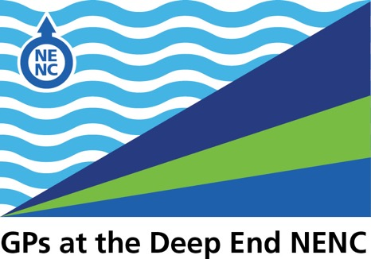

**Network Engagement**

15 practices attended our 8th Webinar where the keynote presentation was by Dr G Rowlands, Professor of Primary Care at Newcastle University, about her recent research findings on Organisational Health Literacy and General Practice. We had fruitful discussions on the upcoming pilots on social determinants of health and immunisation catch up team (see below). In addition to this we formally fed back the output of the face-to-face engagement event held in April.

3 pilot projects are currently being developed:

* **The Immunisation Catch-Up Team** providesa service for DE practices that are currently unable to meet their pre-school vaccination (QOF) targets. Practices will receive the support from a third-party provider for 2 weeks to put on additional clinics or home visits (depending on practice wishes). The pilot will run for 6 months starting in January, with an expectation of longer-term funding next year to ensure that all of our communities are appropriately vaccinated.
* **The Social Determinants of Health Link Worker Pilot** is starting with 10 practices who will receive funding to employ or commission a link worker aligned to their practice (as opposed to being shared within their PCN) to meet social determinant needs. Practices are able to identify both the needs and the form in which to meet these and therefore we have had a wide range of proposals, from meeting health literacy needs, to addressing barriers that limit uptake of AAA and bowel screening. Following the pilot we expect to roll this out across all of our 38 practices in 2024-25.
* **Embedding Clinical Psychology** into practices involves running a pilot with our Mental Health FT partners. The evaluation is providing evidence of benefits both for patients through earlier identification and support for needs that would otherwise require a secondary care referral, and for practice staff in becoming more aware of the range of needs that clinical psychology can support. We are working with the ICB Mental Health and Learning Disability Workstream within their transformation programme to explore opportunities to mainstream this approach in communities with the greatest need.

We have also run a very successful pilot of supporting a practice to become a training practice through funding a GP trainer to work within the practice, which releases a practice GP to undertake the required training. We hope to roll this out further in the coming months to more practices.

**Research**

As ever, the network is underpinned by robust research, ensuring that all pilots are evaluated by colleagues from Newcastle University producing evaluations for peer review publication.

**NENC Deep End Research team update**

We have an active research programme supporting our NENC Deep End network in partnership with the NENC NIHR Applied Research Collaboration led by Sarah Sowden at Newcastle University. We are continually

building upon our strong research-practice collaborations, with the aim of ensuring that all activity within our NENC Deep End network:

* is informed by available evidence of ‘what works and why’ to address health inequalities in primary care
* builds upon the existing evidence-base in an applied way that involves our Deep End practitioners and patients

**Education**

Matt Armstrong has recently taken over as NENC Deep End Educational Lead, with the aim of progressing

ideas and projects developed by Vivienne Branton whilst she is on maternity leave. Matt is a GP

at Cruddas Park and developed an interest in the Deep End network during his GP training

where he undertook a research study as part of a MSc degree. His current work aims to improve

knowledge and understanding of the Deep End concept and health inequalities at all levels of

training from undergraduate students to established GPs.

One of the educational projects is re-designing the Deep End fellowship which has previously

been piloted. The new fellowship will act as a ‘bolt on’ to the national new-to-practice

fellowship which is offered to all newly qualified GPs within 2 years of CCT.

Matt is also arranging clinical professional development sessions for staff in Deep End practices

to start in the new year. The sessions will be online teaching sessions held on evenings on a range of

topics highlighted as important by clinicians and managers working in the Deep End.

**Networking**

More widely, the network continues to advocate for member practices through expanding its reach and influence within the emerging ICB, ensuring that we link with multiple workstreams and influencing the ICB Prevention and Healthcare Inequalities Programme that the network sits within.

**Jon Quine**

**www.deependnenc.org**

**NOTTINGHAMSHIRE DEEP END 2023**



Notts Deep End group has been running for over 3 years and has been having monthly ‘breakfast’ meetings via Microsoft Teams. We have had various guests attend the meetings, with the aim of trying to make local connections,and raise the profile and support for practices working at The Deep End.

In October 23 we had our first face to face meeting to discuss the future development of the group. It was a really productive session, and we have an agreed Mission of ‘To achieve equality of health outcomes for ALL patients in Nottinghamshire’ and to continue with focusing on Advocacy (including patient voices) / Education & Awareness / Research in disadvantaged populations / Connecting people, workforce & services.

We are exploring how the group can become more sustainable, and how to fully engage with all the practices at The Deep End in Notts.

We are also keen to explore how to progress research and to use our unique position of having an established trusted relationship with our patients; we hope to use this for further co-production / engagement for research / service planning.

Nottinghamshire continues to host another group of Trailblazer fellows, and several members of the  Deep End group are core20PLUS ambassadors for 23/24.

**Julia White**

**PLYMOUTH DEEP END 2023**

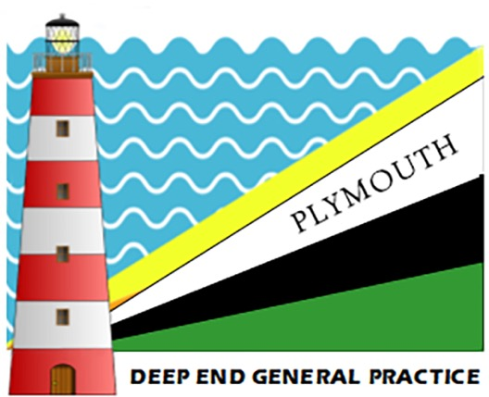

Deep End practice does not get any easier or less busy. With everyone else we continue to struggle with the double whammy of very high workload and relatively low funding.

Two events have particularly impacted on our Deep End practices over the last year. The first is around premises. 3 of our practices work in really terrible and inadequate buildings. We were promised a wonderful new “Cavell Centre” building that would house all 3, plus many other services. I was clinical lead for the project with competitive rounds of application involving a lot of work.

A site was identified by Plymouth City Council, shops were compulsorily purchased and demolished, and a huge community consultation exercise was conducted resulting in a beautiful design. Then the Cavell money was pulled by Government earlier this year and we were left with nothing - except a lot of wasted time.

The most frustrating thing about it is that the next Government initiative to come along is “diagnostic centres”, one of which will go onto the Cavell site in Plymouth. The spin is that our city is getting “a new health building”, and most people do not realise the tragedy and total folly of replacing a primary care, preventative, holistic and integrated project with a secondary/tertiary facility that will make no difference to our terrible health inequalities.

But we are moving on and looking at other ways to provide not only new premises but a new way of doing things. Our plans are now for a “health and wellbeing village” in the heart of Stonehouse, our highest deprivation neighbourhood and we are seeking funding.

The second event was the end of CCGs in England and the move to ICBs resulting in promised funding for a second round of “Deep End GP Fellows” disappearing.

However, we have re-established relationships with the new body and have just agreed funding for 14 “Health Inequality GP Fellows” across Devon, 6 of which will be in placed on Plymouth Deep End practices. These doctors will have additional paid time to conduct research or follow interests in Deep End issues - and receive mentoring and education via the Fairhealth programme.

Our experience last time was hugely positive with many of our first round Fellows now working in Deep End practices (including my own).

We have also just received funding via our Director of Public Health from the ICB health inequalities fund for our Plymouth Deep End practices to undertake proactive projects that will tackle health inequalities. The only stipulation is that project must include a community health worker, which I hope will lead to some innovative projects.

Whilst it is great to be offered money like this, I am concerned that struggling Deep End practices may not have the time or resources to respond to the offer. One of the issues when you are struggling in the deep water with feet not on the ground is that it is harder to reach out for support!

There are lots of other positives in Plymouth. In my own practice we have found funding to extend our homeless/complex needs outreach work to include a “pathway” style hospital in-reach service and we have employed an additional GP plus nursing and mental health support to do this. This HIPP project is helping some of our most vulnerable patients to negotiate better the often-inefficient primary/secondary care interface. With numbers of people experiencing homelessness rising and hospital services ,especially ED ,ever more stretched, this is really making a difference.

The broad scope of our work, the sheer variety of it, our ability now to offer a more portfolio career that can include complex needs and outreach work, teaching experience etc - and funding to pursue particular interests is making Deep End general practice a more attractive career option. We are getting more enquiries from interested doctors to work with us and although all this funding is precarious, and we have to go on looking for it - overall we are optimistic for recruitment.

Just as well when WTE GP numbers are continuing to fall and workload continues to rise. The Deep End gets ever deeper.

**Richard Ayres**

**YORKSHIRE AND THE HUMBER DEEP END 2023**



Dom Patterson has recently been appointed as chair of the RCGP’s health inequalities standing group and is engaged with the RCGP’s work around health inequalities, which is an RCGP priority for 2023-26.

If anyone is interested in joining the new RCGP forum on health inequalities, please get in touch: [dominic.patterson@fairhealth.org.uk](mailto:dominic.patterson@fairhealth.org.uk)

**Fairhealth**

Fairhealth, a charity that contributes to the elimination of health inequalities through health professionals’ education, continues to be led largely by members of the Yorkshire Deep End movement.

Recent activity includes:

* Our suite of learning modules has been reviewed and updated.
* We launched our most recent module: ‘Health Inequalities and Secondary Care’
* [All our courses can be accessed here.](https://www.fairhealth.org.uk/courses)
* Tom Ratcliffe has written two blogs, 'Surviving in a failing system’ and ‘Rise up against the organisation of misery’. All our blogs can be accessed here
* Setting up a [Deep End London page](https://www.fairhealth.org.uk/deep-end-london) on our website.

**Dom Patterson**