Staff Equality Monitoring Report 2022-23

Executive Summary

This is the twelfth annual staff equality monitoring report produced by the Equality and Diversity Unit and follows largely the same format as the previous reports. This report supports the University’s obligations to publish annual staff equality monitoring data as part of the Public Sector Equality Duty (PSED) under the Equality Act 2010.

The publishing cycle reflects the previous academic cycle (August 2022 –July 2023).

The report shows the following important points, changes and challenges:
- The KPI’s set in the University strategy has three diversity components, the variance this year are:
  - Senior women has increased by 1% to 33.8%
  - Declared disability has increased from 5.3% to 6.8%.
  - UK Black, Asian and Minority Ethnic (BAME) representation up from 4.9% to 5.7%.
- The University’s has made significant progress in reducing the percentage of ‘Unknowns’ across all categories since 2021-22, which has contributed most meaningfully to the following:
  - Disability status ‘unknown’ category reduced to 7.2% from 12.4%.
  - BAME ‘unknowns’ reduced to 11.6% from 18%.
  - Religion or Belief ‘unknown’ category reduced by 9% to 27.2%.
  - Sexual Orientation ‘Unknown’ statistics reduced by 8.5% to 22.8%.
- The percentage of all BAME colleagues has increased 3.7% from 2021-22 to 15.3%.
- The balance of colleague’s sex is fairly static, with 55% female and 45% male.
- Science and Engineering saw an increase in female colleagues by 1.5%, reversing last year’s drop.
- The largest cohort of colleagues declaring a disability have a long-term illness or health condition, followed by those who have a mental health condition.
- In Religion or Belief, the largest cohort of colleagues state they have no religion, increasing by 4.8% to 37.7%. Of those with a declared faith, Christian is the biggest demographic at 18.7%.
- Declaration rates within the University’s LGB community are rising, increasing by 1.7% to 7.2%; this is across all Colleges/US, but notably a 3.4% increase in Arts.
- The proportion of International colleagues continues to grow, with 14.3% of our staff from the EU/EEA, with a total of 31.3% from outwith the UK.
- Our colleagues who identified as a different gender identity to that registered at birth is growing, with an increase of 80% since 2021-22, however the numbers are small.
- Arts and Science & Engineering have seen the largest increase of Disability declarations, by 1.9% in both Colleges.
- The Technical and Specialist job family has seen the largest increase in Disability declarations, 2.4% since 2021-22.
- All Colleges/US saw increased declarations from BAME colleagues; 5.6% in Science and Engineering, 4.2% in MVLS, 4.4% in Social Sciences, 3.2% in US and 2.1% in Arts.
- The proportion of BAME colleagues within the Operational and Research and Teaching job families has increased by 4.4% and 5.3% respectively.
- There was a 93% increase this year in case management cases this year.
- The data shows a high percentage of ‘unknown’ in the successful applicants in the recruitment data.

Introduction

The Staff Equality Monitoring Report allows the University to have a standard base for all staff equality information across the organisation. This report meets one of the University’s obligations under the Public Sector Equality Duty (PSED).

The aim of this report is to provide transparent data for all functions in the institution to use when equality information is required, such as when conducting Equality Impact Assessments (EIA).

Structure

This report has been structured to provide a ‘Whole University’ overview by all the main protected characteristics plus full/part time working, and maternity leave followed by specific sections on Age, Disability, Ethnicity, Sex and Sexual Orientation with a breakdown of data by the following:
- College
- Grade 10 staff
- Job Family Profiles
- Grade
- Full/Part Time
- Contract Type
- Nationality
- Recruitment – by all applicants and successful applicants

We have not provided a further breakdown beyond ‘Whole University’ on data for religion and belief as the proportion of staff answering these questions is too small to give meaningful information.

Further information has then been provided on:
- Academic Promotions – by Sex
- Regrading for Professional & Support Staff – by Sex
- Case management - by Sex, Ethnicity and Disability
- Sickness Absences - by Age, Disability, Ethnicity, Sex, and Sexual Orientation

Notes and definitions

This report is based on a census date of 31 July 2023, unless otherwise stated. This date captures staff at their grade prior to any promotions which take effect on 1 August. Percentages have been provided, as there are some instances where numbers are very small and using actual numbers carries the potential to be able to identify individual staff. Overall proportions for each of the sections have been provided in Tables 1-6 below.

Whole University - Total head count is 10161 (up 566 on last year). This is the head count for all staff in the University; those with multiple contracts are only counted once. The three previous year’s total headcount figures were 8691 (2019-20), 9380 (2020-21) and 9595 (2021-22).
College/University Services Split
When using the term ‘By College’ later in this report University Services is also included.

Table 1 - College | %2020-21 | %2021-22 | %2022-23
Arts | 7.9% | 8.5% | 8.5%
MVLS | 32.9% | 29.4% | 28.0%
Science and Engineering | 19.5% | 21.8% | 21.8%
Social Sciences | 15.7% | 16.7% | 16.5%
University Services | 24.0% | 23.6% | 25.2%

Job Family Profile
Some members of the Senior Management Group (SMG) may be classed as ‘Research & Teaching’ or ‘Clinical’ under the Job Family profile. For reporting purposes, they will have been moved into SMG, and the original Job Family figures amended accordingly.

Table 2 - Job Family | %2020-21 | %2021-22 | %2022-23
Clinical | 3.3% | 3.3% | 3.1%
Management, Professional and Administrative (MPA) | 27.5% | 27.5% | 29.9%
Operational | 8.3% | 7.8% | 7.5%
Research & Teaching | 47.4% | 52.9% | 52.0%
Senior Management Group (SMG) | 0.2% | 0.1% | 0.1%
Technical & Specialist | 13.4% | 8.4% | 7.3%

By Full/Part Time
All staff who work less than one FTE are considered Part Time.

Table 3 - Full Time / Part Time | %2020-21 | %2021-22 | %2022-23
Full Time = FTE 1.0 | 65.5% | 63.5% | 63.3%
Part Time = FTE - 0 + anything < 1.0 | 34.5% | 36.5% | 36.7%

By Contract Type
The contract types are as follows;
F = Fixed term as per FT & OE Contract policy
O = Open ended with funding end date
P = Open ended + Permanent in Temporary Fixed Term Appointment
S = Fixed term - SOSR e.g. Maternity leave cover

Table 4 - Contract Type | %2020-21 | %2021-22 | %2022-23
F = (F) Fixed term | 29.1% | 20.8% | 15.7%
O = (O) Open ended with funding end date | 15.6% | 14.6% | 13.4%
P = (P) Open ended + (C) Permanent in Temporary Fixed Term Appointment (Head of College/Principal/Vice Principal roles etc.) | 54.2% | 56.1% | 58.5%
S = (S) Fixed term - SOSR e.g. Maternity leave cover | 1.1% | 8.5% | 12.4%
In the last year the University has moved some colleagues from Fixed term contracts to SOSR contracts, these have in the main part been GTAs, Tutors and Demonstrators. This is reflected in the decrease in Fixed Term contracts and the increase in SOSR contracts since 2020-21 to 2021-22.
Grade Grouping
Table 5 - Grade Grouping | % 2020-21 | % 2021-22 | % 2022-23
Grade 1 | 2.5% | 1.6% | 1.1%
Grade 2 | 4.2% | 3.8% | 4.2%
Grade 3 | 6.0% | 4.2% | 3.7%
Grade 4 | 4.9% | 5.6% | 5.3%
Grade 5 | 15.7% | 14.6% | 15.1%
Grade 6 | 19.6% | 20.7% | 20.8%
Grade 7 | 16.6% | 17.7% | 18.2%
Grade 8 | 12.5% | 12.9% | 13.0%
Grade 9 | 7.6% | 8.1% | 8.0%
Grade 10 (see Table 6 for definition) | 6.7% | 6.9% | 7.1%
Clinical | 3.3% | 3.3% | 3.1%
Other | 0.5% | 0.5% | 0.4%

Table 6 – Grade 10 staff  (based on Actual Grade Description) | % 2020-21 | % 2021-22 | % 2022-23
Professor & Equivalent MRC Grades | 88.6% | 88.5% | 87.1%
Senior Administrative Group | 8.9% | 9.4% | 11.0%
Senior Management Group (SMG) | 2.5% | 2.1% | 1.9%

Age
Two charts are provided for the whole University age data, using 5-year groupings and then 10-year age groupings. For all subsequent charts, the age data is provided using the 10-year age groupings only.

Disability
Two charts have been provided for the whole University disability data, whether staff have stated they have a disability, and then by impairment category. For all subsequent charts the disability data is only provided by whether staff have stated they have a disability or not. Disability statistics include colleagues who have self-identified as ‘disabled’, as well as those who have provided details of an impairment or long-term health condition, whether they have self-identified as ‘disabled’ or not. HESA has made minor changes to the impairment categories this year, and therefore they may not truly match to the previous years.

Ethnicity
Two charts have been provided for the whole University ethnicity data. For all subsequent charts all ethnic minority categories have been combined into Black, Asian or Minority Ethnic (BAME).

The nomenclature Black, Asian and Minority Ethnic (BAME) was introduced in the 2016-17 report as agreed at the time by members of the University’s Race Equality Group. The University understands this is not a collective experience, however as numbers are small we cannot currently present the data in smaller subsets.

The figures shown in the report’s Ethnicity section as ‘Unknown’ includes the category option ‘Not known’ where staff genuinely do not know their ethnicity, for example those who were adopted. HESA has made changes to the ethnicity categories this year, and therefore they may not match directly to previous years.

Maternity
This outlines the percentage who returned to work, the percentage still on leave and due to return, those whose contract ended within the period and those who resigned within the reporting period.

Gender Reassignment
To collect information in relation the protected characteristic of gender reassignment the University currently uses the 2022-23 HESA recommended question ‘Does your gender identity match your sex as registered at birth?'. Responses are based on the staff member’s own self-assessment. Due to the wording of the HESA recommended question, it is possible people who identify as Non-binary may be included in the statistics.

Nationality
This is based on information provided by staff about their right to work in the UK. For the purpose of this report, we have used the following categories: UK, EU/EEA and International.

Sexual Orientation
For the purposes of this report, the sexual orientation categories of Lesbian, Gay and Bisexual have been combined and shown as LGB. The whole University data shows the full breakdown, including where information has not been declared.

Due to high undeclared rates, all subsequent charts only rates of declared sexual orientation or ‘prefer not to say’ data is provided. The ‘Unknown’ figures have been excluded from those graphics but have been included in the statistics used to create them.

Recruitment - Applications and Successful Applicants
The census date is based on the date the post was first advertised, 01 August 2022 – 31 July 2023. The data excludes direct appointments. The data also excludes those who withdrew during the application process or prior to an offer decision. The data will include individuals more than once if they applied for multiple roles during the time period. Some roles have more than one post available and so have more than one successful applicant. Total number of resulting applications was 26930 (up 5645 from 2021-22). Data is provided for applicants and successful applicants.

We continue to have high numbers of instances where we receive no monitoring data from applicants; this is recorded as ‘Unknown’ in the data set. We continue to work with the University’s Recruitment Team to understand the causes and engage with them to seek and implement solutions to minimise this in the future.

Case Management
This section provides data on formal employment related procedures - Managing Attendance, Discipline and Grievance cases during the report period 01 August 2022 – 31 July 2023. Data is provided by Sex, Disability and Ethnicity. Grievance case numbers are based on the staff member who raised the Grievance.

Additionally, within this section data is provided on Sickness Absences between 01 August 2022 –
31 July 2023. Figures are based on staff who had at least one absence of 20 or more continuous working days. Charts are provided by Age, Disability, Ethnicity, Sex and Sexual Orientation.

Academic Promotions and Professional & Support Staff Regrading
The data for promotion is only provided by Sex as further disaggregation carries a risk of identifying individual staff.

Pay Gap Information
In accordance with the Public Sector Equality Duties, the Gender Pay Gap and Equal Pay information for Disability and Ethnicity are provided in line with our legislative requirements in a separate report.

Whole University Profile

Age
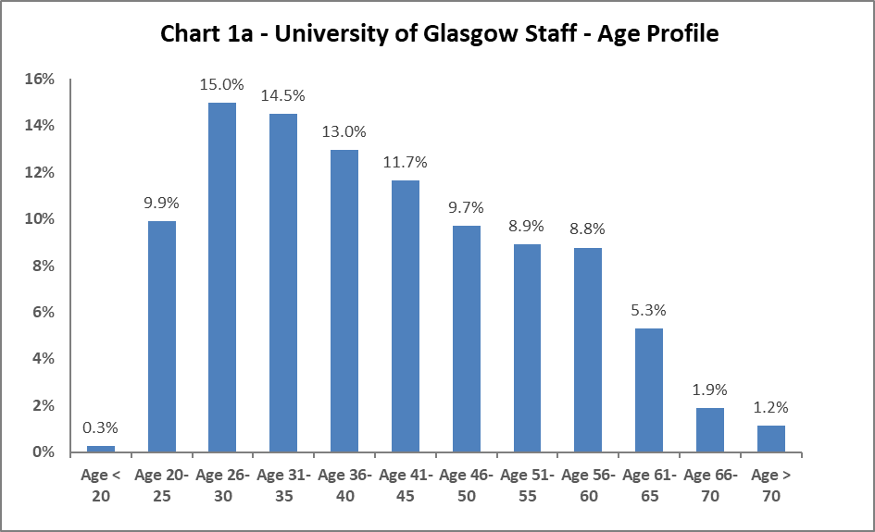

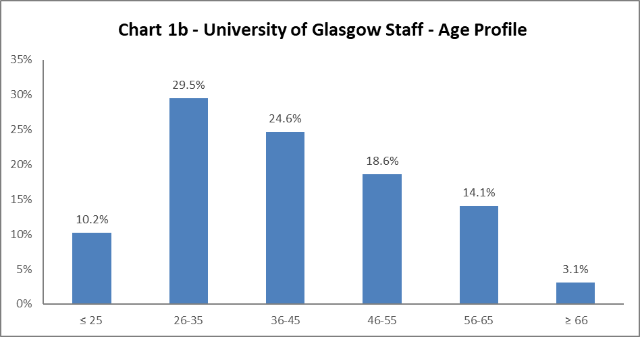

The University's age profile in 2022-23 is very similar to the previous year. There are minor reductions in the 26-35 category and increases in the 36-55 age categories.

Disability

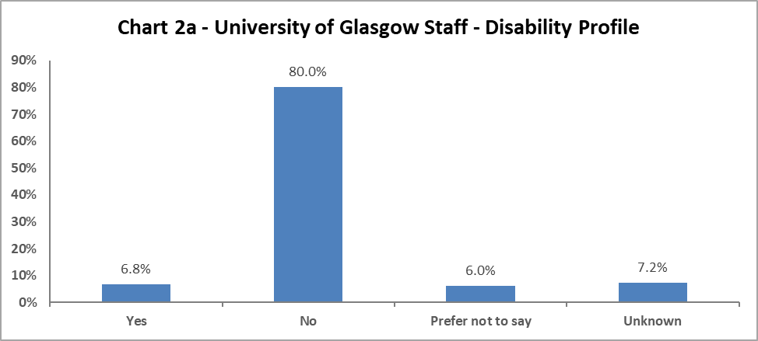

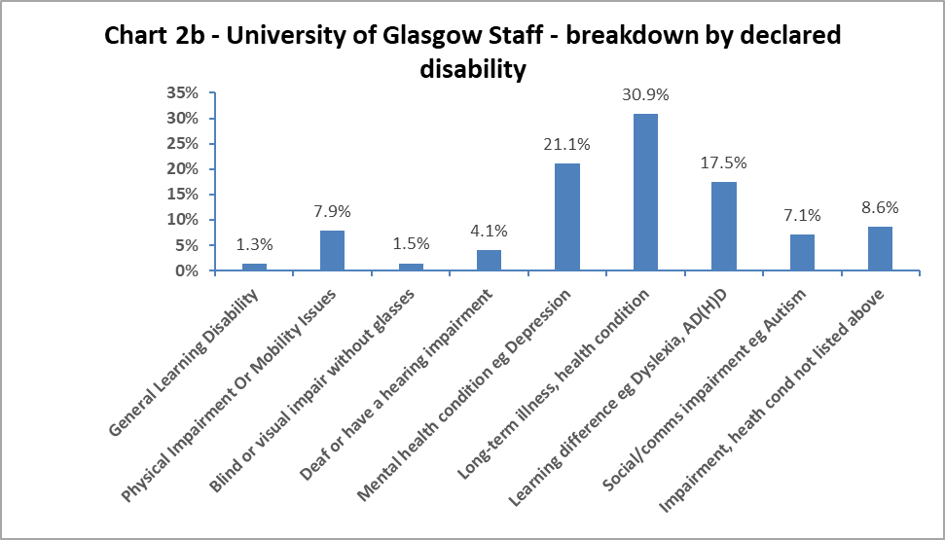

Chart 2a shows 6.8% colleagues have declared a disability, this is a 1.5% increase from last year. In addition, there has been a significant drop in the number of ‘Unknowns’ (from 12.4% in 2021-22 to 7.2% in 2022-23) and ‘Prefer not to say’ (from 8.9% in 2021-22 to 6% on 2022-23). There has been a specific drive to improve this data quality within People and Organisational Development (POD), with monthly reminders sent to colleagues who have not completed this data. The improvement seen implies colleagues are gaining confidence in the University’s recording systems.

When considering impairment type, in Chart 2b, HESA has renamed some of the categories this year, reducing the options from 10 to nine. The largest cohort continues to be those a long-term illness or health condition, increasing by 1.7%. The next highest category is colleagues with a mental health condition, though this has decreased by 1.6%; this on top of a decrease in 2021-22 of 2.2%. For other impairments, the data shows there has been an increase of 0.5% of those who are Deaf or have a hearing impairment and increase of 2.5% of those with a learning difference such as dyslexia or AD(H)D and an increase of 0.8% of those with a social/communications impairment since 2021-22.

Marital Status

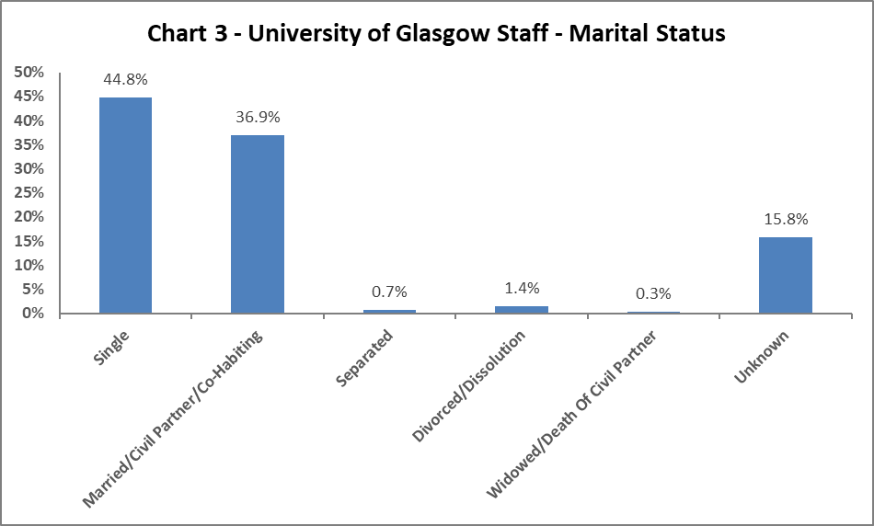

Chart 3 shows the largest percentage of colleagues are single, with a minor increase from 2021-22 of 1.1%, and a 0.9% increase in those who are married/civil partnership/co-habiting. All other marital status areas have seen minor fluctuations, with the exception of ‘Unknown’, which has grown by 9%, but this is likely to be due in part by the removal of the ‘Unspecified’ category from 2021-22.

Full Time/Part Time

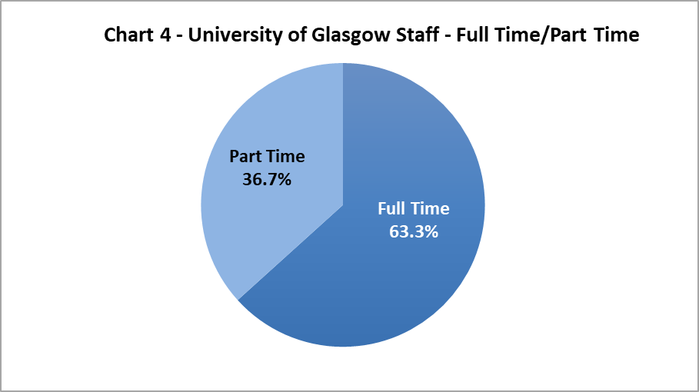

Chart 4 shows approximately two thirds of colleagues work full time and one third work on a part time basis. These proportions have only seen minor changes since 2021-22.

Nationality

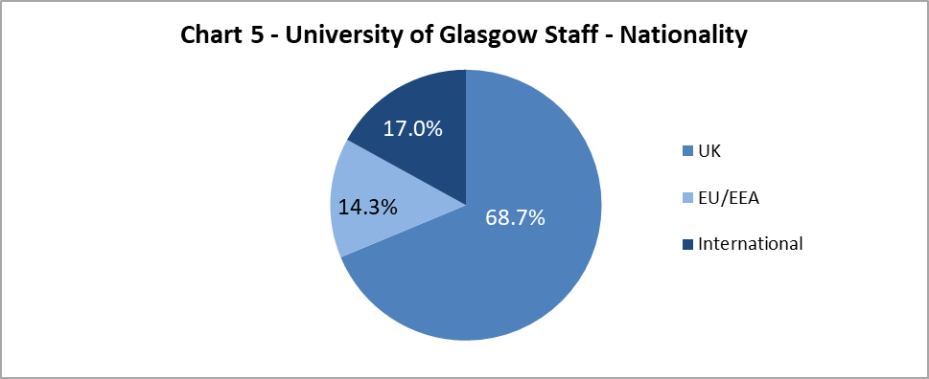

The data shows the University continues to grow our International colleague cohort, with a 2.5% increase since 2021-22, this adds to the 2.2% increase seen in 2020-21. The proportion of EU/EAA colleagues has stayed static since 2020-21, with UK colleagues reducing by 2.4%, following a 2.5% decrease in 2020-21.

Ethnicity

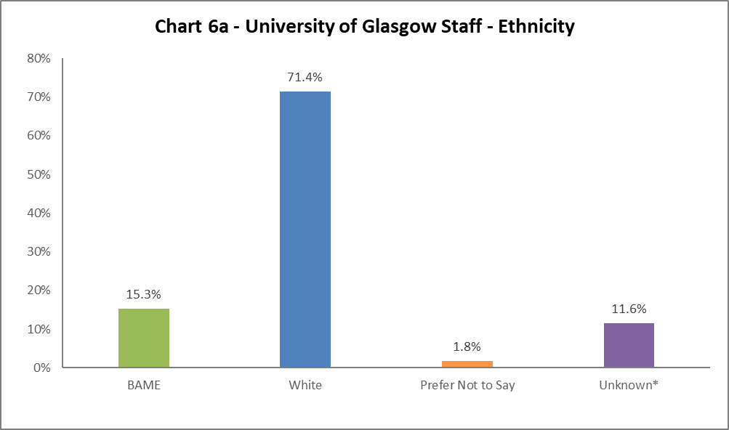
Chart 6a shows the University has seen an increase of 3.7% in declarations colleagues from a Black, Asian or Minority Ethnic (BAME) background, to 15.3%. There has been a 2.3% increase of colleagues from White backgrounds and a 6.4% decrease in the ‘Unknown’ category. There has been a specific drive by POD to improve the data quality, with monthly reminders sent to colleagues who have not completed this data. This improvement implies colleagues are gaining confidence in the University’s recording systems.
Chart 6b shows the breakdown of ethnicities; these categories have been changed by HESA since 2021-22, notably to some of the ‘White’ categories, and some colleagues will want to consider which category now fits their identity. There have been 1.3% increase in colleagues who are Asian Chinese or British Chinese, and a 5.4% decrease in those with an ‘Unknown’ status.

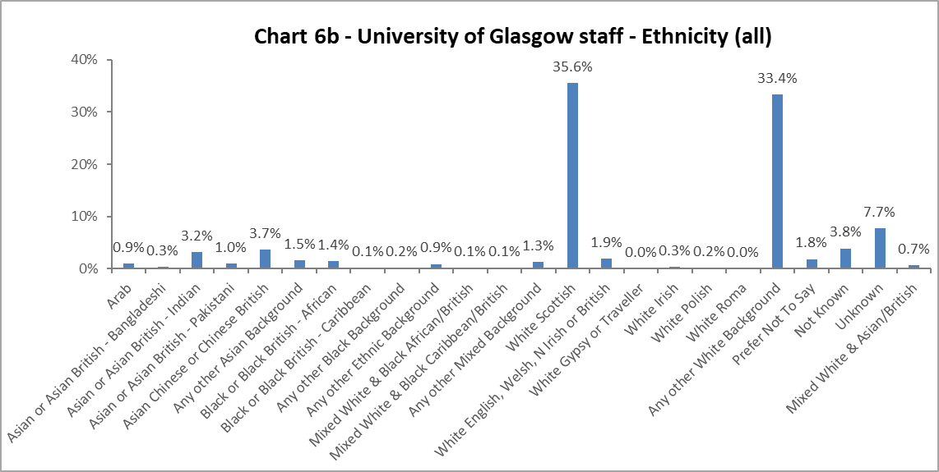

Religion and Belief

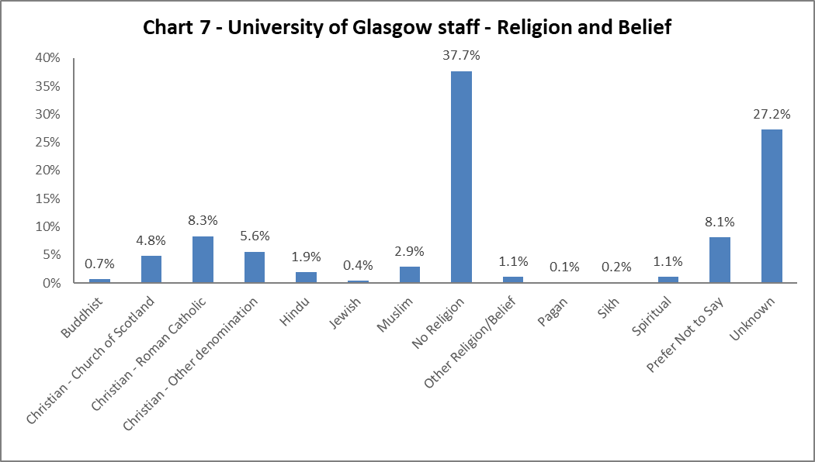
The largest component of colleagues declaring continue to state they have no religion, an increase of 4.8% from 2021-22. 18.7% of colleagues state they are Christian, an overall increase 1.9% from 2021-22. There has been a slight drop in Hindu, Muslim and Spiritual colleagues, since 2020-21. There has been a 9% decrease in the ‘Unknown’ category.
Sex
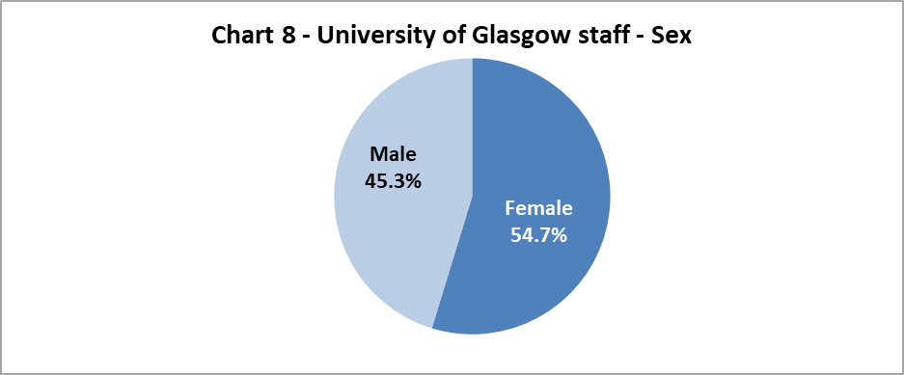

Chart 8 shows the proportion of colleagues by Sex, this only changed by 0.7% between the sexes from 2021-22.

Sexual Orientation

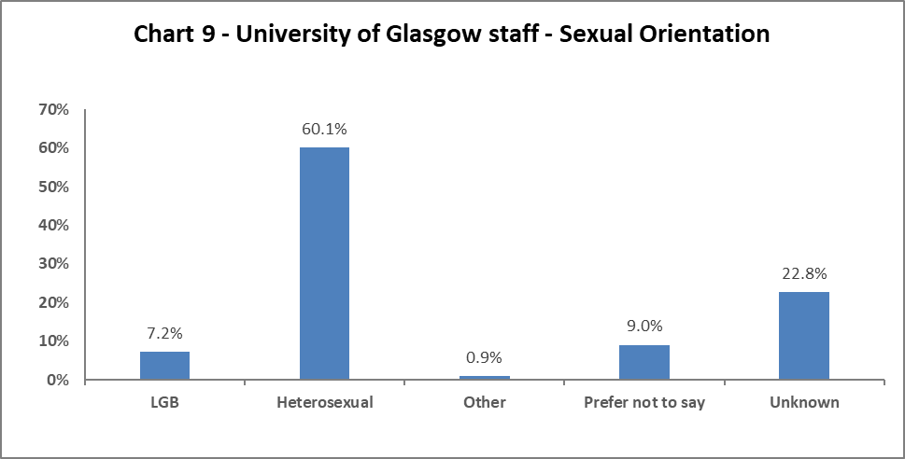

Chart 9 shows the percentage of colleagues who identify as Lesbian, Gay or Bisexual – this has increased by 1.7% to 7.2%. There has been a drop of 8.5% of ‘Unknown’ category, with a 1.2% increase in those who ‘Prefer not to Say’ and an increase of 5.5% of those who are Heterosexual.

Maternity Leave

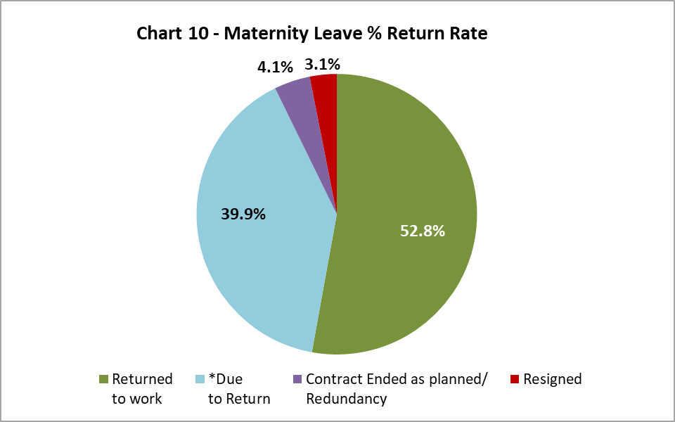

There has been a 0.4% decrease in resignations post maternity leave from 2021-22. Colleagues’ contracts ending whilst they are on Maternity Leave has seen a 0.1% increase from 2021-22.

Gender Reassignment

54 colleagues responded negatively to the HESA recommended question relating to gender identity: ‘Does your gender identity match your sex as registered at birth?’. While numbers remain small, this represents an 80% increase from 2021-22.

Profile by Age

By College

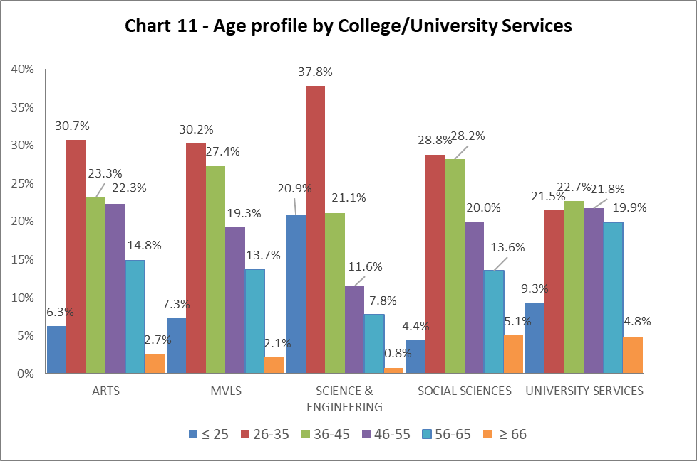

Table 7 | ARTS | MVLS | SCIENCE & ENGINEERING | SOCIAL SCIENCES | UNIVERSITY SERVICES
Age Range | % | % | % | % | %
≤ 25 | 6.3 | 7.3 | 20.9 | 4.4 | 9.3
26-35 | 30.7 | 30.2 | 37.8 | 28.8 | 21.5
36-45 | 23.3 | 27.4 | 21.1 | 28.2 | 22.7
46-55 | 22.3 | 19.3 | 11.6 | 20.0 | 21.8
56-65 | 14.8 | 13.7 | 7.8 | 13.6 | 19.9
≥ 66 | 2.7 | 2.1 | 0.8 | 5.1 | 4.8

Chart 11 above is a visualisation of the distribution of ages in each College/US which can be compared with the Whole University distribution in Chart 1. Table 7 above gives the relevant percentages. There has been a marked increase in the percentage of 26–35-year-olds in Arts and US (3.6% and 3.3% respectively). This in turn has seen a drop in the percentage of 36–45-year-olds in Arts from 27.6% to 23.3% from 2021-22 to 2022-23. We continue to have a significantly younger population in Science and Engineering compared to other Colleges and US.

By Grade 10 staff

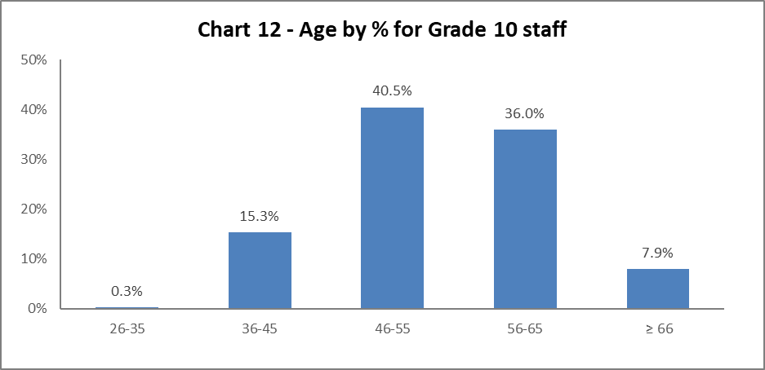

Chart 12 above shows most Grade 10 colleagues are aged 46 or over. This is a fairly static picture compared to 2021-22.

By Job Family Profile

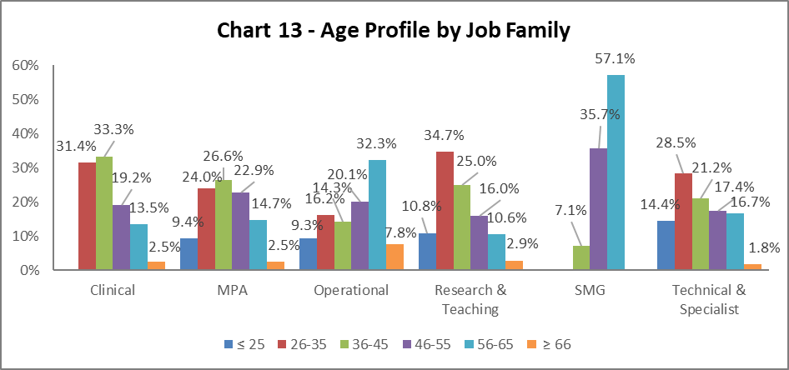
Table 8 | Clinical | MPA | Operational | Research & Teaching | SMG | Technical & Related
Age Range | % | % | % | % | % | %
Age ≤25 | 0.0 | 9.4 | 9.3 | 10.8 | 0.0 | 14.4
Age 26-35 | 31.4 | 24.0 | 16.2 | 34.7 | 0.0 | 28.5
Age 36-45 | 33.3 | 26.6 | 14.3 | 25.0 | 7.1 | 21.2
Age 46-55 | 19.2 | 22.9 | 20.1 | 16.0 | 35.7 | 17.4
Age 56-65 | 13.5 | 14.7 | 32.3 | 10.6 | 57.1 | 16.7
Age ≥66 | 2.5 | 2.5 | 7.8 | 2.9 | 0.0 | 1.8
Chart 13 above outlines the age distribution by job family. MPA and Technical and Specialist job families have a standard bell curve, with Clinical and Research and Teaching job families with a younger demographic. Operational job family continue to have an older demographic, with the most staff over the age of 66.

By Grade

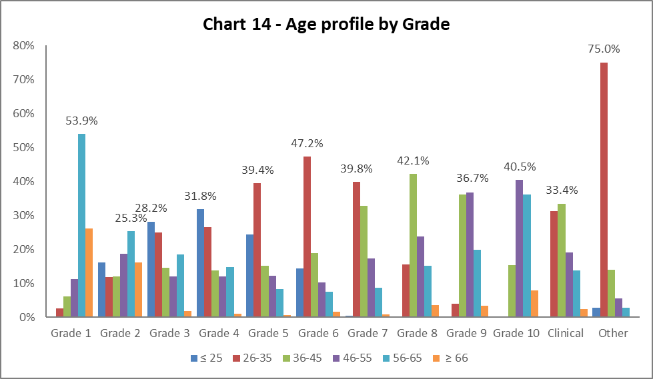

Table 9 | Grade 1 | Grade 2 | Grade 3 | Grade 4 | Grade 5 | Grade 6 | Grade 7 | Grade 8 | Grade 9 | Grade 10 | Clinical | Other
Age Range | % | % | % | % | % | % | % | % | % | % | % | %
Age ≤ 25 | 0.0 | 16.1 | 28.2 | 31.8 | 24.4 | 14.4 | 0.4 | 0.1 | 0.0 | 0.0 | 0.0 | 2.8
Age 26-35 | 2.6 | 11.8 | 25.0 | 26.6 | 39.4 | 47.2 | 39.8 | 15.5 | 3.9 | 0.3 | 31.3 | 75.0
Age 36-45 | 6.1 | 12.1 | 14.5 | 13.8 | 15.1 | 19.0 | 32.9 | 42.1 | 36.2 | 15.3 | 33.4 | 13.9
Age 46-55 | 11.3 | 18.7 | 12.1 | 12.1 | 12.2 | 10.3 | 17.2 | 23.7 | 36.7 | 40.5 | 19.1 | 5.6
Age 56-65 | 53.9 | 25.3 | 18.4 | 14.7 | 8.2 | 7.5 | 8.8 | 15.1 | 19.8 | 36.0 | 13.8 | 2.8
Age ≥ 66 | 26.1 | 16.1 | 1.8 | 1.1 | 0.6 | 1.6 | 0.9 | 3.6 | 3.3 | 7.9 | 2.5 | 0.0

Chart 14 and Table 9 show the grade profile for age range. This reflects 2021-22 age range by grade. With exception of grade 1 and 2, where staff are likely to be older, reflecting the job families in these grades, generally as the grades increase the profile gets older.

By Full/Part Time

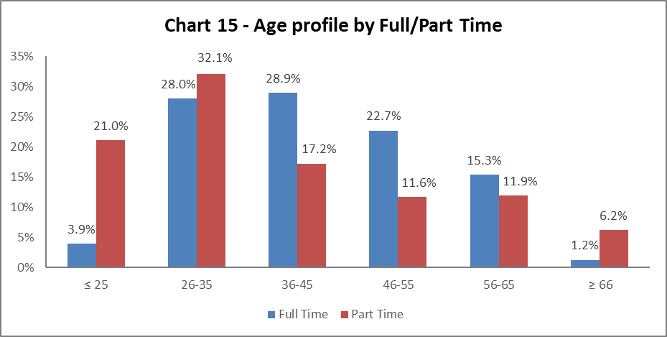

Chart 15 shows the age profile of both full time and part time colleagues. There have been minimal changes since 2021-22.

By Contract Type

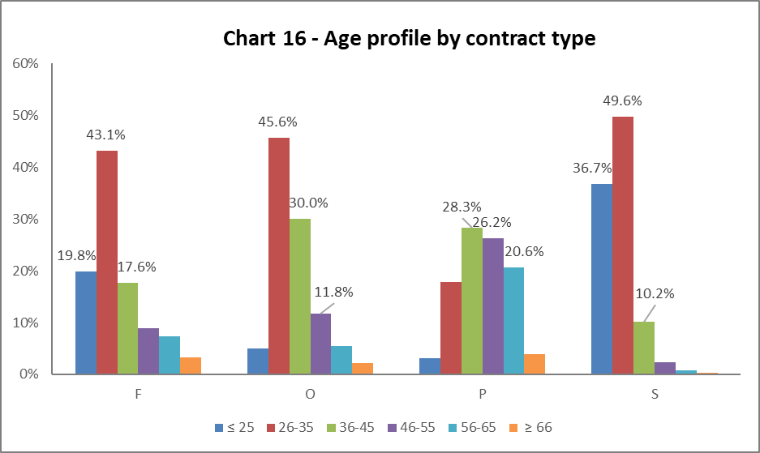

Key
F = Fixed term as per FT & OE Contract policy
O = Open ended with funding end date
P = Open ended (‘Permanent’) + Perm in Temp Fixed Term Appointment (HoC/Principal/VP role)
S = Fixed term - SOSR e.g. temporary cover for situations such as maternity or parental leave and long-term absence or for one-off projects
Table 10 | F | O | P | S
Age Range | % | % | % | %
Age ≤25 | 19.8 | 5.1 | 3.2 | 36.7
Age 26-35 | 43.1 | 45.6 | 17.8 | 49.6
Age 36-45 | 17.6 | 30.0 | 28.3 | 10.2
Age 46-55 | 8.8 | 11.8 | 26.2 | 2.4
Age 56-65 | 7.4 | 5.4 | 20.6 | 0.8
Age ≥66 | 3.2 | 2.1 | 3.8 | 0.2

Chart 16 above shows that Open ended with Funding End Date (code O) and both types of Fixed Term (F & S) workers are generally younger (under 35), this reflects both 2020-21 and 2021-22 data.

By Nationality

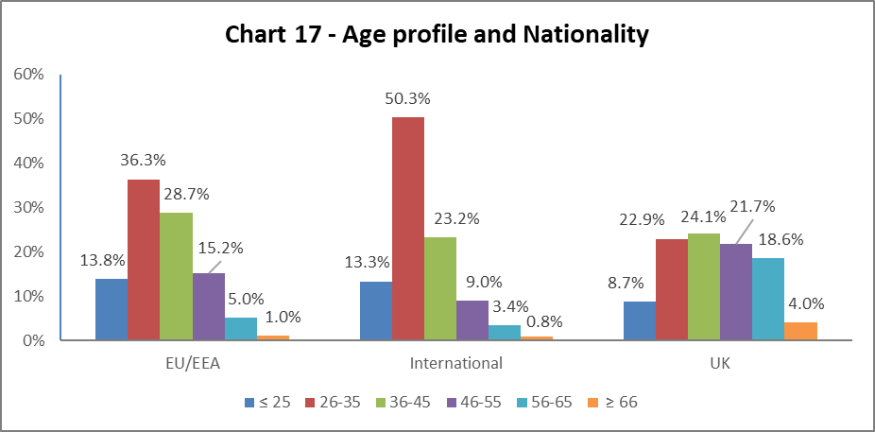

Table 11 | EU/EEA | International | UK
Age Range | % | % | %
Age ≤25 | 13.8 | 13.3 | 10.2
Age 26-35 | 36.3 | 50.3 | 29.5
Age 36-45 | 28.7 | 23.2 | 24.6
Age 46-55 | 15.2 | 9.0 | 18.6
Age 56-65 | 5.0 | 3.4 | 14.1
Age ≥66 | 1.0 | 0.8 | 3.1
Chart 17 and Table 11 shows the age range of staff and their nationality. As with previous years, a higher percentage of our EU/EEA and International staff are younger than our UK staff.

Recruitment – by Applications and Successful Applicants
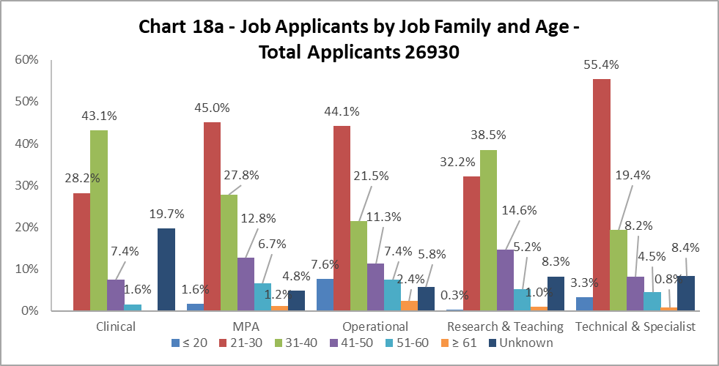

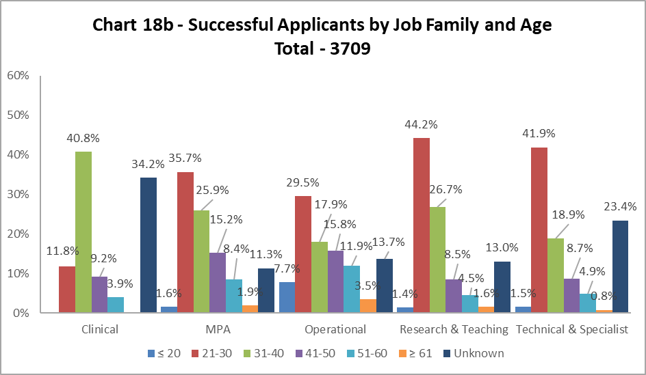
Charts 18a and 18b show the age of applicants and those who were successful. The biggest disparities are seen in the age range 21-30 in Clinical, Operational and Technical and Specialist job families, where you are less likely to be successful by 16.4%, 14.6% and 13.5% respectively. Conversely, Research and Teaching job family, where applicants aged 21-30 are more likely to be successful, by 12%, an increase from last year when it was 8.4%. There continues to be high proportion of ‘Unknown’ in the successful data set, noting, this is higher than last year.

Profile by Disability

By College

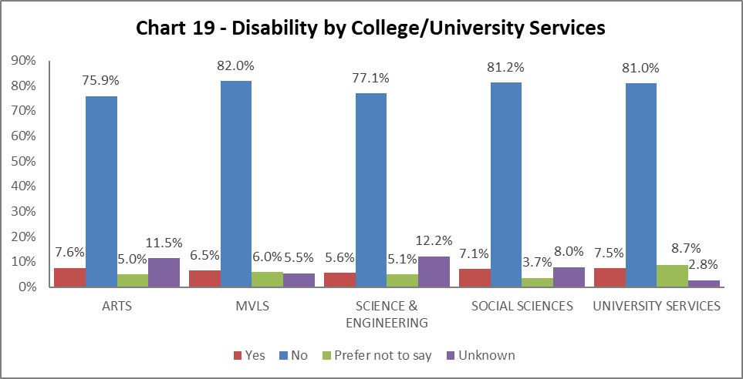

Chart 19 shows the percentage of declared disabled colleagues within College/University Services (US). All Colleges have seen an increase in declaration rates. The largest is Science and Engineering and Arts with an increase of 1.9% in both since 2021-22. All Colleges/US have seen a reduction in the ‘Unknown’ and ‘Prefer Not to Say’ categories, reflecting the drive to improve data quality.

By Grade 10 staff

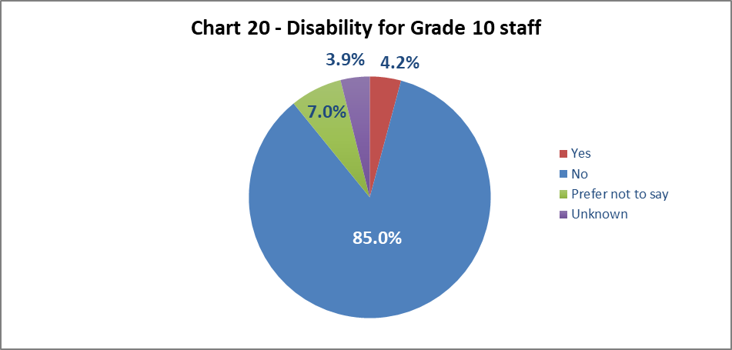

Chart 20 shows 4.2% of senior staff have declared a disability. This is an increase from last year by 0.8%, but it is still lower than the University wide figure of 6.8%.

By Job Family Profile

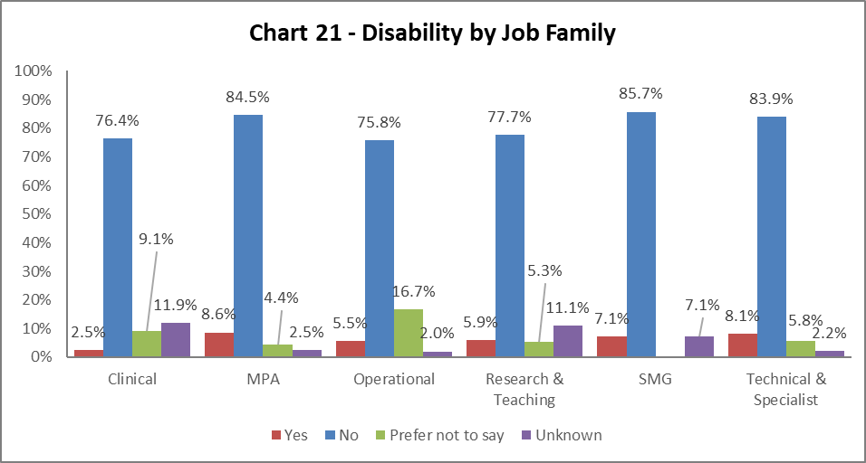

Chart 21 shows all job families have seen increased disability declaration rates from 2020-21, except for SMG. The highest percentage increase is with Technical and Specialist by 2.4% since 2021-22. All areas have seen a reduction in the ‘Unknown’ and ‘Prefer Not to Say’ categories.

By Grade

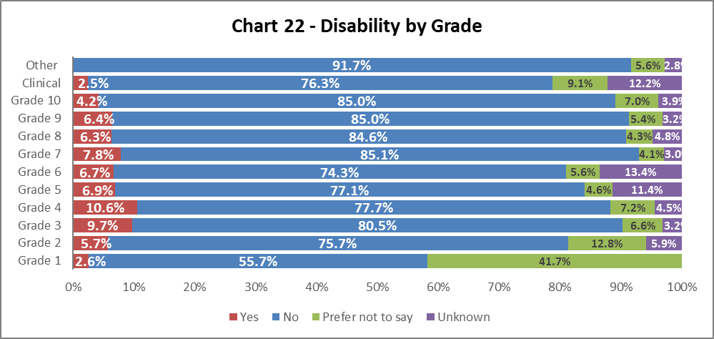

Chart 22 shows disability declaration rates by Grade. There has been an increase in disability declaration rates across all grades, notably by 2.1% in grade 2, 3.3% in grade 4, by 2.5% at grade 5 and 1.5% at grade 9. Again, we see significant reductions across all grades in the ‘Unknown’ and ‘Prefer not to say’ declarations.

By Full/Part Time

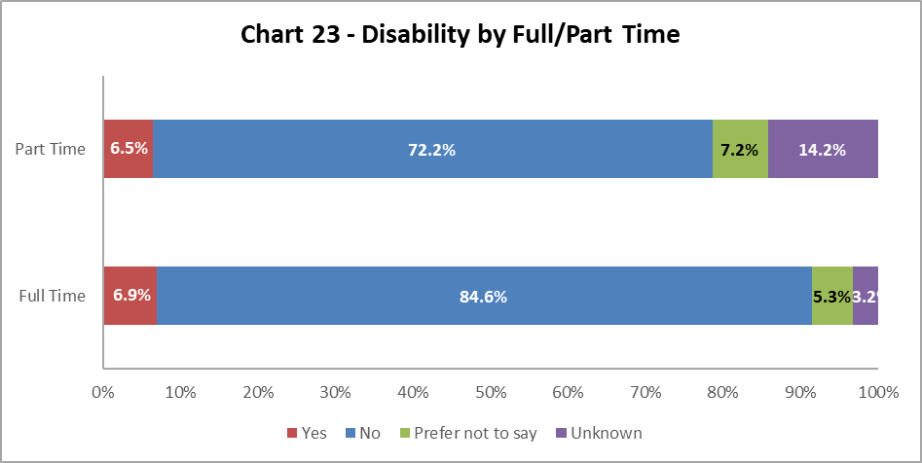

Chart 23 shows colleagues with a disability are equally as likely to work on a full time or part time basis. Since 2021-22, there has been over 1% increase in those declaring a disability who work full time or part time.

By Contract Type

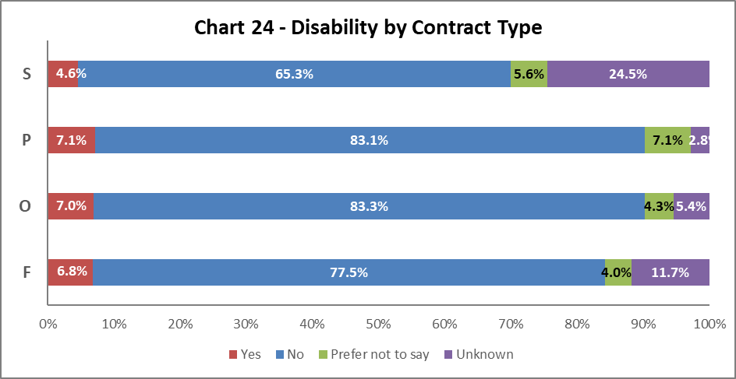

Chart 24 above shows disabled colleagues are most likely to have a Permanent contract (Code P), an increase 1.3% from 2021-22. However, there are marked increases in declarations in all contract types since last year. Open-ended contracts (code O) by 1.6% and Fixed term (code F) by 1.8%.

By Nationality

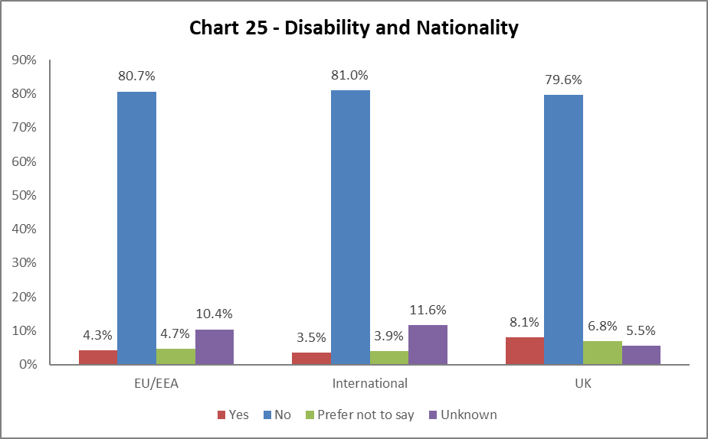
Chart 25 shows a higher proportion of colleagues from the UK have declared a disability when compared to International and EU/EEA staff. This is an increase of 1.9% since 2021-22. All declaration rates are higher this year, and ‘Unknowns’ and ‘Prefer Not to Say’ have reduced.

BSL Users

As part of the University’s British Sign Language (BSL) Action Plan we have reviewed the number of staff who declared a level of proficiency in the use of BSL. 19 staff have declared a level of proficiency, the majority at beginners level.

Recruitment – by Applications and Successful Applicants
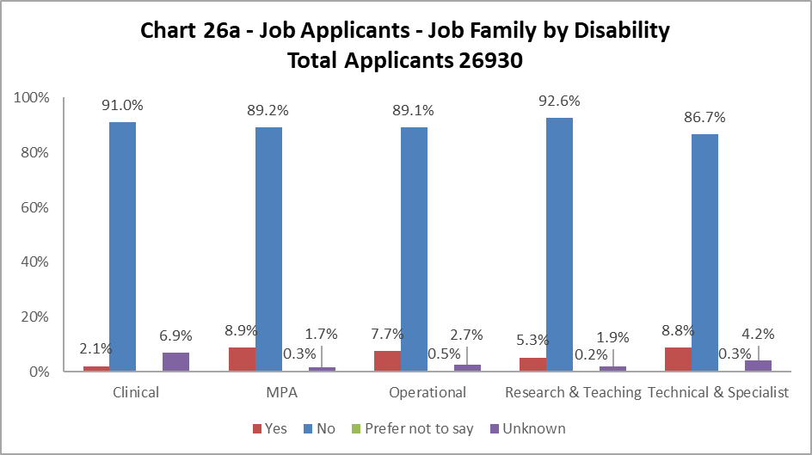

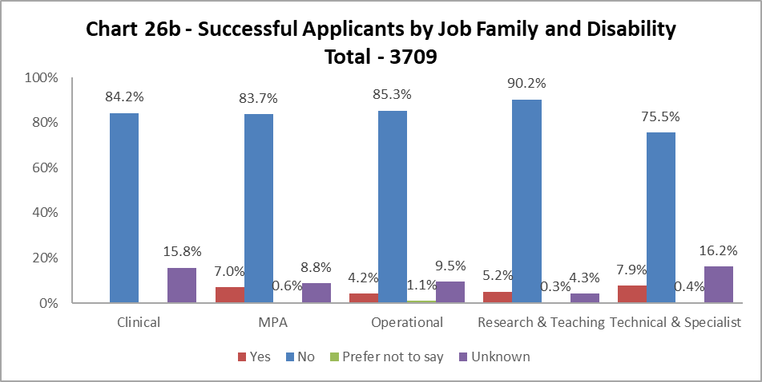

Charts 26a and 26b shows most job families had slightly more disabled applicants than were successfully appointed. Reflecting last year, most differences were relatively small, with the exception of the Operational job family where the difference was 3.5%, an increase from the previous year of 2.6%. The smallest drop was in Research and Teaching where the difference was only 0.1%. The percentages of ‘Unknown’ is growing in the successful applicant pool.

Profile by Ethnicity

By College

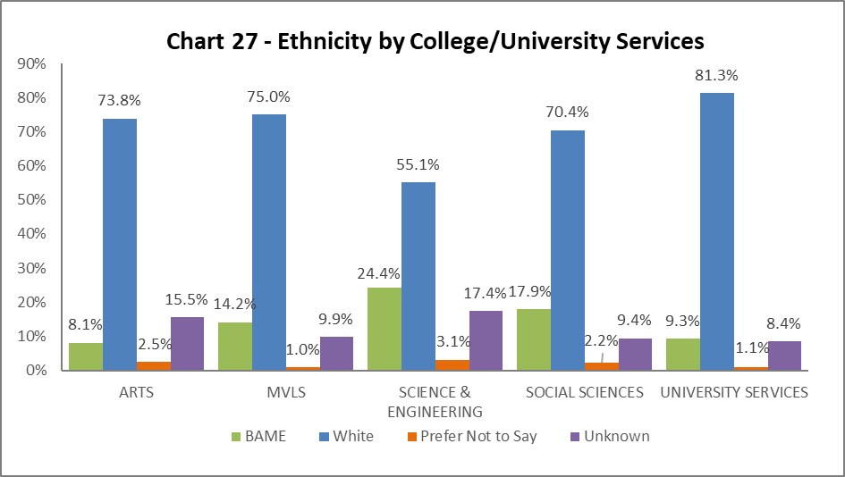

Chart 27 shows the breakdown by ethnicity of colleagues in College/US. The percentage of ethnic minority colleagues increased across all Colleges/US since 2021-22. A rise of 5.6% in Science and Engineering, 4.2% in MVLS, 4.4% in Social Sciences, 3.2% in US and 2.1% in Arts. All Colleges/US have seen a significant reduction in the percentages of ‘Unknowns’, which shows an improvement in the data quality.

By Grade 10 Staff

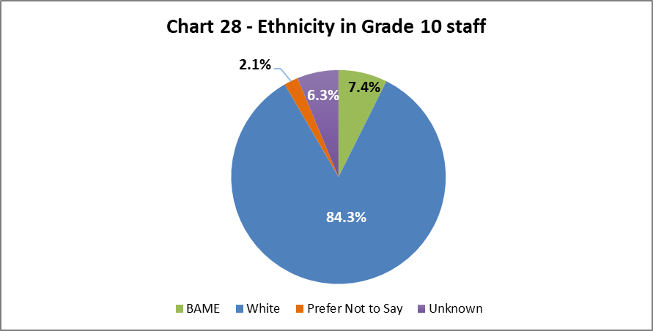
Chart 28 above show the ethnicity of staff at Grade 10. There has been an increase of 0.6% in BAME colleagues in senior roles since last year.

By Job Family Profile
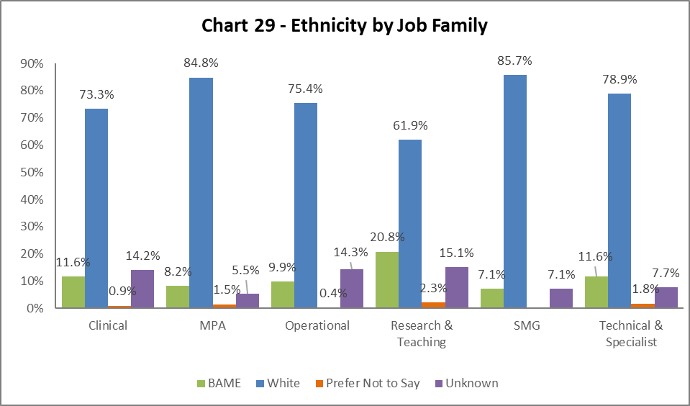

Chart 29 shows the ethnicity of colleagues by job family. There has been an increase in BAME colleagues across all job families since 2021-22. This is most notable in both Operational and Research and Teaching job families, increasing by 4.4% and 5.3% respectively. This may be fuelled by the reduction in the ‘Unknown’ statistics across all job families.

By Grade

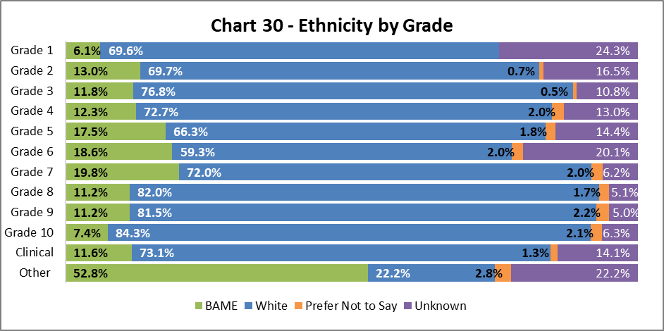

Chart 30 above shows the grade and ethnicity of colleagues. There has been an increase in BAME colleagues across all grades. The largest increases are in Grades 2 (by 6.2%), 5 (by 6.8%) 6 (by 5.7%) and Other (by 14.2%) since 2021-22. All grades have seen a reduction in the percentage of ‘Unknown’ and a slight increase in the percentage of those choosing ‘Prefer not to say’.

By Full/Part Time

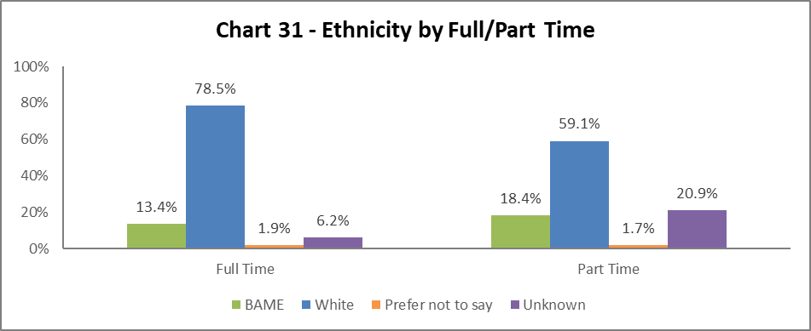

Chart 31 shows the ethnicity of colleagues working full time and part time. Both cohorts have seen increased rates of BAME declarations since 2021-22, notably the part time colleagues with an increase of 7.4%.

By Contract Type

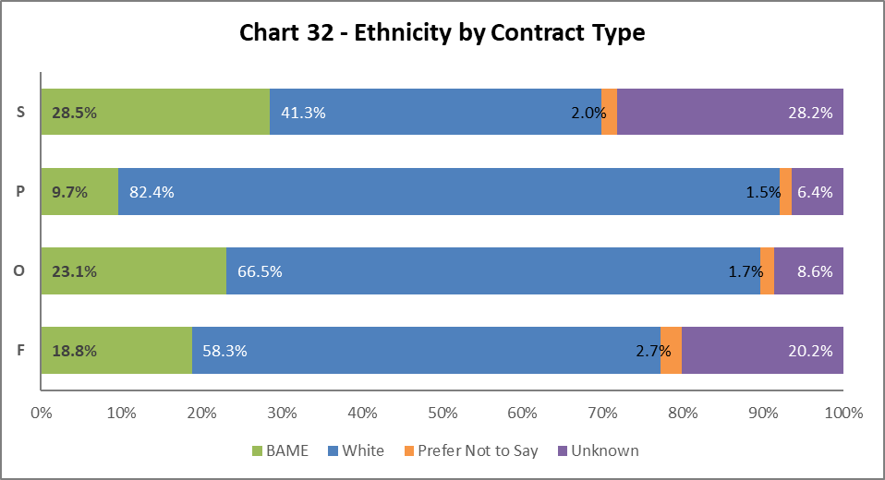

Chart 32 indicates the percentage of BAME colleagues has increased since 2021-22 across all contract types. This is highest in SOSR contracts (type S) with an increase of 12.1% followed by Fixed Term (type F) by 5.4%. As referenced before, this is due to a reduction in the ‘Unknown’ categories.

By Nationality

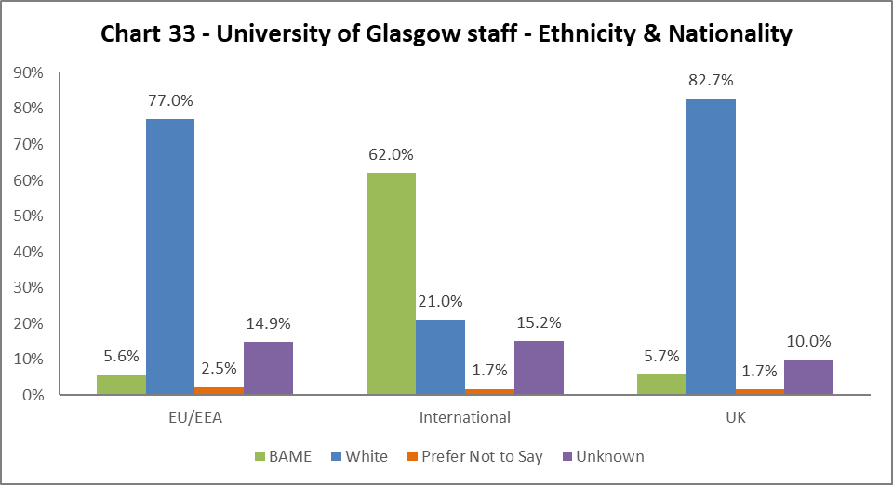

Chart 33 outlines the nationality and ethnicity of our staff. 62%% of our international colleagues are from BAME backgrounds, an increase of 11.2% from 2021-22, contributing significantly to the ethnic diversity of the University’s population. Of our UK staff, 5.7% are from BAME backgrounds – this is an increase of 0.8% since 2021-22.

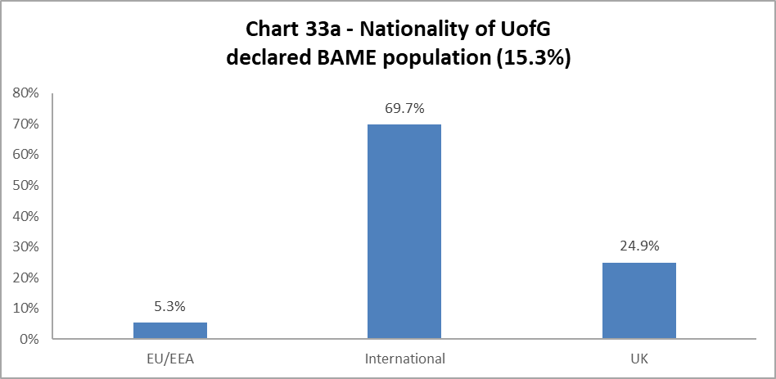
Chart 33a outlines the nationality of our whole BAME staff population (15.3% of total – see Chart 6a). More than two-thirds of our BAME colleagues are from international backgrounds.

Recruitment – by Applications and Successful Applicants

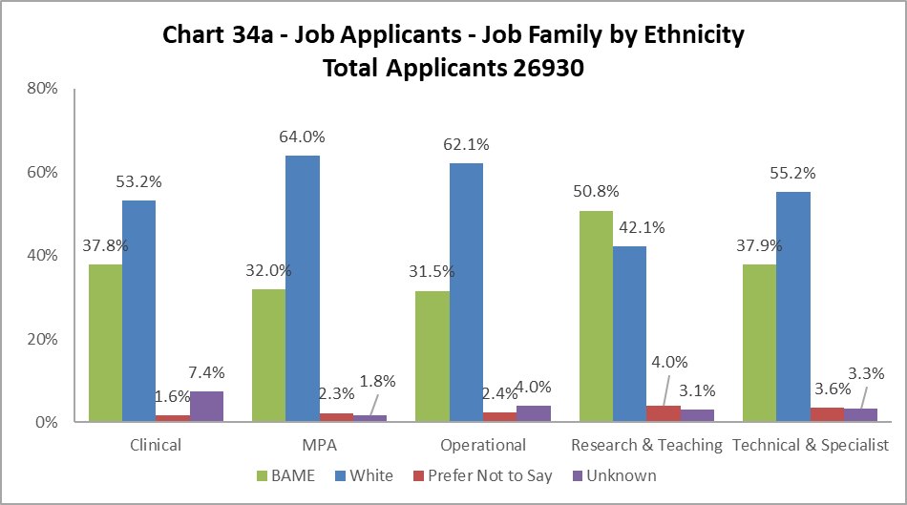

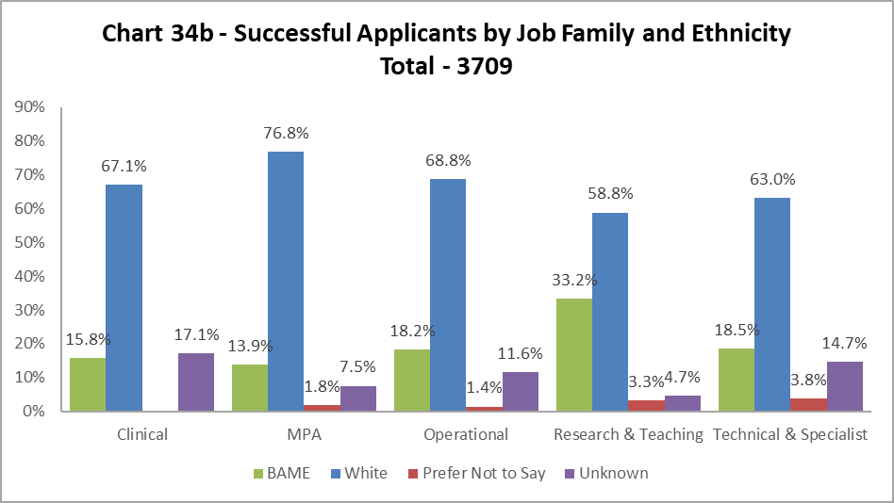

The data, as illustrated by Chart 34a and 34b, shows BAME applicants are proportionally less likely to be successful in all job family profiles. The drops between applications to successful applicants are over 20% in Clinical and Technical and Specialist job families, but in MPA and Research and Teaching this is over 15%. This needs further investigation to fully understand.

Profile by Sex

By College

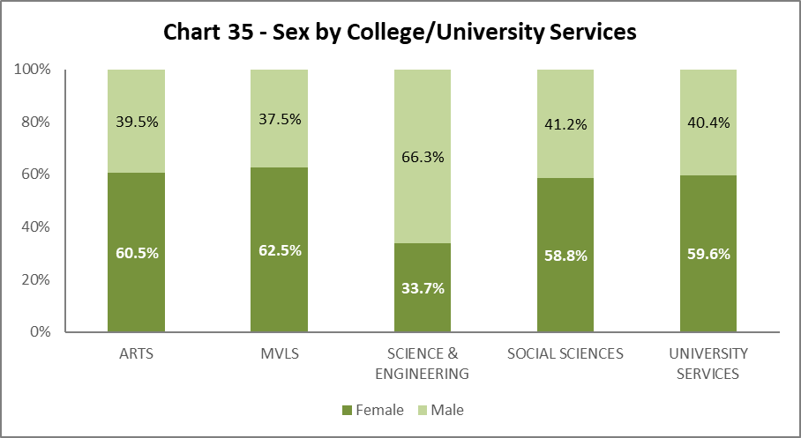

Chart 35 shows the split by Sex in College/US. Science and Engineering has seen an increase in females by 1.5%, reversing a 1.2% drop in the previous year. All other Colleges/US have only minor fluctuations.

By Grade 10 Staff

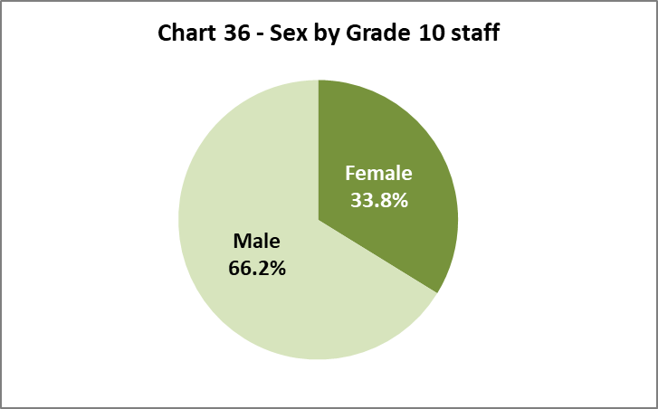

Chart 36 illustrates 33.8% of senior colleagues are Female, this a 1% increase from 2021-22.

By Job Family Profile

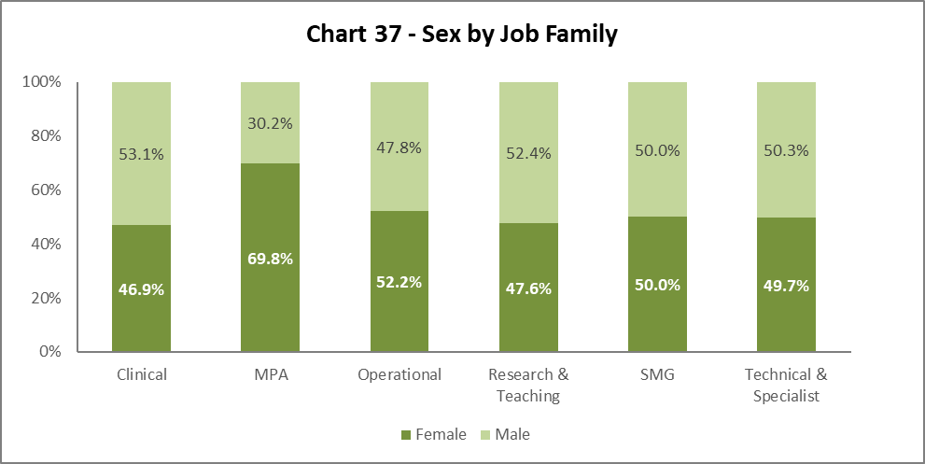

Chart 37 shows SMG is 50/50 Female to Male, as with previous years. There are other minor fluctuations across the job families.

By Grade

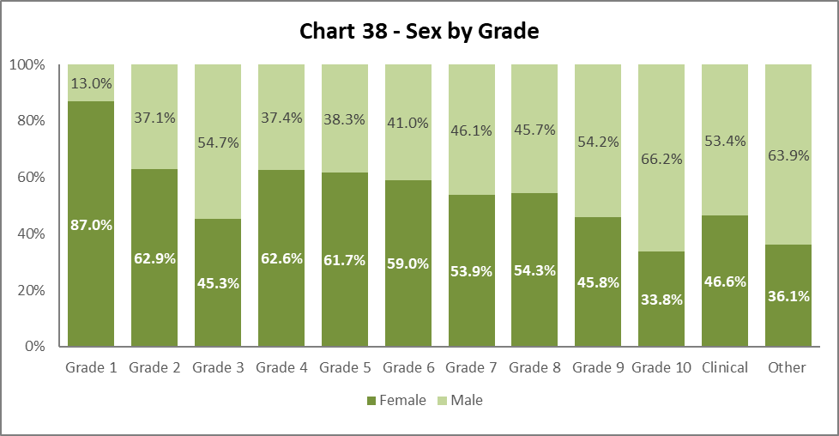

Chart 38 reflects similar proportions of females and males in each grade to last year. There is a notable increase in females in Grades 1 (by 2.6%) and 9 (by 2.5%). In general, the chart shows the usual curve, with higher percentages of females from Grade 4 to 8 and more males in Grade 9 and 10.

By Full/Part Time

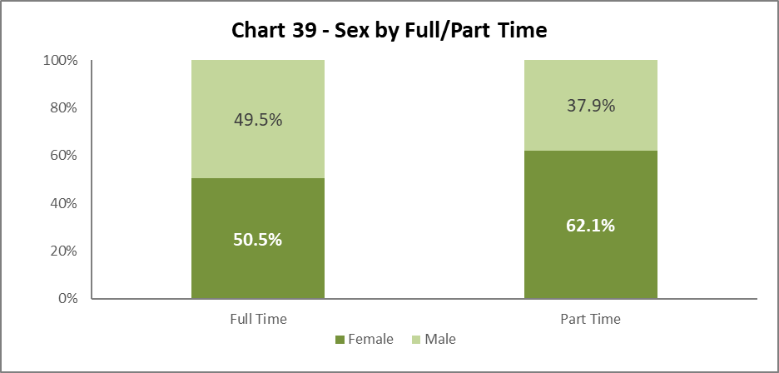
Chart 39 illustrates the breakdown by Sex of Full and Part Time staff. There has been a minor increase in the percentage of females working full time by 0.7% and in the percentage of females working part time by 0.6% since 2021-22.

By Contract Type

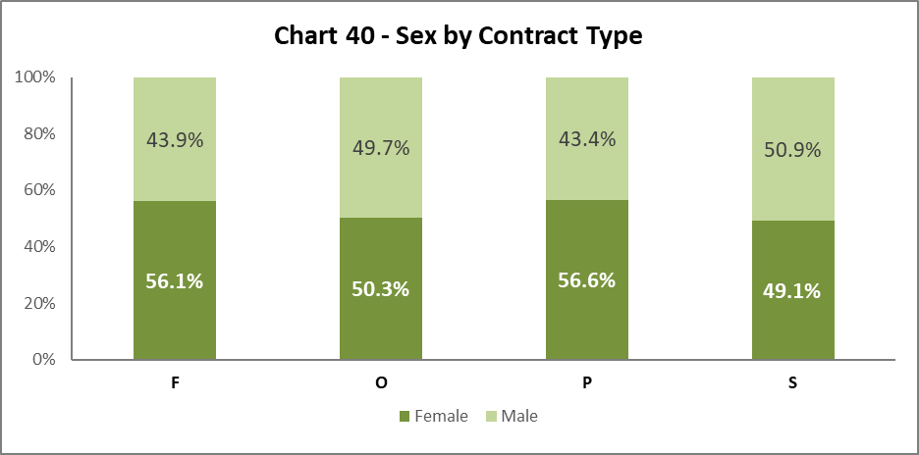

Chart 40 shows Sex by contract type. There has been little change from 2021-22 in the sex balance between the contract types.

By Nationality

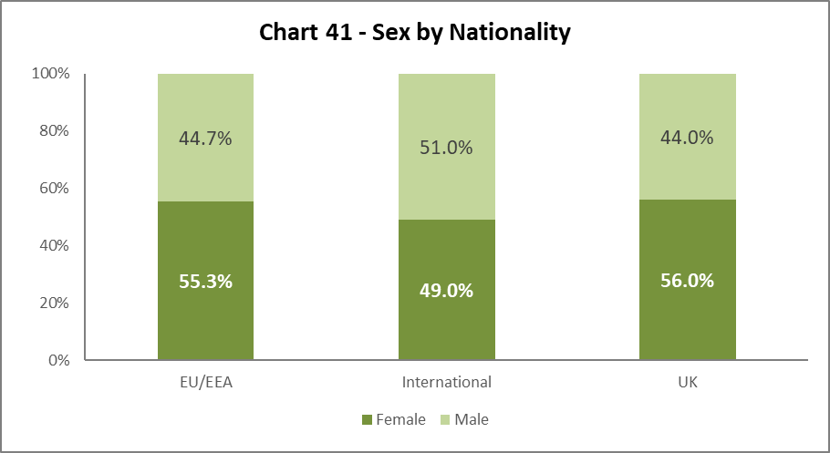

Chart 41 shows an increase in females from the EU/EEA (by 1.3%) and from an International background (by 1.8%).

Recruitment – by Applications and Successful Applicants

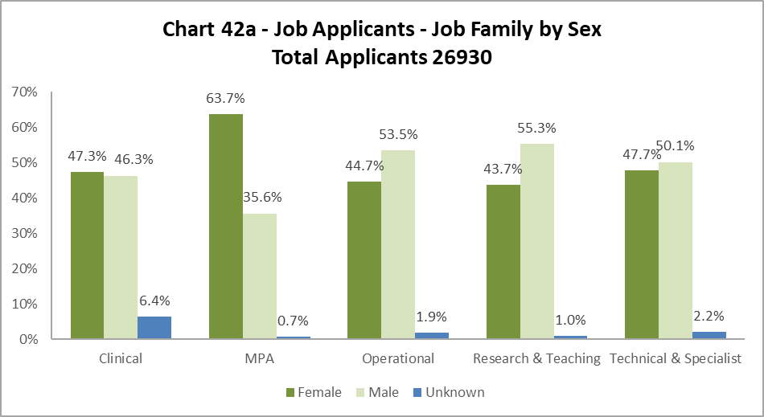

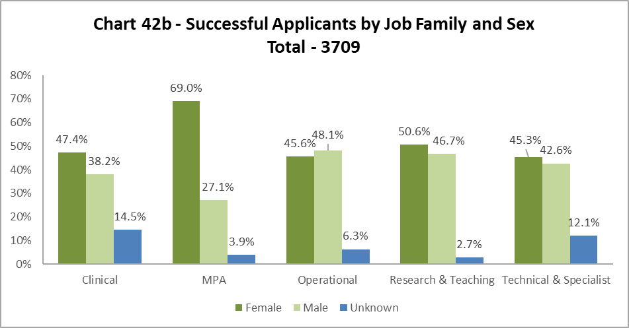

Charts 42a and 42b indicate Females are usually more successful than Males between application and successful appointment. This is noticeable in the MPA and Research & Teaching job families.

Profile by Sexual Orientation

22.8% of all staff have not answered the question on Sexual Orientation. As such the ‘Unknown’ figures have been excluded from these graphics but have been included in the statistics used to create them.

By College

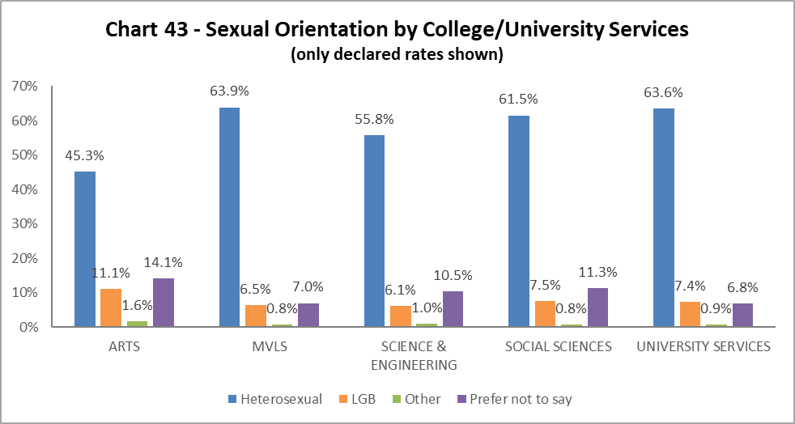

Chart 43 outlines the percentage of colleagues who have declared their LGB status. All Colleges/US have seen continued growth in the percentage of colleague indicating they are LGB. Most notably Arts has seen a 3.4% increase since last year, and has the largest percentage of LGB staff across the University.

By Grade 10 Staff

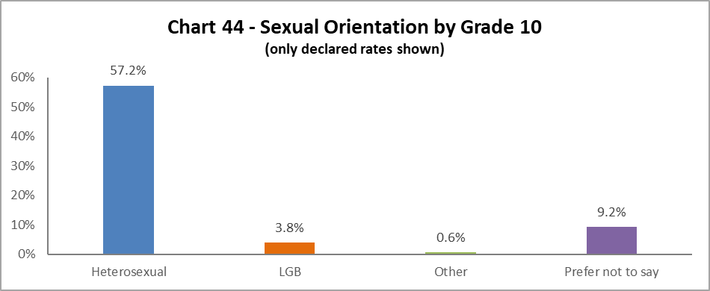

3.8% of Grade 10 colleagues identify as LGB, this is an increase of 0.6% from 2021-22.

By Job Family

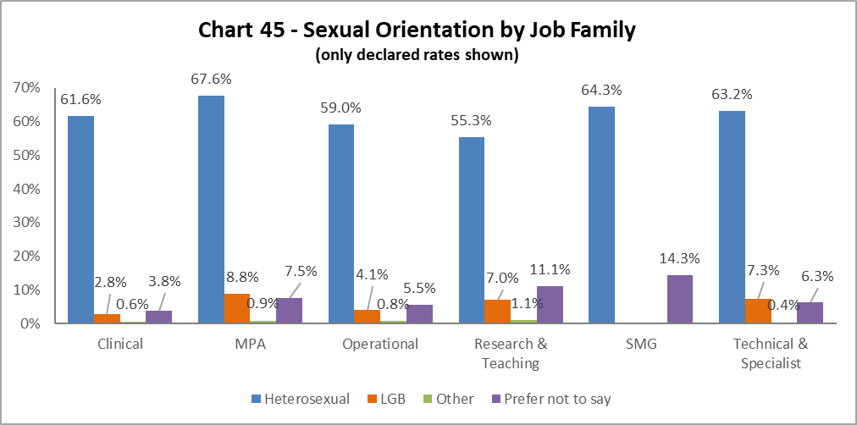

All job families (except SMG) have seen an increase in LGB colleagues. The most significant increases since 2021-22 are in the Research and Teaching (increase of 1.9%), MPA (increase of 1.6%) and Operational (1.3%).

By Grade

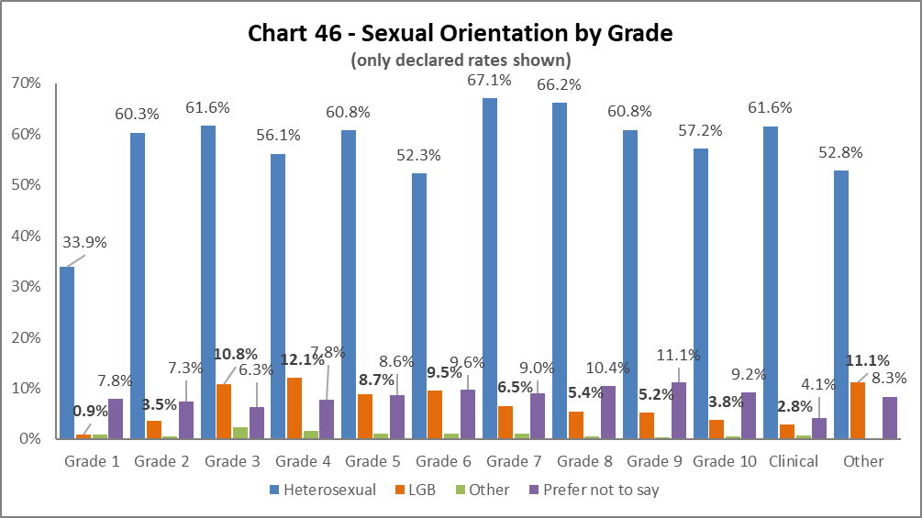
LGB declarations by grade show interesting fluctuations since 2021-22. Grade 3 has gone down by 0.6%, but Grades 4 - 7 have gone up by 4.8%, 2.3%, 3.5% and 1.2% respectively.

By Full/Part Time

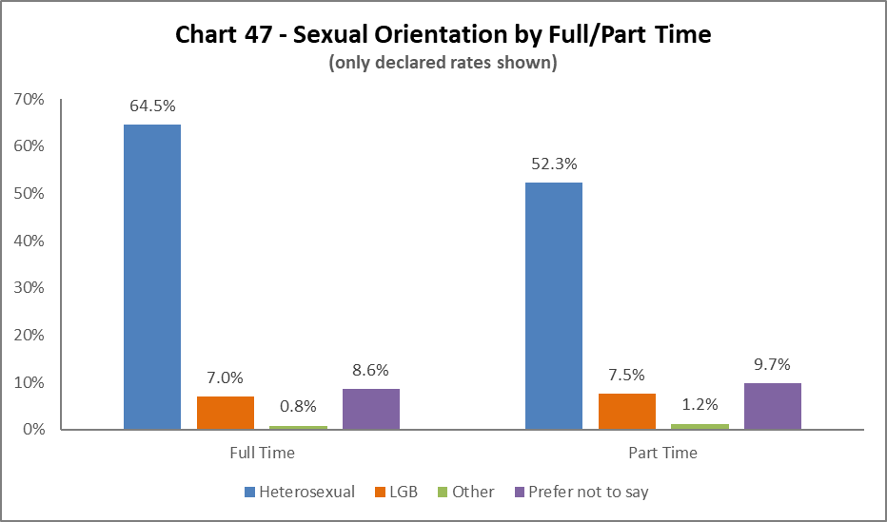
In a change since 2021-22, this year more LGB colleagues work part time, an increase of 2.6%. This reflects a growing percentage of LBG staff working part time over a number of years.

By Contrast Type

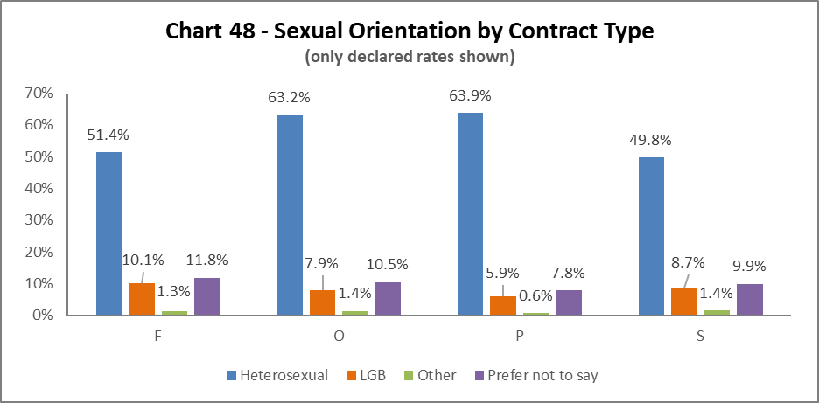
The highest proportion of LGB colleagues continues to be on Fixed term (code F) contracts, however there is growth across all contract types of LGB colleagues. The smallest growth since 2021-22 is in Permanent contracts (type P) of 0.9%.

By Nationality
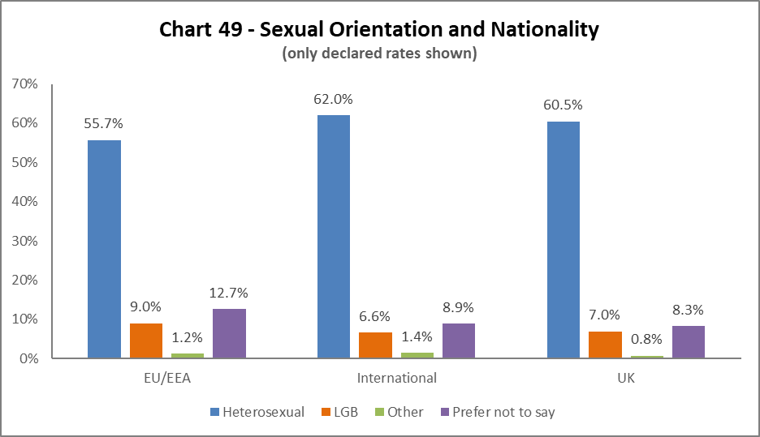
As in 2021-22, the highest proportion of LGB colleagues are from the EU/EEA, reflecting a 2.7% increase from last year. There has been a 1.5% increase in UK, and 2.1% increase in International LGB colleagues since 2021-22.

Recruitment – by Applications and Successful Applicants

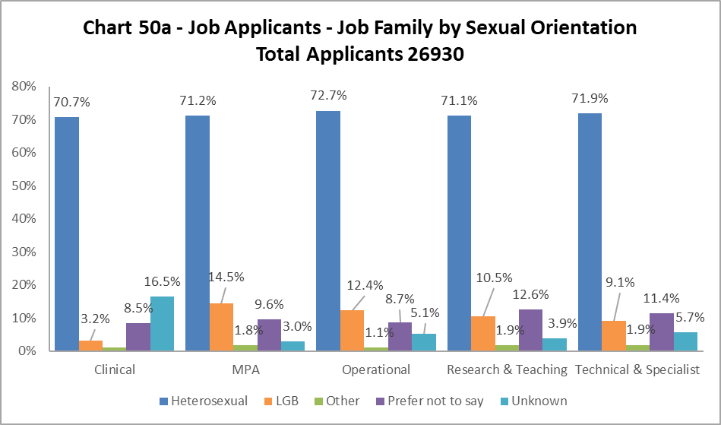

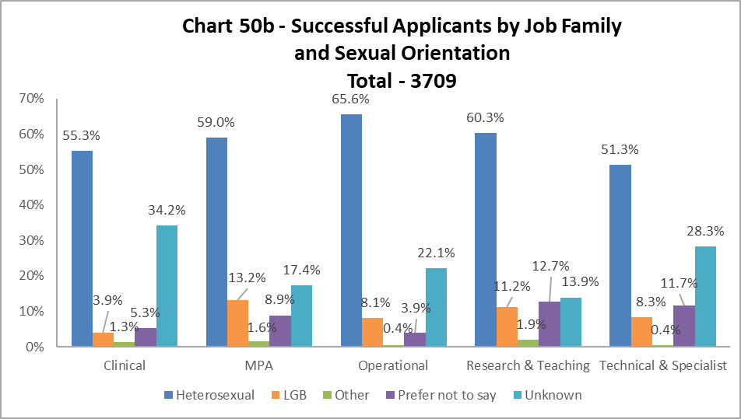

The proportion of successful LGB applicants closely matches that of the applicant pool across most job families, the exception being Operational staff, where the drop is of 4.3%.

Case Management – General

2022-23 saw a 93% increase in the number of Managing Attendance, Discipline and Grievance cases – 166 in total, compared to 86 in 2021-22 and 103 in 2020-21. A new system to record and manage cases was rolled out in 2022-23, and more accurate reporting is considered the cause. It should be noted that although the number of cases has increased, the percentages below still relate to small numbers.

By Sex

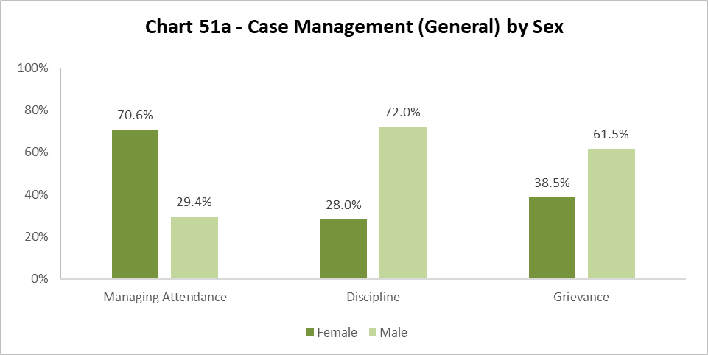

Chart 51a shows a higher percentage of those involved in Managing Attendance cases were Females, however this reflects the previous two years. Males were significantly more likely to be taken through a Disciplinary process, again reflecting the last two years. In a change from 2021-22, Males are more likely to raise a Grievance, which is a reverse of the 2021-22 data. Last year 72.7% Females raised a Grievance, this has dropped by 34.2% in 2022-23.

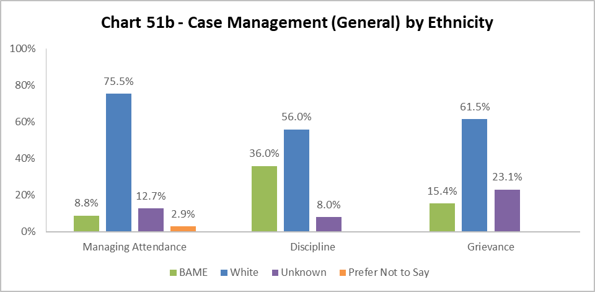

Chart 51b considers the ethnicity of colleagues involved in case management. The whole University BAME population is 15.3%. The percentage of BAME colleagues involved in Managing Attendance cases is lower than 2021-22, and the University average. The percentage of BAME colleagues involved in Discipline processes is 29.3% higher than last year and is more than double the University benchmark. The percentage who raised a Grievance, is 5.3% higher than 2021-22, but aligns with the University benchmark.

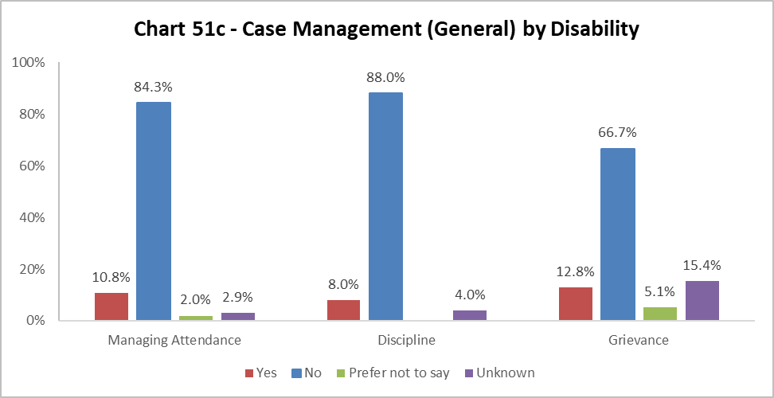

Chart 51c, considers the disability status of colleagues involved in case management cases.

The University population of disabled colleagues is 6.8%. The percentages involved in Managing Attendances cases is higher by 4%, however this is a drop of 5.5% from 2021-22. The percentage involved in Discipline has increased by 8% since 2021-22, where none were recorded. There has a slight decrease in the percentage of Disabled colleagues raising a Grievance by 0.8% since 2021-22, however this is still higher than the University benchmark.

Case Management – Sickness

The sickness figures relate to colleagues who have been absent for 20 or more continuous working days between 01 August 2022 – 31 July 2023. This involves 4.9% of those under report. This is a decrease of 0.1% from 2021-22.

Age

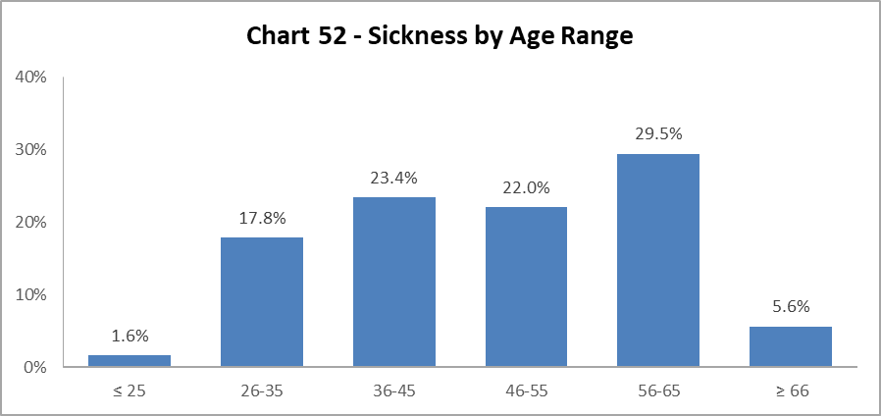

Chart 52 shows most colleagues who were off sick for 20 days or more, were in the 56-65 age group, which is slightly higher than 2021-22 by 2.6%. However, the spread across the age ranges is fairly even, reflecting the bell curve across the University.

Disability

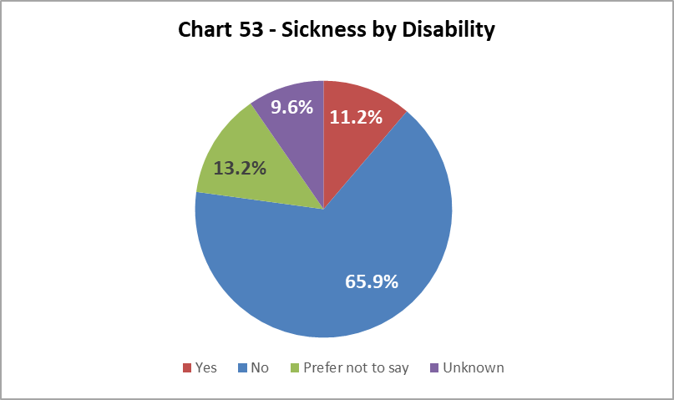

Chart 53 shows the proportion of disabled colleagues absent for 20 days or more was 11.2%, which represents a decrease of 2.7% from 2021-22.

Ethnicity

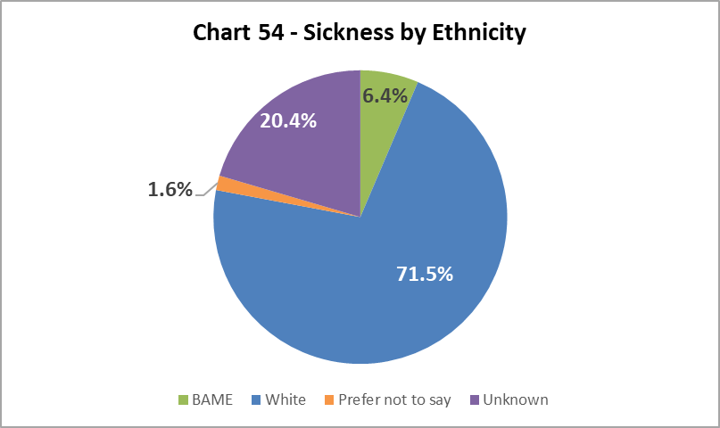

Chart 54 shows that, of colleagues who were off sick for more than 20 days, 6.4% were from a BAME background; this is a 1.2% decrease since 2020-21, and is slightly lower than the University benchmark.

Sex

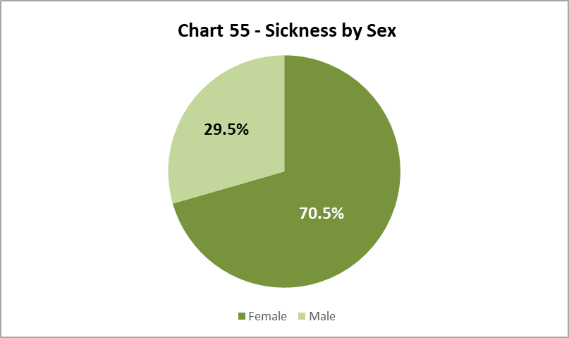

As in previous years, a higher proportion of Female colleagues have been off sick for 20 days or more than the overall University population (54.7%) as illustrated in Chart 8. The percentage of females off on long term sick has increased by 5.7% since 2021-22.

Sexual Orientation

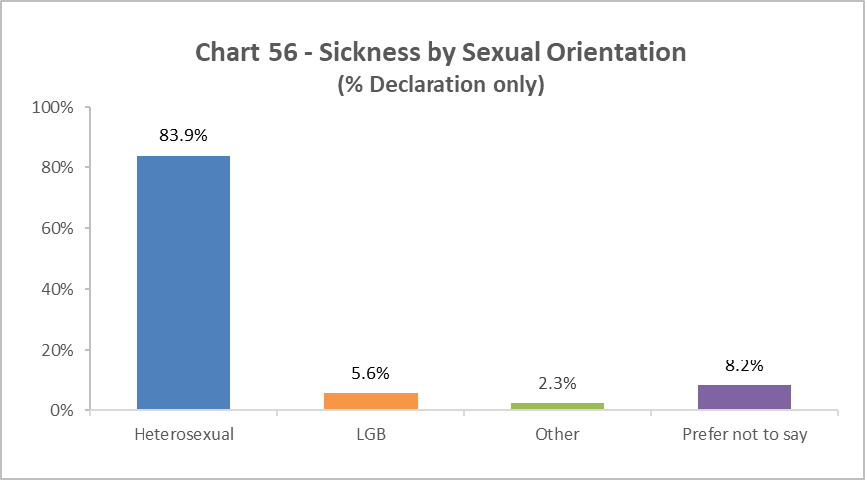

Chart 56 shows that of those who were off sick for more than 20 days, 5.6% declared as LGB. This is lower than the University wide LGB declaration rate, and a decrease of 5.7% from 2021-22.

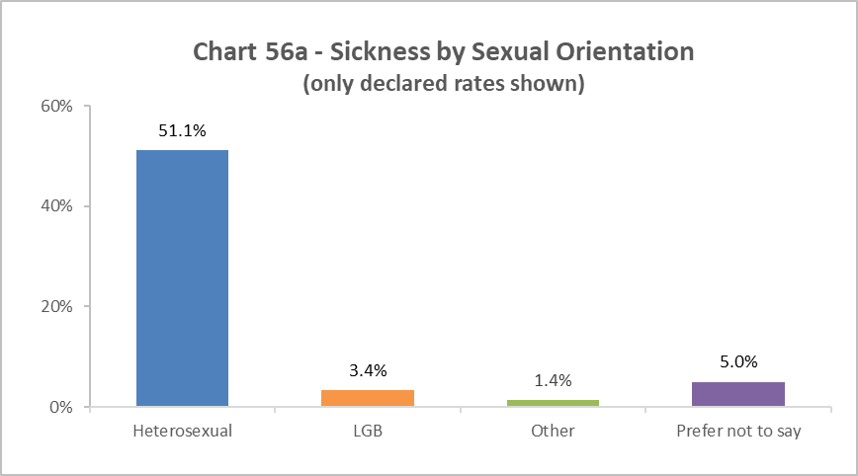
Chart 56a is a new graph which shows the percentage of colleagues by sexual orientation of overall declaration rates. ‘Unknown’ figures have been excluded from this graphic but included in the statistics used to create it, allowing for comparison with earlier charts (43 – 50b). It shows a further reduction of LGB colleagues on long term sickness absence, and a further reduction when compared to the overall University benchmark of 7.2% (Chart 9).

Academic Promotions

Table 12 - Academic Promotions 2023 - R&T and Clinical Job Families Only
Grade Applied For |  | Success Rate  For Grade | Female | Male
GRADE 7 | Applicants |  | 57.6% | 42.4%
 | Successful |  | 58.1% | 41.9%
 | Promoted (%) | 93.9% | 94.7% | 92.9%
GRADE 8 | Applicants |  | 49.4% | 50.6%
 | Successful |  | 50.0% | 50.0%
 | Promoted (%) | 89.2% | 90.2% | 88.1%
GRADE 9 | Applicants |  | 48.1% | 51.9%
 | Successful* |  | 49.4% | 50.6%
 | Promoted (%) | 81.9% | 84.3% | 79.6%
READER | Applicants |  | 31.3% | 68.8%
 | Successful* |  | 30.8% | 69.2%
 | Promoted (%) | 81.3% | 80.0% | 81.8%
CLINICAL | Applicants |  | N/a | 100%
 | Successful |  | N/a | 100%
 | Promoted (%) | 100% | N/a | 100%
PROFESSOR | Applicants |  | 39.5% | 60.5%
 | Successful* |  | 37.7% | 62.3%
 | Promoted (%) | 80.2% | 76.5% | 82.7%
SUCCESS RATE FOR ALL APPLICANTS % |  | 84.7% | 85.3% | 84.1%

*Includes those who were unsuccessful in their application to this grade but were successful in gaining promotion to a Grade above their current Grade.

Table 12 provides breakdown by Sex of the Academic Promotions 2022-23 process. The overall success rate is higher for Females than Males, reflecting 2020-22. At most grades the variation is marginal, except at Grade 9, where Females are more successful (by 4.7%), and conversely at Professor, where Males are more likely to be successful (by 6.2%). It is worth noting success rates go down as the grade get more senior, and in this round no Females applied for promotion in the Clinical grades. Additionally, the proportion of Female applying reduces from Grade 7 to Professor.

The overall success rate for those with a declared a Disability (6.5% of applicants) was 71.4%. For those from an ethnic minority background (19.4% of applicants) the success rate was 85.7%.

Regrading for Professional & Support Staff

Table 13 - Regrading 2022-23 - Professional and Support Staff by Grade
Grade Applied For |  | Success Rate | Female | Male
GRADE 1-5 | Applicants |  | 53.8% | 46.2%
 | Successful |  | 58.3% | 41.7%
 | Promoted (%) | 92.3% | 100% | 83.3%
GRADE 6-10 | Applicants |  | 64.3% | 35.7%
 | Successful |  | 63.0% | 37.0%
 | Promoted (%) | 96.4% | 94.4% | 100%
SUCCESS RATE FOR ALL APPLICANTS % |  | 95.1% | 96.0% | 93.8%

Table 14 - Regrading 2022-23 - Professional and Support Staff by Job Family
Job Family |  | Success Rate | Female | Male
MPA | Applicants |  | 76.9% | 23.1%
 | Successful |  | 79.2% | 20.8%
 | Promoted (%) | 92.3% | 95.0% | 83.3%
OPERATIONAL | Applicants |  | 50% | 50%
 | Successful |  | 50% | 50%
 | Promoted (%) | 100% | 100% | 100%
TECH & SPEC | Applicants |  | 30.8% | 69.2%
 | Successful |  | 30.8% | 69.2%
 | Promoted (%) | 100% | 100% | 100%
SUCCESS RATE FOR ALL APPLICANTS % |  | 95.1% | 96.0% | 93.8%

Table 13 above shows applications for regrading by Sex. Female were more successful in grades 1-5 and Males were more successful in Grades 6-10.

Table 14 shows much higher percentages of Females applying for regarding in the MPA job family which roughly reflects the make-up of this Job Family (Chart 37). In a reverse from 2021-22, this year Females were more likely to be successful in this job family than Males. Both the other job families had a 100% success rate, although it should be noted far fewer applications came from Females in the Technical and Specialist job family.

Equal Pay
The University has a duty to publish pay gap information by 30th April every two years under Regulation 7 of the Equality Act 2010 (Specific Duties) (Scotland) Regulations 2012. The most recent Equal Pay reports for Gender, Ethnicity and Disability was published in April 2023.

END.

As in previous years, MRC staff have been removed from this category and reallocated to the relevant grade based on salary scales.

