Logging into a SSD 10 workstation via the Cisco AnyConnect VPN Service

Sections:
Power on your device Connect to Wi-Fi Connect to VPN
Additional notes VPN combinations
Sync Offline Files (H Drive users Only) Sync OneDrive Files

Power on your device and allow Windows to boot

- Power on your device
- After Windows boots, mouse click, or key press will remove the welcome screen
- Click OK to accept the University of Glasgow workstation usage policy and you will be presented with the SSD 10 login screen.

Connect to Wi-Fi

Note: At home If you connect to a wired network connection, either directly or via a docking station, skip step 2 and go to step 3.

- Note: On campus If you connect to a wired network connection, either directly or via a docking station, then you go to step 4.

Click on the Internet/WI-FI button to open the wireless network screen:

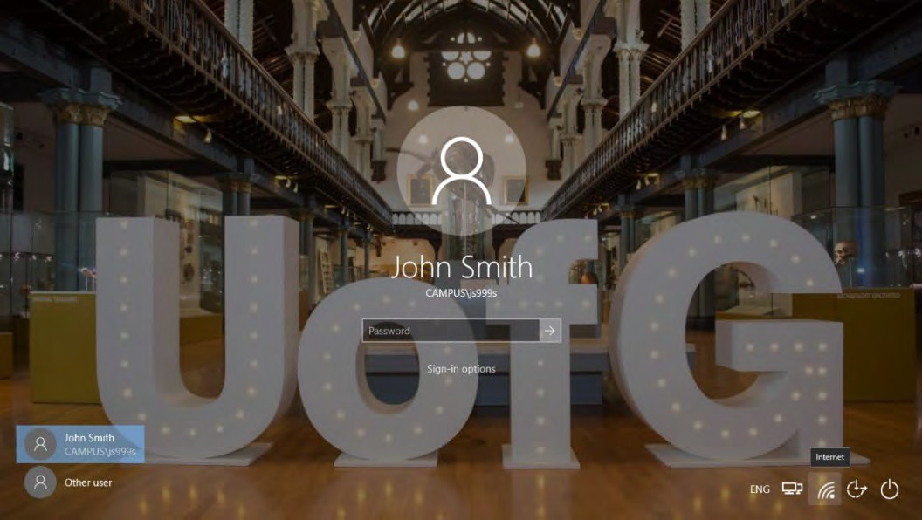
  - If you are on campus you will connect to the Wi-Fi network named “FlexAccess”
  - If you are elsewhere (home) you will connect to a wireless network in your location following the network provider’s guidance. Select Automatically Connect so that it will connect to this network when within range.

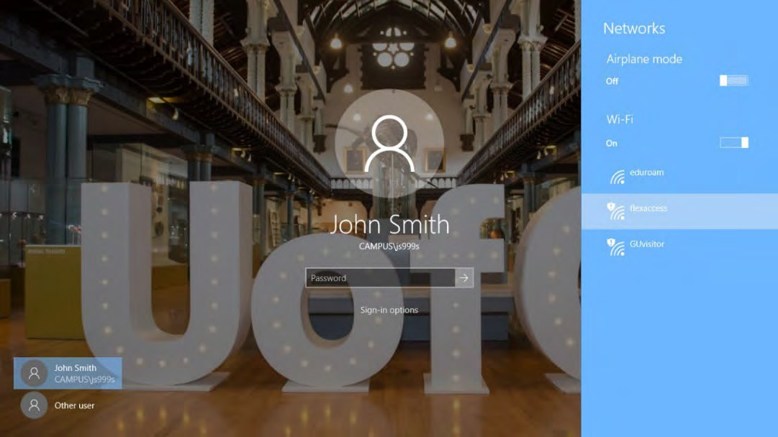

Connect to VPN

When you are connected to your selected network, click the highlighted icon on the bottom right of the screen labelled Network sign-in.

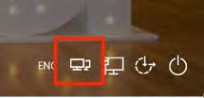

The VPN service should launch, SBL should be listed by default, please click Connect:

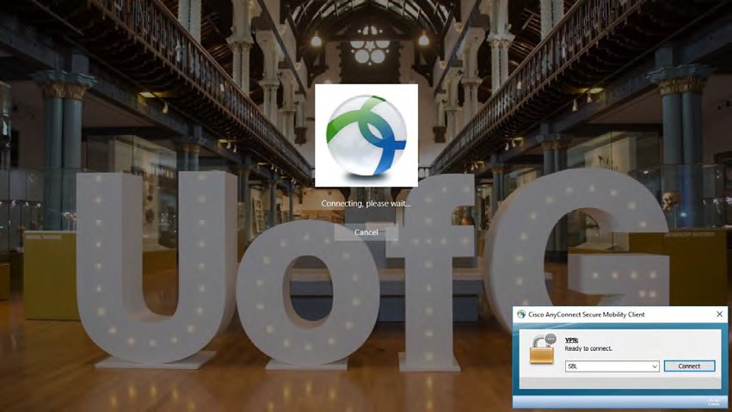
From the Group drop down list select either SBL (for off campus use) or SBL_campus (for on campus use), depending on where you are working. Enter your University of Glasgow GUID credentials and click OK.

Some users may see the following screen when connecting to VPN for the first time
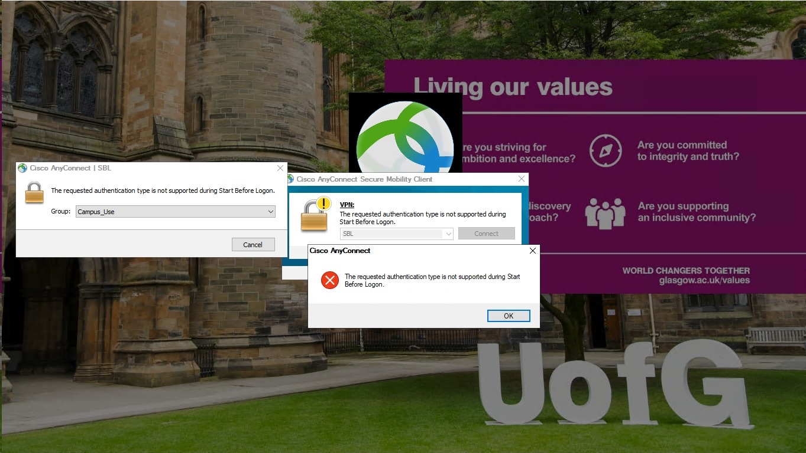

If you see this, close the box containing the red circle with the X and then click on the drop-down in the Cisco AnyConnect | SBL box and choose either SBL, if off campus, or SBL_on_Campus, as below
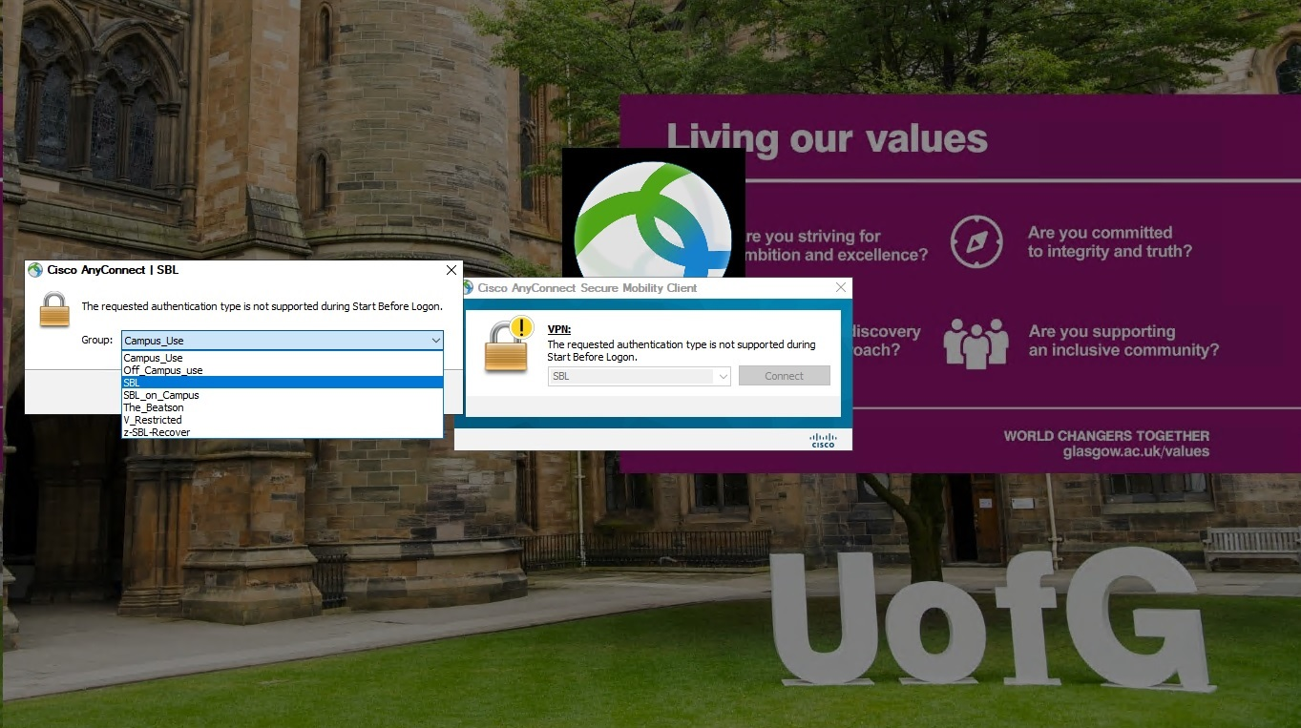

Then enter your GUID and password and click Connect.

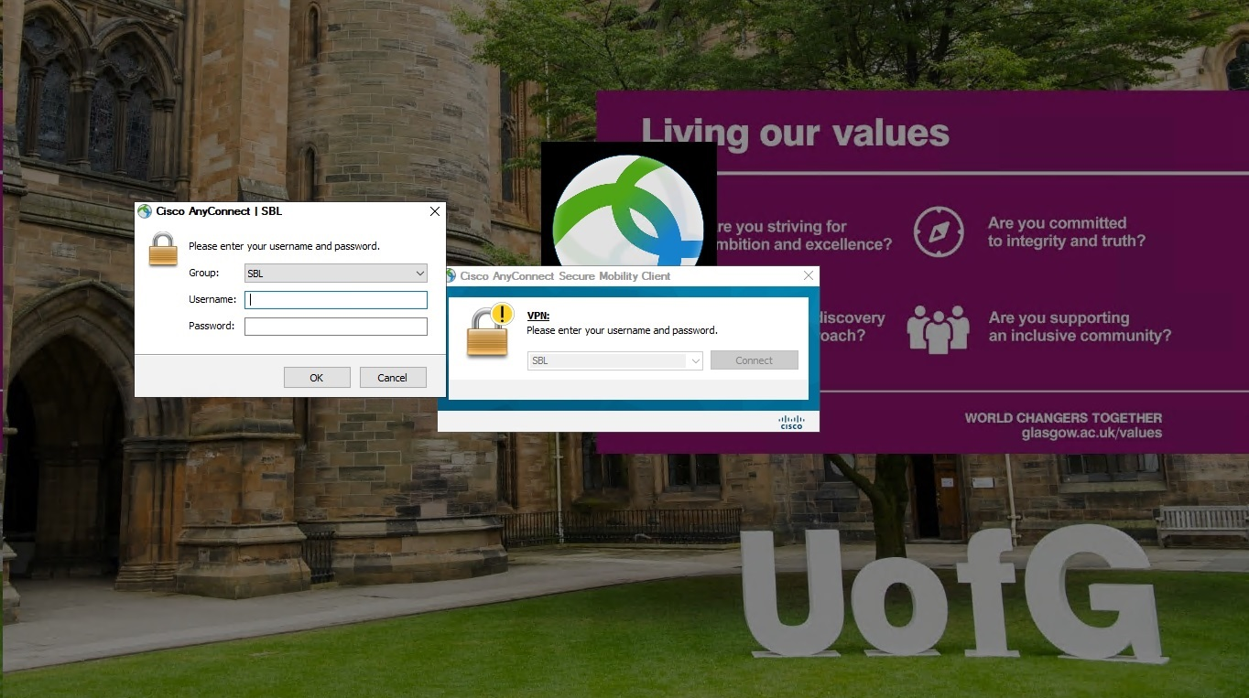
Once VPN is connected, you will now be presented with the normal SSD 10 log in screen. Click “Other User” at the bottom left then enter your University of Glasgow GUID credentials and press the Enter key or click the right facing arrow. First time login can take up to 10 minutes to complete.

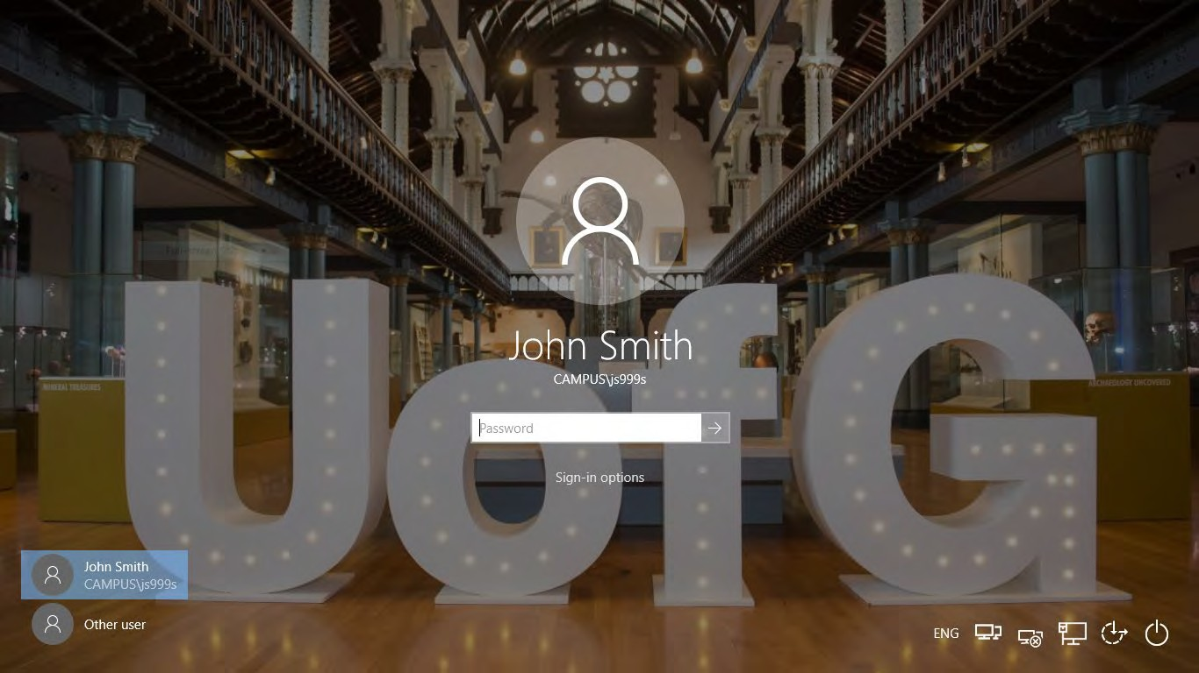
If this is your first login, a prompt will welcome you and say it is setting up offline files and then it will restart.

**
After the device restarts, please remember to re-connect to the VPN via the instructions above.
**

Note: Every time you power on or restart the device, we recommend that you connect to the VPN prior to Windows login to gain full function of SSD10.
Additional Notes
The wireless network “FlexAccess” on its own will not grant access to the internet. The first time you connect to this network, windows may tell you that it cannot access the internet.

This is normal and you are safe to close this window.

VPN Combinations

Wi-Fi: FlexAccess | > | VPN Server: SBL | > | Group: SBL campus
Wi-Fi: Eduroam | > | VPN Server: SBL | > | Group: SBL campus
All other Wi-Fi | > | VPN Server: SBL | > | Group: SBL

Sync Offline Files – (H Drive Users Only)

It is recommended that you synchronise offline files when you have logged into your laptop. To do this please follow this procedure:
With VPN connected click on the taskbar at the bottom right click on the UP arrow then right click on the Sync Center symbol then select “Open Sync Center”:

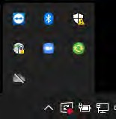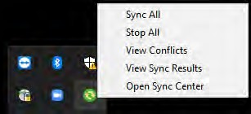

Once Sync Center has opened. Left click on Offline Files to highlight it then Right click and select “Sync Offline Files”

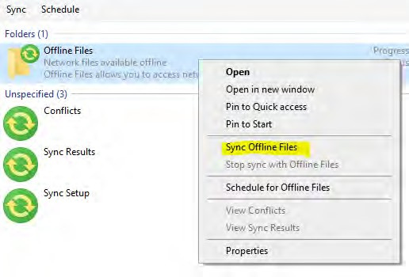

A green bar should then start to move across the screen saying “Sync in Progress”:

Depending on how many files you have currently stored in your H Drive will decide how quickly the sync completes. Please keep your laptop switched on and connected to the VPN until you are prompted with Sync Completed or it will inform you when the last sync was completed:

Note: You can close Sync Center once you have started the “Sync Offline Files” process and return to check the status later.

Sync OneDrive files

On the taskbar, click the UP arrow and click on the OneDrive icon and click Sign In:

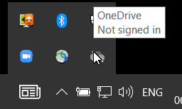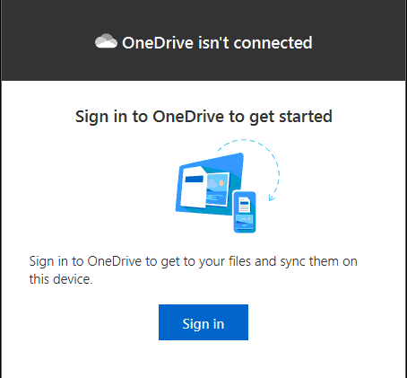

Enter your University Email Address, click Sign In and approve the MFA prompt (if setup) Click Next on the Location
Click on “Use this folder” if prompted Follow on-screen instruction
After a few minutes, your files should now appear in the relevant folders.

For any issues, please contact the UofG Helpdesk or call: 0141 330 4800

