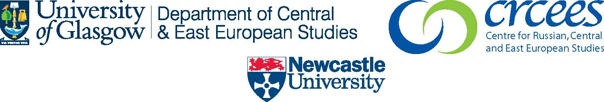
Social Integration and Cohesion in Post-Communist Europe
17-18 October 2008

Supported by Roberts fund, University of Glasgow, Centre for Russian, Central and East European Studies, University of Newcastle
www.gla.ac.uk/crcees

Conference Registration Form

Name: ---------------------------------------------------------------------------------------------------

Institution: ---------------------------------------------------------------------------------------------------

Address: ---------------------------------------------------------------------------------------------------

---------------------------------------------------------------------------------------------------

Email: ---------------------------------------------------------------------------------------------------

Please indicate special dietary requirements:

Please indicate any mobility issues:

Fee payable: (registration, tea/coffee and lunch)

□ Academic/ Full time employment £25 per day
□ Student £15 per day

Please return no later than Monday, 13 October 2008 to:

ADA-CHARLOTTE REGELMANN
DEPARTMENT OF CENTRAL AND EAST EUROPEAN STUDIES
UNIVERSITY OF GLASGOW
8-9, LILYBANK GARDENS
GLASGOW G12 8RZ

Tel: 0141 330 8587
Email: a.regelmann.1@research.gla.ac.uk

